SEMESTER II- RESEARCH METHODOLOGY ASSIGNMENT I AND II
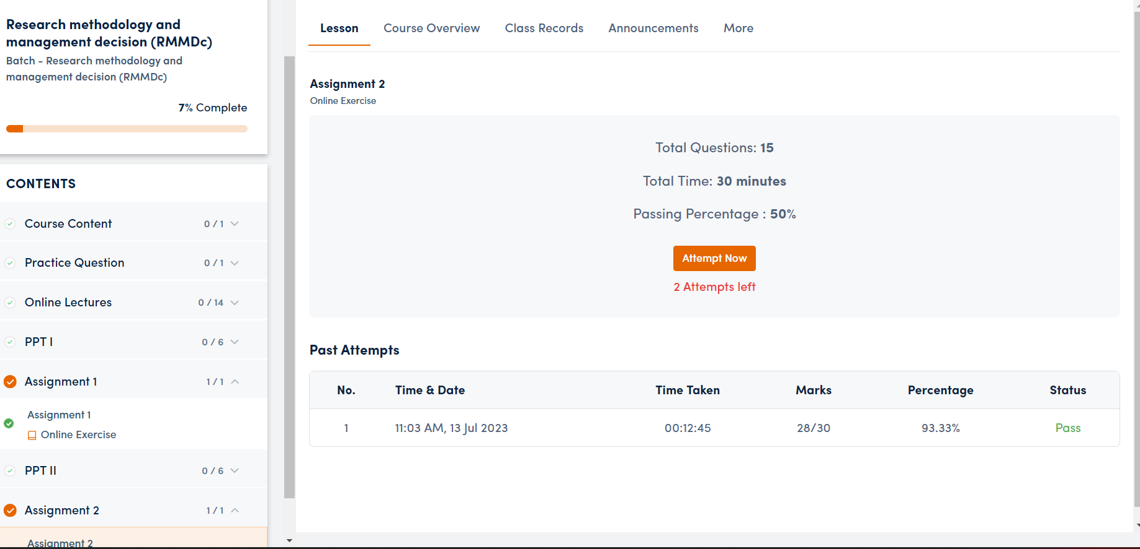

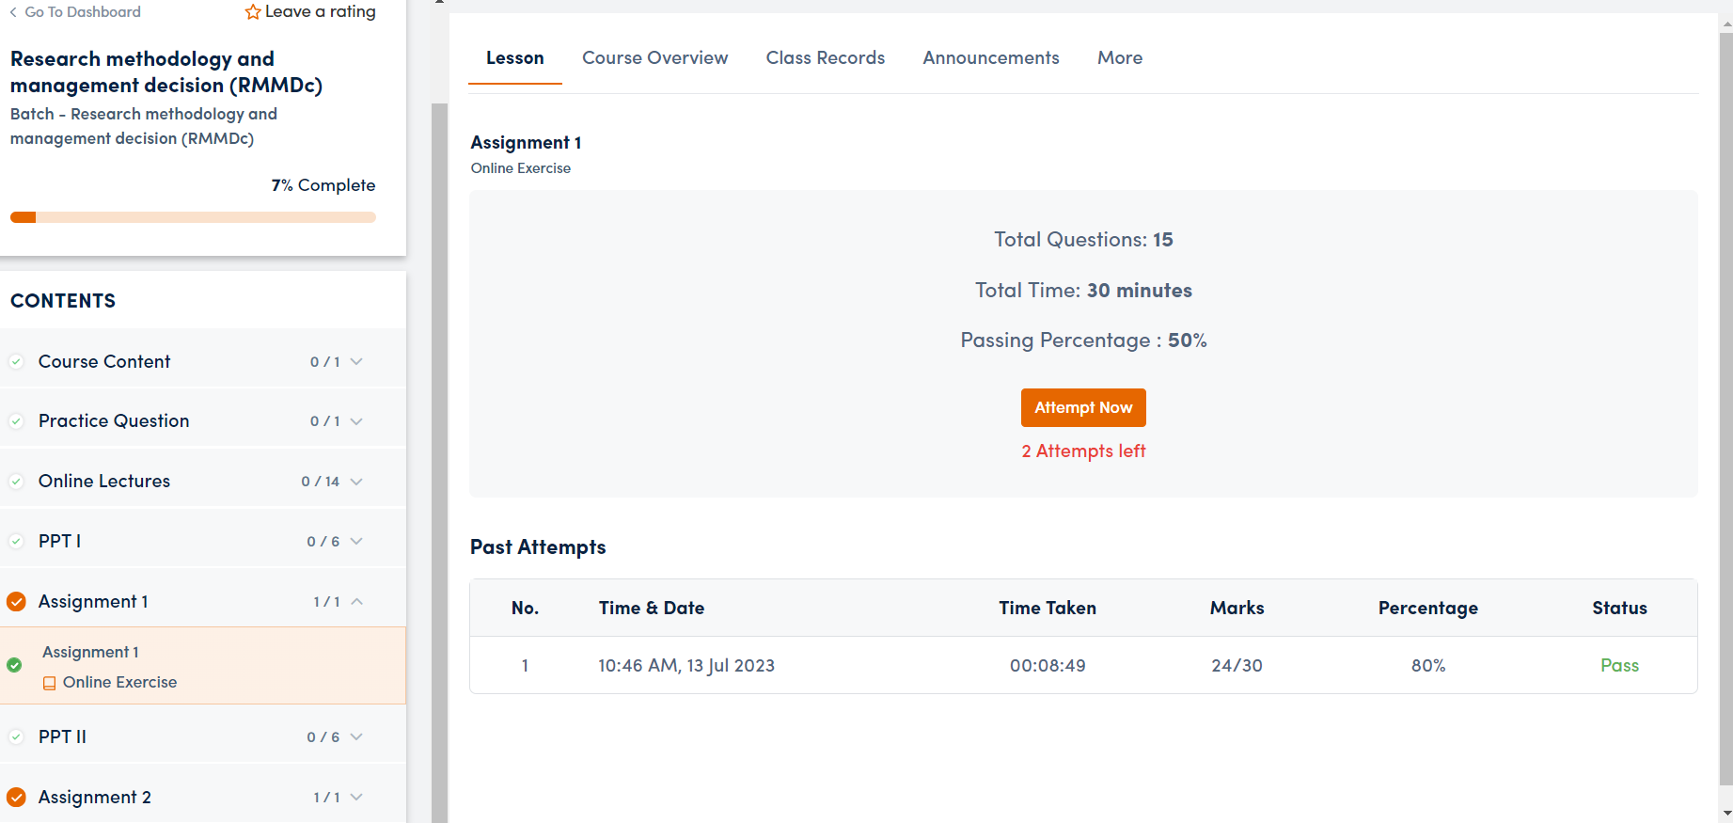

SEMESTER II- MANAGEMENT INFORMATION SYSTEM(MISC) ASSIGNMENT I AND II
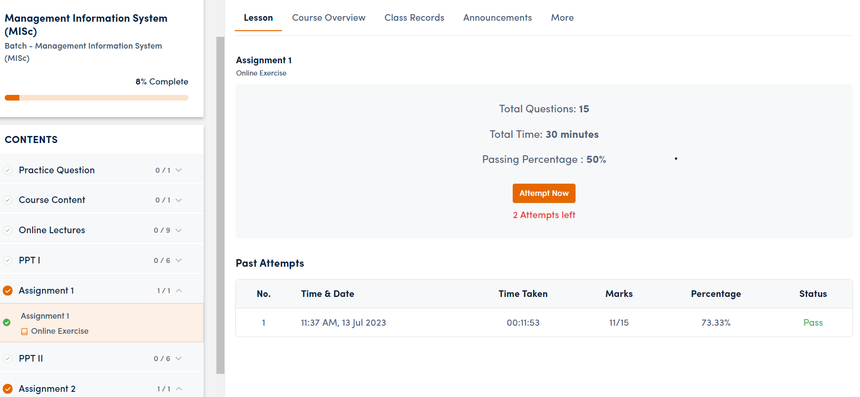

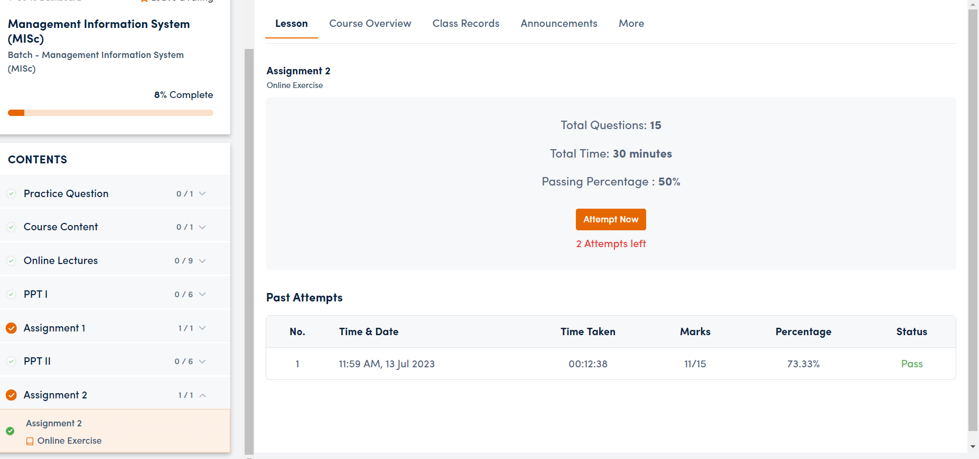

SEMESTER II- HUMAN RESOURCE MANAGEMENT (HRMc) ASSIGNMENT I AND II
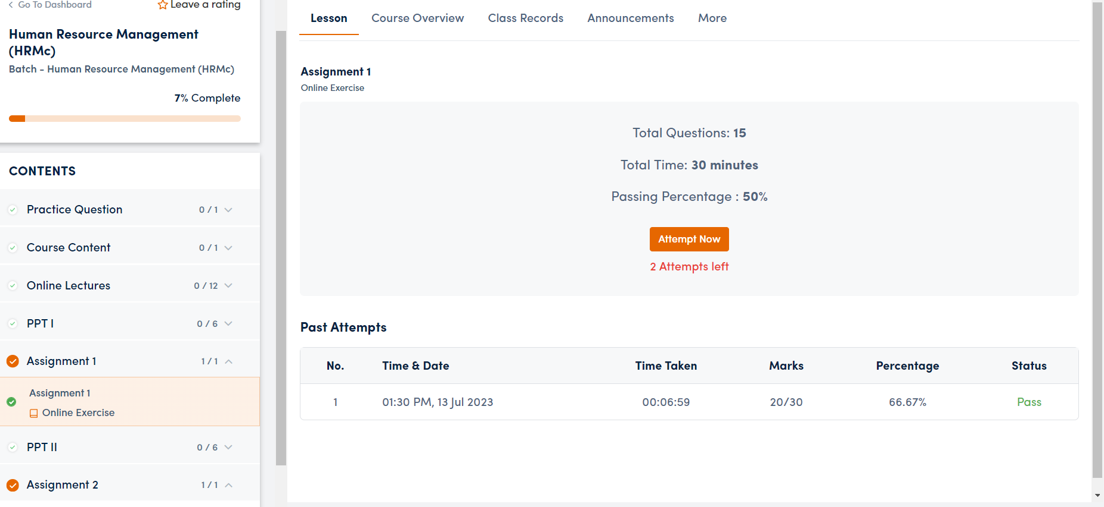

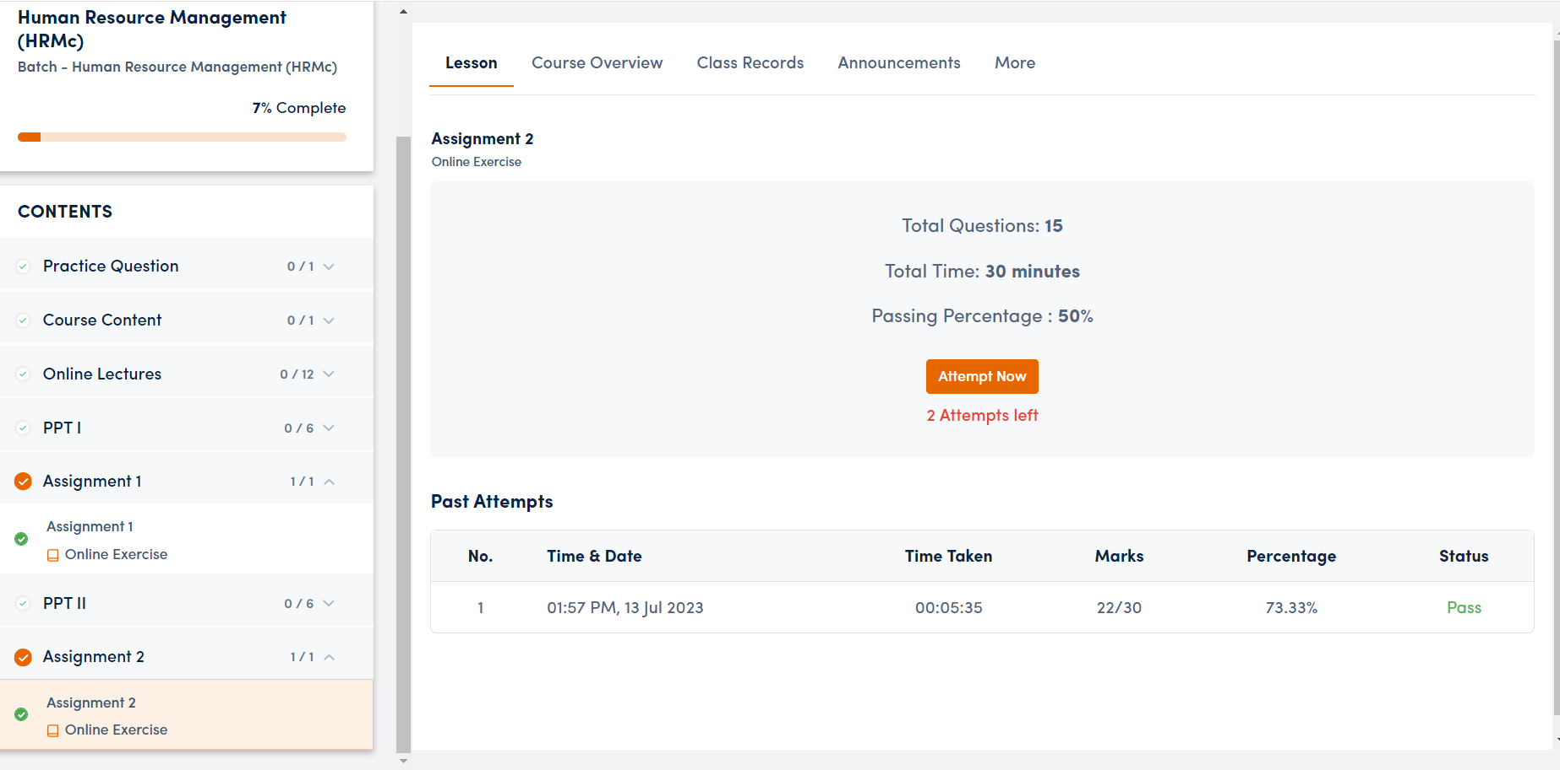

BUSINESS ANALYTICS (BAC) ASSIGNMENT I AND II
