Tableau Public download link and steps. (This is free version of Tableau)

https://www.tableau.com/products/public/download

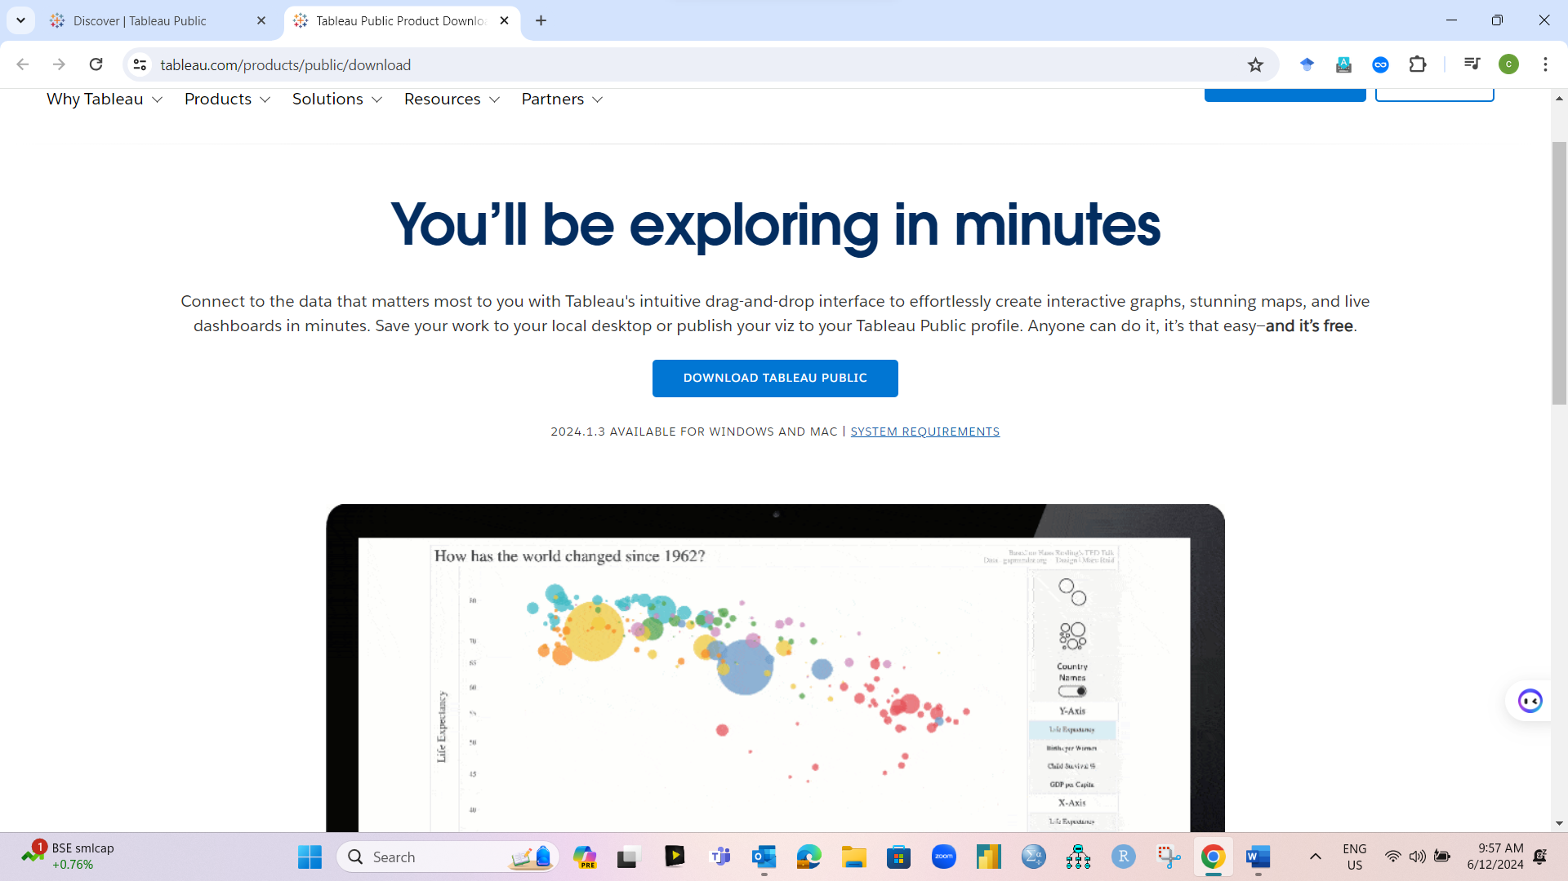

Fill the detail in given form and then download the apps

