Link to download

<https://www.tableau.com/academic/students>

Click on get tableau for free

Then this window will appear, fill out the institute and students’ detail with college email id.

(Please remember, only give your college email id).

You need to provide proof of students, like I card, admission letter etc.

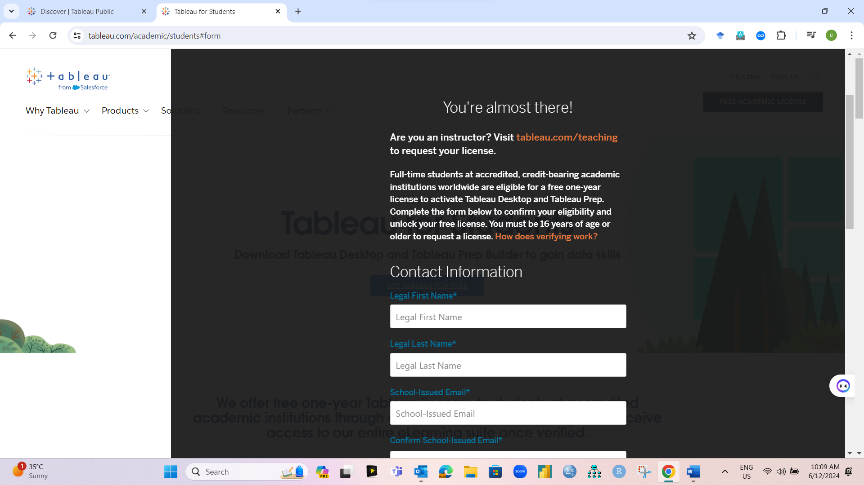

After submission of form, you will receive mail in your college email id, about Product key and product link within 24 hours.

Follow the steps download and install tableau software. After entering the product key, licence will be activated for one year.

**Difference between Tableau Public and Tableau Desktop.**

**Tableau Public save feature is not given (i.e. you cannot save your work) But in Tableau Desktop save feature is available.**

**Rest of the features are same in both.**