**Need to know correct answer.**

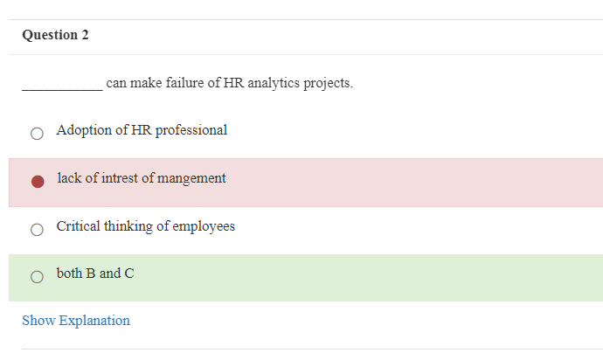

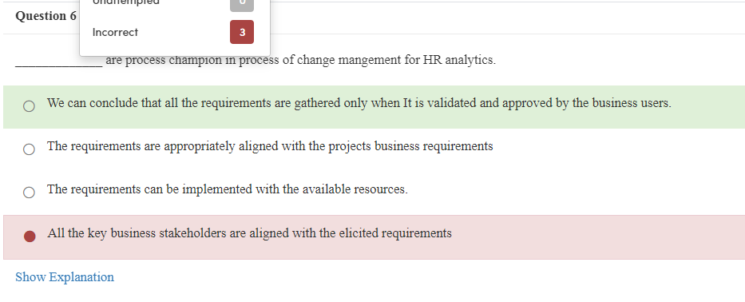

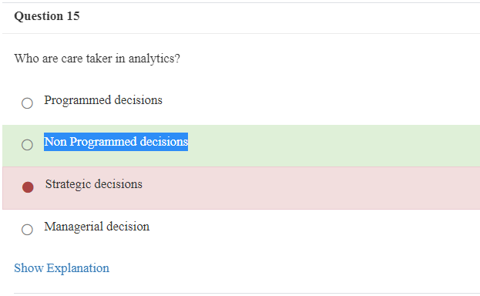

In book page number 77 it is mention that below all option are correct, (All of the above) but on test result it shows incorrect. – attempt 2

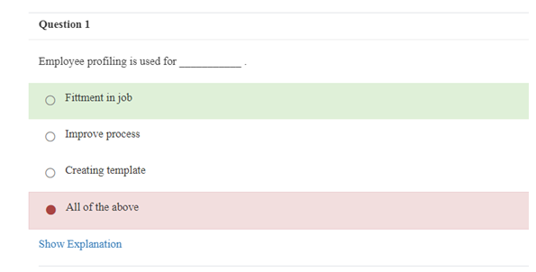

Same given in the slides provided in the module.

Kindly correct. It. And assign me the correct score of that attempt.

