Business Analytics

Assignment I

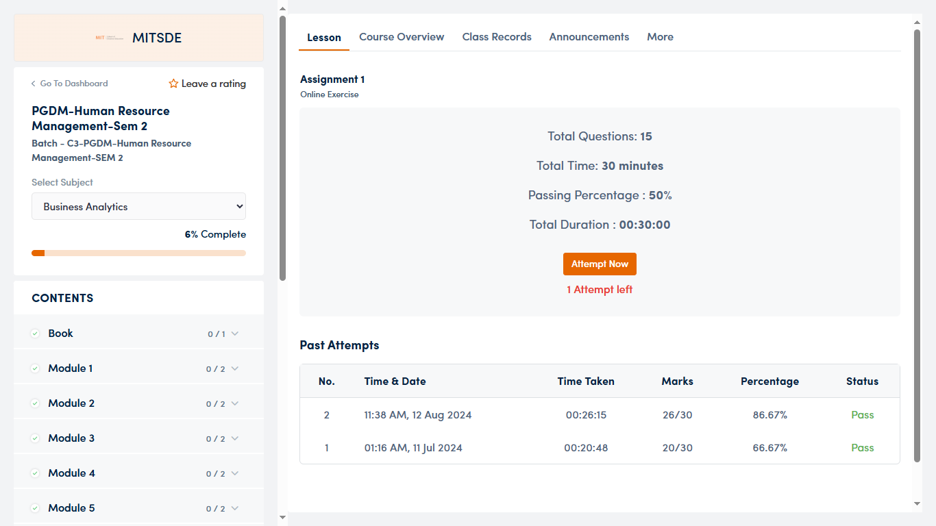

Assignment II

Financial Management

Assignment I

Assignment II

