After submitting the examination form –

I got the examination form submission acknowledgment letter from [admissions@mitsde.com](mailto:admissions@mitsde.com)

Screen shot mentioned below-

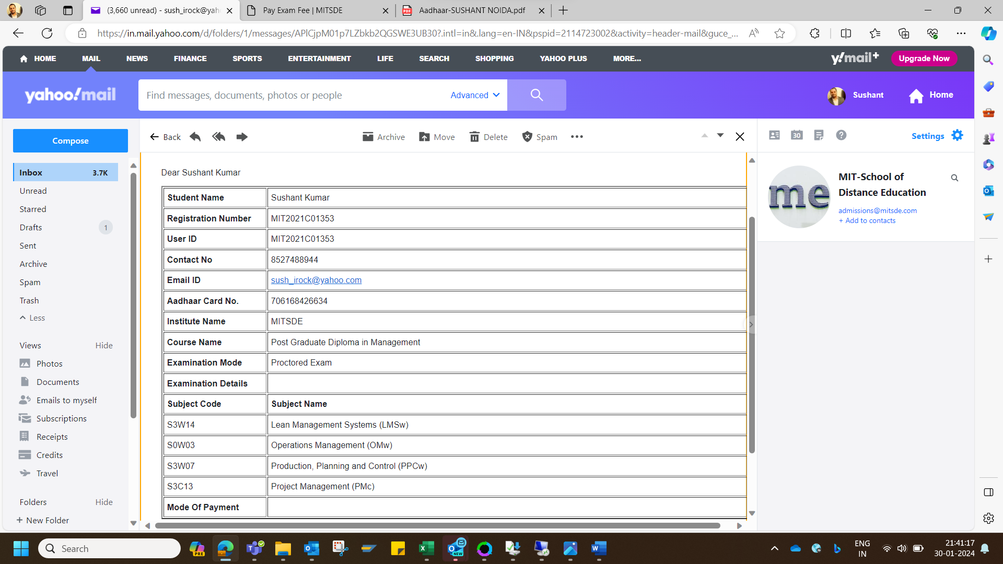

Meanwhile at the e-library after submitting the examination form it takes me to the next step/page where the detail and payment of the exam free was asked- *as mentioned in the screen shot*

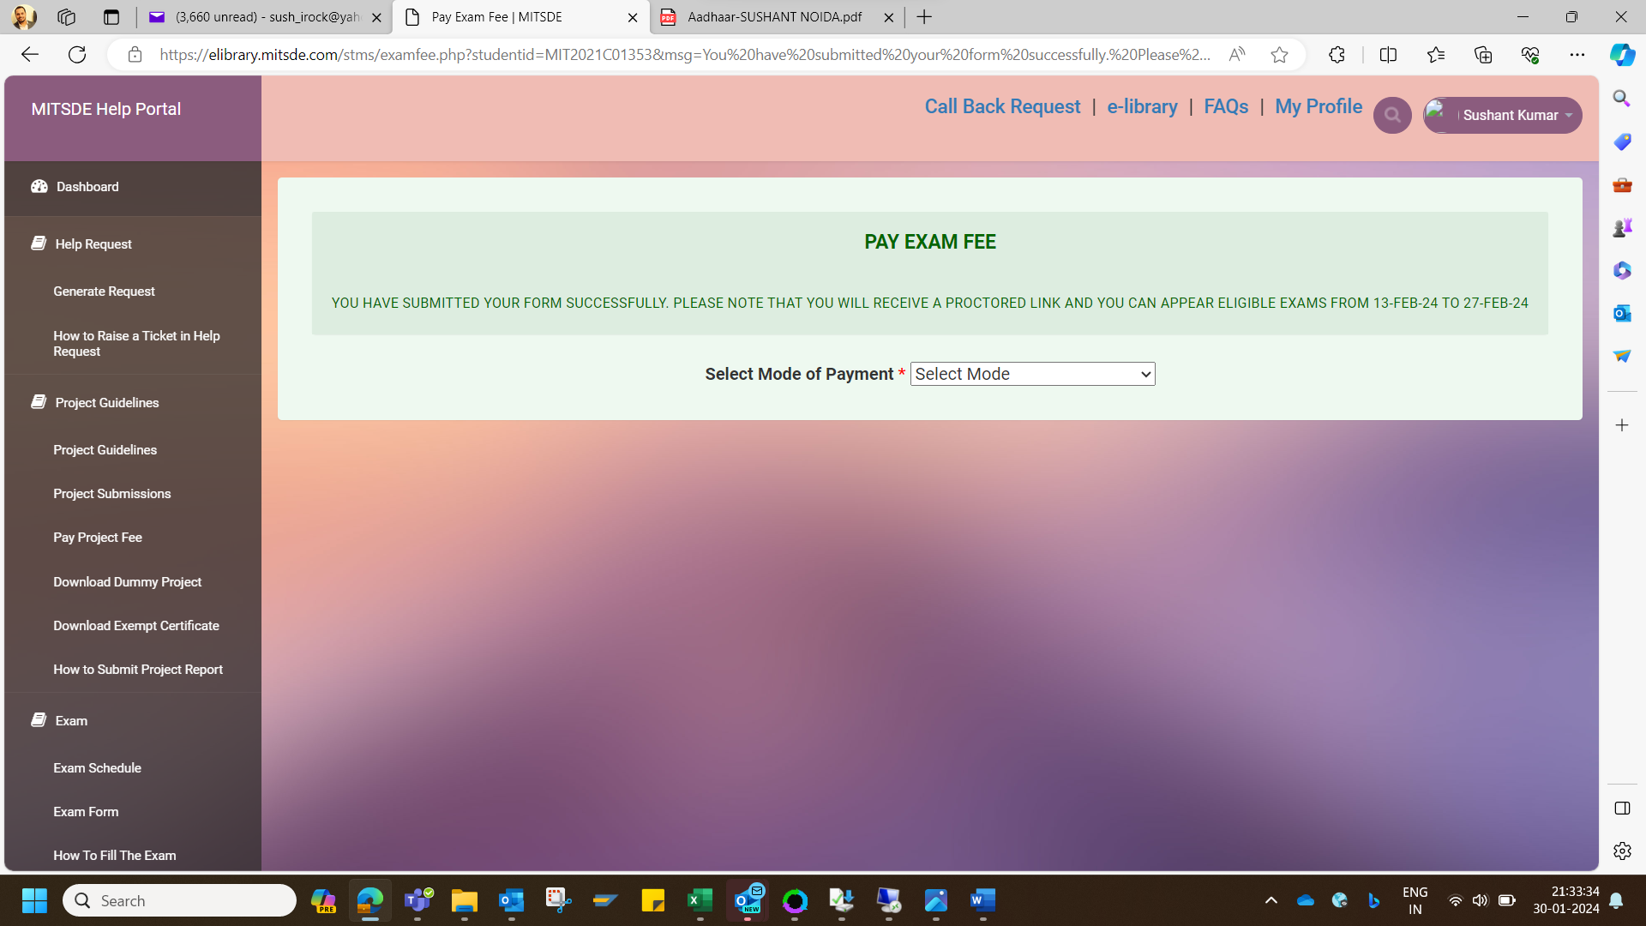

Since I have already paid the examination fee on 19th Jan’24 (detail & screen-shot of payment is attached at the end)

So,I have selected the already paid mode from the drop-down and entered the details as mentioned in the screen shot.

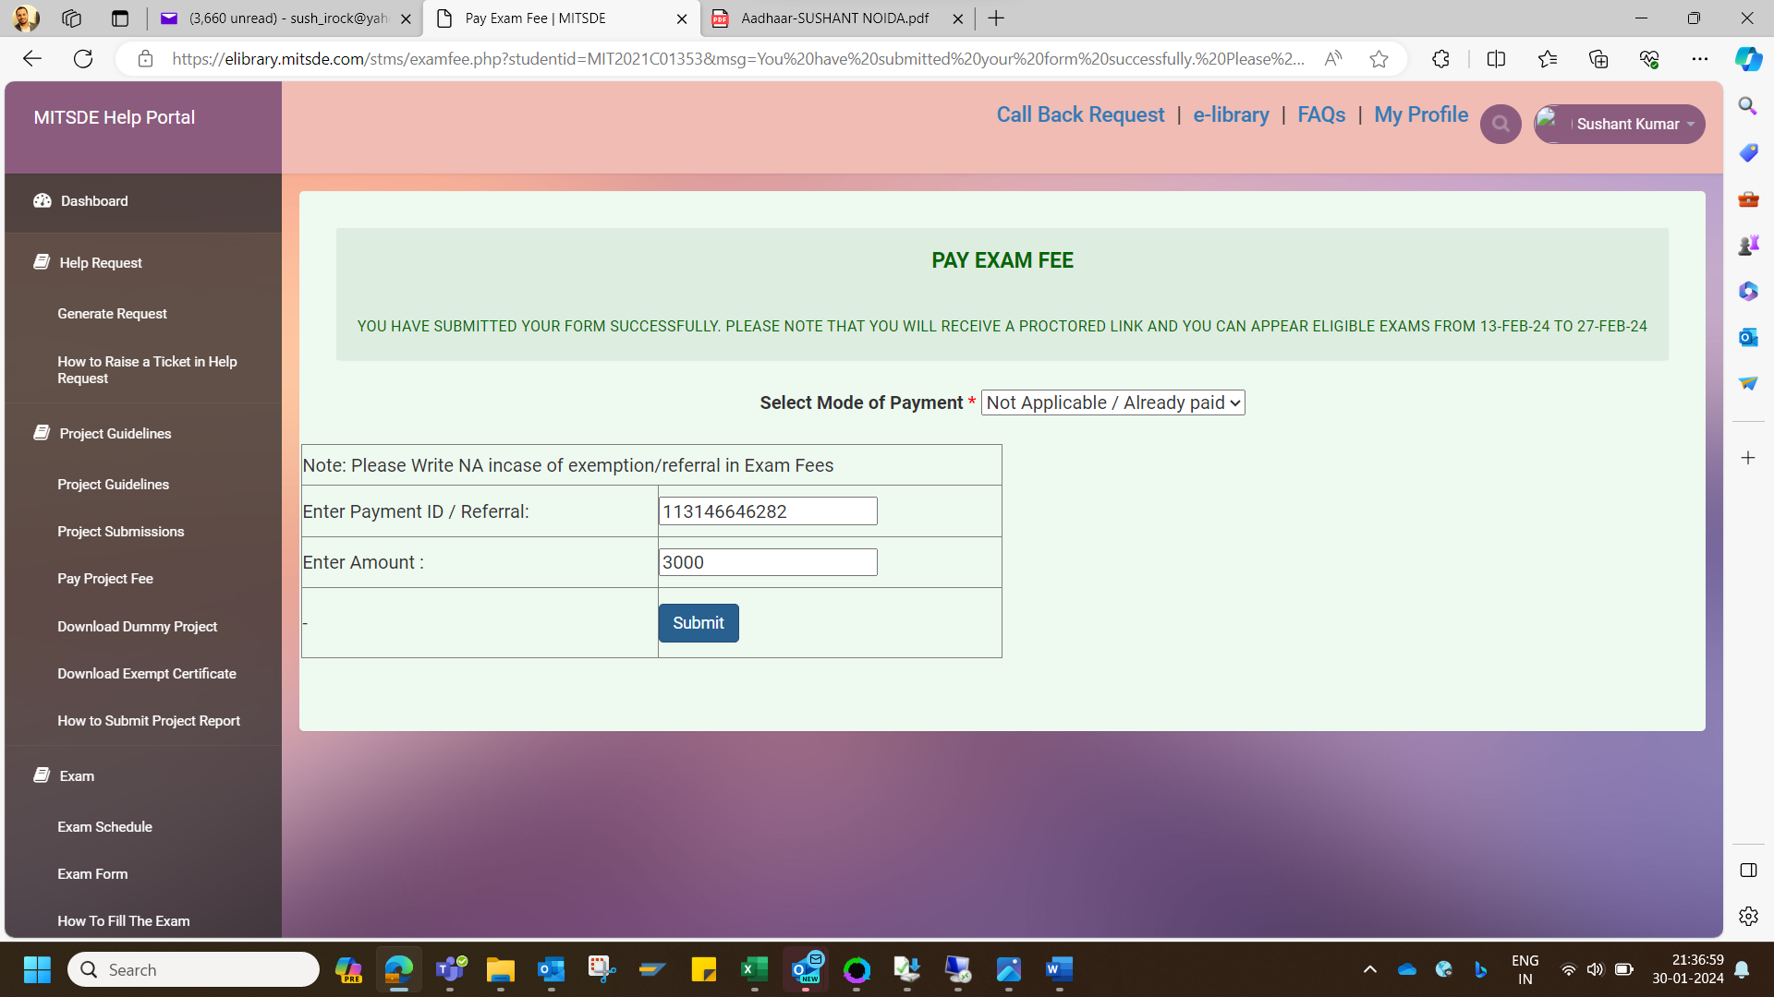

After entering the required column I submitted this page.

But it again takes me the PAY EXAM FEE page.

I tried few times more but It again and again takes me to the same page.

As mentioned in the screen shot.

