**A PROJECT REPORT ON**

**“Implementing CRM System**

**to Enhance Customer Service and Aftermarket Business of**

**M/s Shandong Heavy Industry India Pvt Ltd”**

**UNDERTAKEN AT**

**“MIT School of Distance Education”**

**IN PARTIAL FULFILMENT OF**

**“Post Graduate Certificate in Management”**

**MIT SCHOOL OF DISTANCE EDUCATION, PUNE**

**GUIDED BY**

**“PROF BHAGYASHREE PANDE”**

**SUBMITTED BY**

**“SURESH KUMAR K”**

**STUDENT REGISTRATION NO.: MIT202312345**

**YEAR 2022- 24**

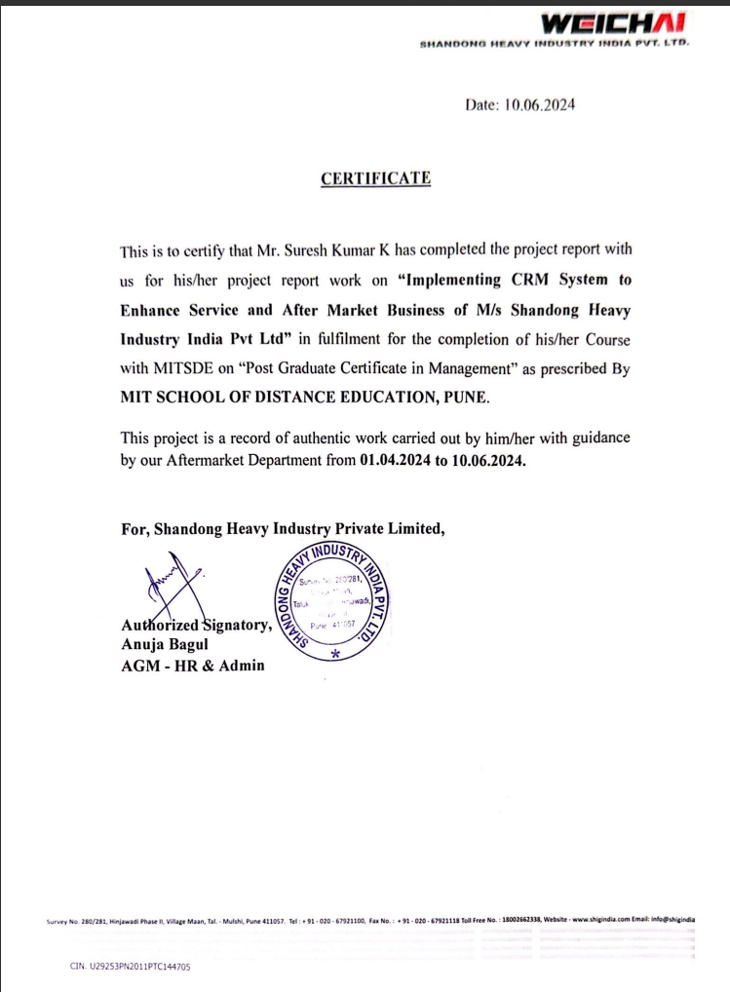

**Declaration**

I hereby declare that this project report entitled “Implementing CRM System to Enhance Customer Service and Aftermarket Business at Shandong Heavy Industry India Pvt Ltd” is a bonafide record of the project work carried out by me during the academic year 2023-2024, in fulfilment of the requirements for the award of “Post Graduate Certificate in Management” of MIT School of Distance Education.

This work has not been undertaken or submitted elsewhere in connection with any other academic course.

Sign:   
Name: Suresh Kumar K  
Student ID: MIT202312345

**Acknowledgement**

I would like to take this opportunity to express my sincere thanks and gratitude to “prof Bhagyashree Pande”, Faculty of MIT School of Distance Education, for allowing me to do my project work in your esteemed organization. It has been a great learning and enjoyable experience. I would like to express my deep sense of gratitude and profound thanks to all staff members of M/s Shandong Heavy Industry India Pvt Ltd, for their kind support and cooperation which helped me in gaining lots of knowledge and experience to do my project work successfully.

At last but not least, I am thankful to my Family, Friends and Colleagues for their moral support, endurance, and encouragement during the course of the project.



Sign:  
Name: Suresh Kumar KStudent ID: MIT202312345

**Abstract**

This project report provides a comprehensive analysis of the implementation of a Customer Relationship Management (CRM) system at Shandong Heavy Industry India Pvt Ltd (SHIG India). The primary objective is to enhance customer service and improve the company's aftermarket business operations. The initial sections delve into the concept of CRM, emphasizing its functions, advantages, and benefits. It outlines how CRM systems streamline business processes, improve customer satisfaction, and drive revenue growth.

The report then examines the current challenges faced by SHIG India in managing customer relationships and aftermarket services. These challenges include inefficiencies in handling customer data, manual processes that hinder timely customer support, and obstacles in revenue growth due to inadequate customer relationship management. The latter part of the report explores the anticipated impact of CRM implementation on SHIG India’s customer support and aftermarket business growth. It discusses the strategic benefits of adopting a CRM system, such as enhanced data management, increased sales efficiency, better customer service, and a positive return on investment (ROI).

The findings suggest that a well-implemented CRM system will enable SHIG India to centralize customer data, automate routine tasks, and provide tools for efficient sales and customer service operations. This will lead to stronger customer relationships, increased customer loyalty, and significant improvements in business performance.

Overall, this project underscores the critical role of CRM systems in modernizing business operations and achieving long-term business success.

**TABLE OF CONTENTS**

1. **Introduction** .............................................. Page 7
2. **Organizational Profile** ............................. Page 10
3. **Project Objectives and Scope** .................. Page 11
4. **Literature Review** ..................................... Page 17
5. **Methodology** ............................................... Page 21
6. **Data Analysis and Interpretation** ……..... Page 26
7. **Implementation Strategy** ........................... Page 33
8. **Conclusion / Findings** ................................. Page 41
9. **Suggestions / Recommendations** ………... Page 43
10. **Annexure** ..................................................... Page 49
11. **References / Bibliography** .......................... Page 50

**Chapter 1: Introduction**

**Project Introduction**

In today's competitive market, businesses need to efficiently manage customer relationships to thrive. Integrating the business with technology will help to manage the customer relation in a better and efficient way, which will be backed with informed decision making. This project report focuses to present a detailed study on how Customer Relationship Management (CRM) system is supporting to enhance Customer Service function and Aftermarket Business (CS&AB) of M/s Shandong Heavy Industry India Pvt Ltd (SHIG India). This project is trying to explain three major aspect through 8 chapters. In the first stage to give a brief idea about the CRM system and SHIG India. In the next stage the report is trying to figure out features of CRM system and the execution process & the challenges addressed during and implementation level. In the third stage the report is discuss about the cost, the benefits and operational challenges and its solution.

**About CRM System**

Customer relationship management (CRM) system is a technology for managing all interactions with current and potential customers. The objective of a CRM system is to improve relationships to grow the business. CRM technology is the connecting interface between customers and the company. This system based approach support the company to stay connected with customers, streamline processes, and improve profitability.

CRM system is a software that helps track each interaction with a prospect or customer. That can include sales calls, customer service interactions, marketing emails, and more.

CRM tools can unify customer and company data from many sources and even use AI (artificial intelligence) to help better manage relationships across the entire customer lifecycle, spanning departments like marketing, sales, digital commerce, and customer service interactions.

**Necessity of CRM System**

Understanding the customer behaviour & expectation are the key to make customer relationship work for business growth. The analytical capability of new age CRM supported with AI will be the tool. Despite its strong market position, SHIG India faces challenges in managing customer relationships and streamlining its CS&AB operations.

The CS&AB is crucial for Mobility & Power Generation Industry. The Vision for sustainable growth SHIG India need to invest in new age technologies and take leveraging advantage. Effective management of Customer Relationships and efficient handling of sales processes can lead to significant improvements in customer satisfaction and business performance. However, the current manual handling approach to customer data and sales management poses as challenge for on time customer support and hampering revenue growth of Aftermarket business. This challenge can be addressed by taking a robust CRM system in the organization.

**Basic Function of CRM System**

Different CRM system are available in the market to match with expectation of specific Industry and Company. The best suited CRM for SHIG India is designed with three basic functions.

1. **Operative CRM**

This function is an integrated platform where the human and system are getting interacted to feed the CRM with essential input for processing. The functions such as data entry (customer information gathering), uploading product information, marketing campaign, pre-defined answer for FAQ etc.

1. **Analytical CRM**

This programmed function reveal the real picture of the business to the management. This include the customer behaviour, expectation gap, challenges of product, service, sales trend, and profit. This function is also known as data mining.

1. **Collaborative CRM**

This function operate as customer interface platform. Customers can access to product information, raise queries, and place order. This function is supported by operative CRM, where all required inputs are loaded according to strategic customer support information sharing policy.

**Advantage of CRM Based Business Management**

**Advantages of CRM Based Business Management**

1. Customer Satisfaction
2. Revenue & Profitability Growth
3. Customer Loyalty & Retention
4. Micro Level Marketing
5. Reporting

**Customer Satisfaction**

It is a measure of how products and services supplied by a company meet or surpass customer expectation. Pre-defined CRM survey module can help to measure the satisfaction and take action to maximize the satisfaction level. Customer Interest is ever evolving due to continuous improvement of respective industry or product. Hence it is important to automate the survey process to get prepared to be competitive in the market.

Another important points of customer satisfaction is differentiation of product & services from competitor & maintaining good brand reputation.

**Revenue and profitability Growth**

By focusing the most profitable customers & the products the company can increase the Revenue and Profitability. CRM will help derive useful information from available data which will support the company to make informed decision instead of guess work.

**Customer loyalty and retention**

Customer loyalty is defined as a customer’s likeliness to do repeat business with a company. A customer become loyal to a company mainly because of the benefits the customer is getting from their product or services. Loyal Customers will promote the company and their product & services through word of mouth and recommendation.

**Micro level Marketing**

According to customer behaviour and response, company can prepare customized, sharp marketing tools to promote the product and service to their target & loyal customers. CRM will help to identify the product and service in demand and which customers are repeating the business. This insight with creative thinking can make better marketing campaign.

**Reporting**

Advanced tools in CRM can help to create daily dashboard for sales and service & customer compliant. This can be the input for continuous improvement in product and services. CRM also help to keep all records and prepare monthly and annual reports and visual insights in the form of graphs, Trends, funnel etc.

**Chapter 2: Organizational Profile**

**Company Introduction**

Shandong Heavy Industry India Pvt Ltd (SHIG India) is an INR 500 Cr Company, growing at 37% CAGR. SHIG India is a subsidiary of Weichai Power Company Ltd PRC, one of the largest Diesel engine manufacturers in the world. SHIG India has started their Indian operation in 2011 focusing to provide complete Power kit solution in heavy duty mobility, Power Generation, Industrial & Marine Industry. At Present More than 20 Original Equipment Manufacturers (OEM) from across India has been associated with SHIG. OEMs use the product and solutions from SHIG India to power their machines, equipment and create advance and using their products and

SHIG India provide end to end solutions to their customers through Business to Business partners from across India. SHIG India’s corporate office & manufacturing facility is located in Hinjawadi, Pune.

SHIG India is headed by Mr. Zhong Lie the Managing Director, supported by Mr. Gurunath Kulkarni, Vice President of Sales & marketing & Mr. Yashwant Ingle Vice President Production and Supply Chain Management. SHIG India carry out its’ operation through 15 Departments, every Department is headed by Gen managers and supported by 100+ managers & Executives.

**Mission Statement**

The mission of MITSDE is to provide affordable and flexible education through innovative distance learning methodologies. It strives to bridge the gap between academic knowledge and practical skills, enabling students to excel in their chosen fields and contribute to society.

**Current Challenges:**

1. Fragmented customer data leading to inefficiencies and missed opportunities.
2. Lengthy sales cycles and cumbersome sales processes.
3. Difficulty in tracking customer interactions and feedback.
4. Inadequate tools for personalized marketing and customer service.

**Project Rationale:**

A robust CRM system is essential to address these challenges. By centralizing customer data and automating key processes, the CRM system will enable SHIG India to enhance its CS&AB, thus improve customer satisfaction, and drive sales growth. This project aligns with the company's strategy of leveraging technology to achieve operational excellence and market leadership. SHIG India is well known in the Industry for its product quality, reliability and leadership in mobility solution domain. Even though their parent company is well organized and equipped with latest technology and systems & process, SHIG India still

**Chapter 3: Project Objectives and Scope**

**Objective of Study**

1. **Enhance Customer Management:**

Implement a CRM system to better manage customer interactions and data.

1. **Increase Sales Efficiency:**

Streamline the sales process to improve efficiency and effectiveness.

1. **Growth in Revenue and Profit:**

Generate additional revenue from available resource and increase the margin by adapting customized products and service offering.

1. **Improve Customer Satisfaction:**

Provide better service support to customers, leading to higher satisfaction.

1. **Data-Driven Decision Making:**

Utilize CRM data to inform strategic business decisions.

**Scope of the Project**

This project intended make a clear understanding the implementation of a CRM system, including system selection, customization, data migration, training, and evaluation. The scope also includes analysing current business processes and identifying areas for improvement.

**Detailed Objectives:**

**Enhance Customer Relationships:**

Customer centric approach is basic for any successful business. CRM system is the modern platform to effectively communicate with customers. A hybrid approach of customer relationship – in person interactions supported with system will make win-win deals. Understanding what are customer’s needs and wants, prioritize them and provide with accuracy. The hybrid model of customer relationship management will increase the business with up selling & cross selling strategies.

Implement tools and processes to improve communication with customers, enabling personalized interactions and timely responses to inquiries and issues. Building a strong relationship with channel partners and end customer from very beginning of selling a product to the customer. This includes registering the product in the name of customer with all required details to arrange required support elements close to the customer which shall be available on immediate support.

**Increase Sales Efficiency:**

Increasing sales efficiency is one of the key objective of implementing the CRM system. By using precision tools & advanced funnelling of SAP system, the sales team can make better decision and prepare customized solutions according to customer expectation. SHIG India follow B2 B business model, where the first level of customer expectation are funnelled and share more accurate and convertible sales leads are getting uploaded to the SAP system. This will increase the accuracy and efficiency of sales.

Optimize the sales pipeline by automating routine tasks, reducing manual efforts, and providing sales teams with better tools to manage leads and close deals faster. At present all activities are manual driven, which leads to human error, delay in response, missing to meet customer urgency and tracking payment & settlement. The system will support to understand the emerging market & product expectations

**Growth in Revenue and Profit:**

The investment for CRM in respect of money, resources and time should be reasonably benefitted in terms of Revenue growth & Profit. Expecting 15-20% Growth in revenue and 15% margin one year after the CRM become completely operational. Identified potential areas for revenue growth is making the existing customers part of the system, streamline new customers from sales process and selling new products & services to total customer base with attractive benefit schemes. The strategy to increase the margin is to sell customized solutions and avoid products & services which is not interested, no more in demand. This can be find out by data analysis and customer behaviour pattern.

**Data Management:**

Centralize all customer-related data in a single platform, ensuring that accurate and up-to-date information is available to all relevant departments for informed decision-making. Analysis of data will reveal important hidden informations which increase efficacy of money invested, help to prevent blockage of funds in dead stocks and predict the sales forecast in advance and create a smart inventory to meet parts demands of various stages of product life. A clear picture of product performance can be seen, by analysing the periodic services & failure trends of every products on regular interval. This monitoring and analysis by related dept will help the company to improve product quality, organize required training for customers & Channel partners to avoid any mistake.

**Performance Metrics:**

Define and track key performance indicators (KPIs) such as customer satisfaction scores, sales cycle duration, conversion rates, and overall ROI of the CRM implementation. SHIG India leadership has a clear vision for their India growth. Thus increase in talent hiring for CS&AB is obvious. Automating the performance monitoring help SHIG India to keep transparency in the analysis and reward the promising talents and nurture them in futuristic way.

**CRM software Functional Overview**

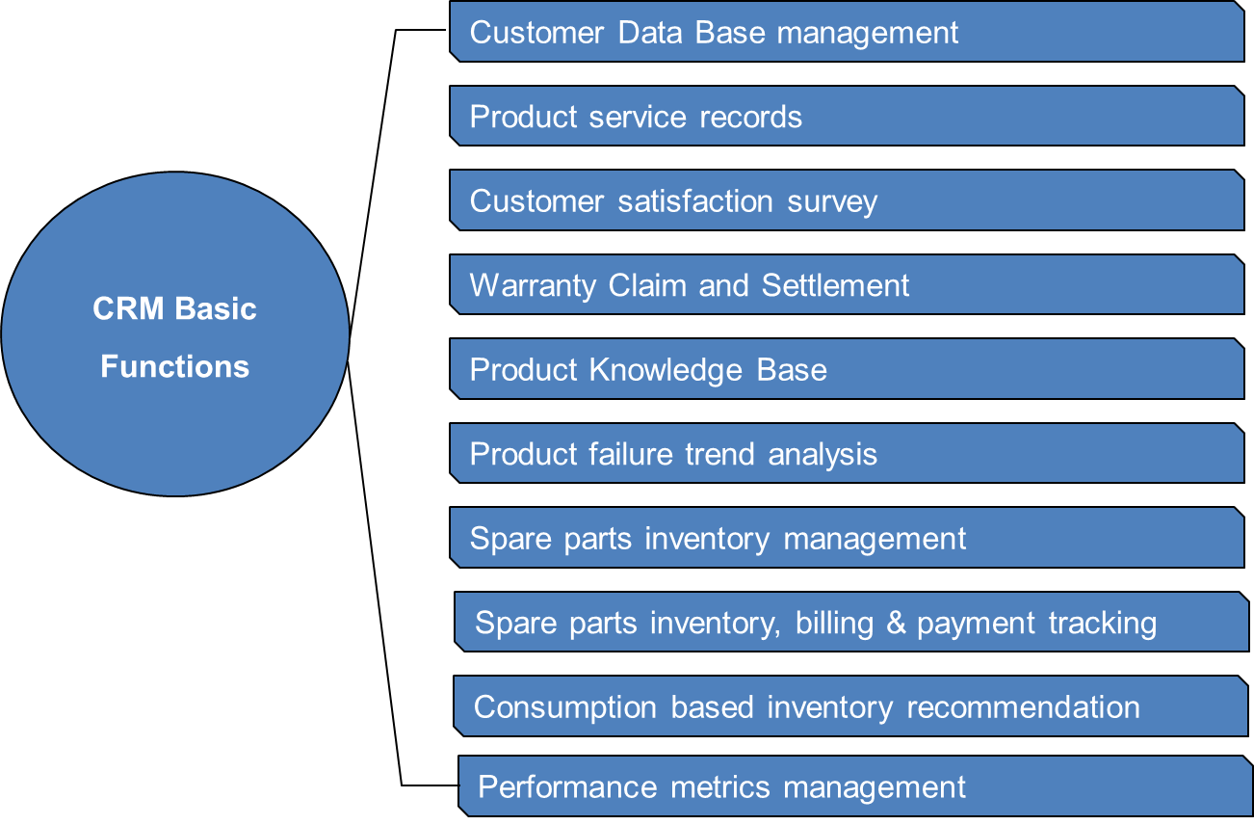

**Project Phases**

1. **Planning:**

**Define Project Scope, Objectives, and Timelines:** In this phase, the project team will establish the project's overall scope, set clear objectives, and develop a detailed timeline. This includes identifying key deliverables, setting realistic milestones, and ensuring alignment with SHIG India's strategic goals. A comprehensive project charter will be created to outline responsibilities, resources, and risk management plans.

1. **Development:**

**Customize the CRM System to Meet Specific Business Needs:** This phase involves tailoring the CRM software to align with SHIG India's unique requirements. Customization may include configuring workflows, developing custom modules, and integrating necessary features that address the company's specific business processes and customer management needs. Close collaboration with CRM consultants and internal stakeholders is essential to ensure the system supports all critical functions.

1. **Testing:**

**Conduct Thorough Testing to Ensure the System Meets All Requirements:** Before full deployment, extensive testing will be conducted to validate the CRM system’s functionality and performance. This includes unit testing, integration testing, user acceptance testing (UAT), and performance testing. Testing aims to identify and rectify any issues, ensuring the system operates smoothly and meets all specified requirements.

1. **Deployment:**

**Roll Out the System in Phases to Minimize Disruptions:** To ensure a smooth transition, the CRM system will be deployed in phases. An initial pilot phase will involve a small group of users to identify any potential issues. Following the successful pilot, the system will be gradually rolled out across the entire organization. This phased approach helps minimize disruptions to daily operations and allows for adjustments based on user feedback.

1. **Training:**

**Provide Comprehensive Training to Ensure Staff Can Effectively Use the New System:** Comprehensive training programs will be developed to equip staff with the knowledge and skills needed to use the CRM system effectively. Training will include hands-on workshops, instructional materials, and ongoing support. Emphasis will be placed on ensuring users are comfortable with the system and can leverage its full capabilities to enhance their productivity.

**Timeline**

A detailed Gantt chart will outline the project timeline, with key milestones for each phase. The project is expected to be completed within four months following necessary leadership approvals. The timeline will include specific start and end dates for planning, development, testing, deployment, and training phases, ensuring a clear path to successful implementation.

**Resources Required**

* **Human Resources:** Project manager, CRM consultants, IT staff, trainers, and key internal stakeholders.
* **Technical Resources:** Servers, software licenses, network infrastructure, and necessary hardware upgrades.
* **Financial Resources:** Budget allocations for software, hardware, training, and ongoing support, including a contingency fund for unexpected expenses.

**System Requirements**

* **Hardware:** High-performance servers, storage devices, and backup systems to support the CRM system’s operations and ensure data security.
* **Software:** CRM software licenses, robust database management systems, and integration tools to connect with existing systems.
* **Networking:** High-speed internet connectivity, secure network configurations, and VPN access for remote users to ensure seamless access to the CRM system.

**Integration**

The CRM system will integrate seamlessly with existing ERP systems, email platforms, and customer support tools. This integration ensures a unified data flow, enabling automated processes and real-time access to critical customer information across all business functions. Collaboration with ERP and IT teams will be essential to ensure compatibility and functionality.

**Data Migration**

A detailed plan will be developed for migrating existing customer data to the new CRM system. The plan will include data assessment, cleansing, mapping, and validation to ensure data integrity and minimize disruption to business operations. Thorough testing will be conducted to verify successful data migration before the full system rollout.

**Potential Risks**

1. **Resistance to Change from Staff:**

Traditional working methods may lead to resistance to new processes and automation. Causes include fear of the unknown, changes in status or power, and difficulty in learning new systems.

1. **Data Migration Issues:**

The existing SAP system must be compatible with the new CRM software. Flexibility in the CRM system is essential to accommodate and utilize existing data effectively.

1. **Integration Challenges with Existing Systems:**

The current software and hardware infrastructure may pose challenges for integration with the new CRM system. Joint efforts by SHIG India's IT team and SAP suppliers will be necessary to analyse and implement required technological updates.

**Mitigation Strategies**

1. **Conduct Change Management and Training Programs:**

Implement structured change management initiatives and comprehensive training programs to facilitate smooth transition and user adoption.

1. **Perform Thorough Data Validation and Testing:**

Conduct extensive data validation and testing to ensure data integrity and accuracy during migration.

1. **Engage Experienced CRM Consultants for Integration:**

Leverage the expertise of experienced CRM consultants to manage the integration process and address technical challenges.

1. **Maintain a Contingency Budget to Address Unexpected Costs:**

Allocate a contingency budget to handle unforeseen expenses and ensure project completion without financial strain.

**Chapter 4: Literature Review**

**Introduction**

A literature review provides a comprehensive overview of existing research and studies related to CRM systems and their impact on business performance. This chapter will discuss various aspects of CRM, including its benefits, challenges, and implementation strategies, drawing from academic journals, industry reports, and case studies.

**CRM Systems: An Overview**

Customer Relationship Management (CRM) systems are designed to manage a company's interactions with current and potential customers. They centralize customer data, automate processes, and provide tools for sales, marketing, and customer service. A CRM system helps businesses to maintain important customer data up to date, track every customer interaction, and manage customer accounts. It is designed to help businesses improve customer relationships and also Customer Lifetime Value (CLV). This is vital because of the vast amount of such data businesses generate daily.

Important business activities such as delivery, service & payment recovery need to be automated and tracked for effective functioning of every connected functions, which may not be effective with manual handling by human.

The system can organize the company, channel partners and customers for effective utilization of the product, service and after sales function for mutually beneficial business interests.

A CRM system shall support organizations to analyse the data gathered from customers can create valuable in sites in terms of product performance, quality, scope for improvement, cost of operation, etc. This can be presented in the form of informative patterns and make useful conclusions and actionable for product improvement, business growth, efficient use of assets and resources.

**Benefits of CRM Systems based on online research**

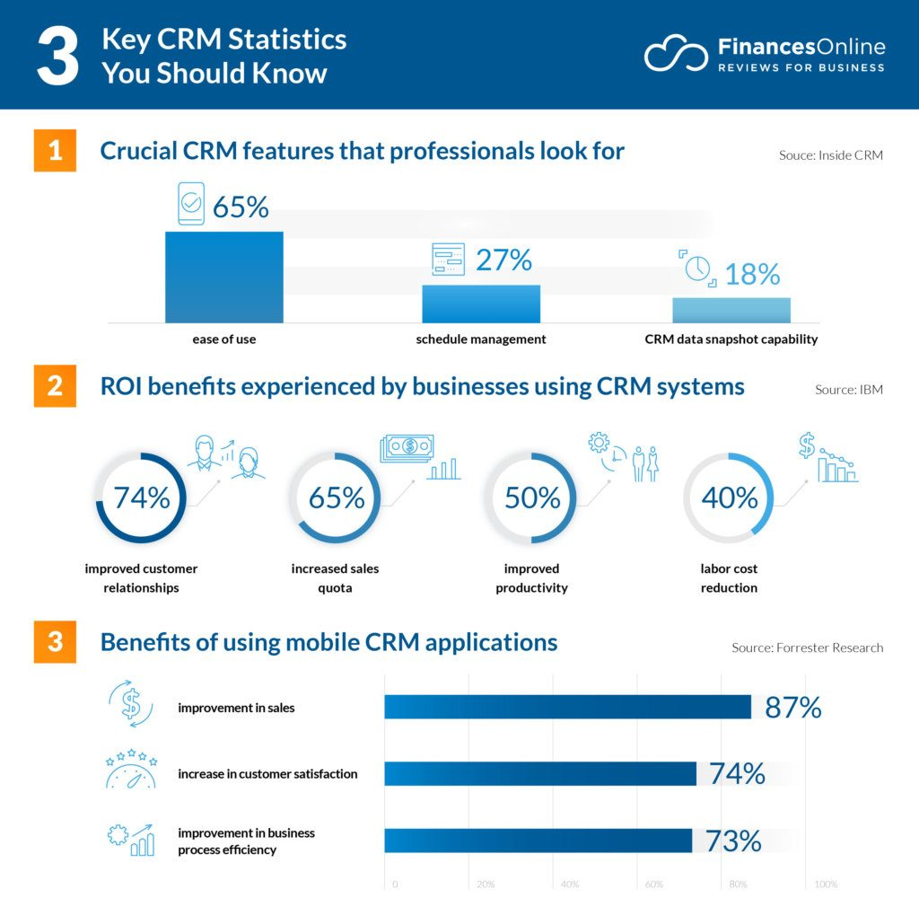

* 1. **Improved Customer Relationships:**

CRM systems enable personalized communication and targeted marketing, leading to stronger customer relationships and increased loyalty. CRM system become the customer connect platform where the meaningful information are being exchanged which is beneficial for all stake holders. The customer specific information such as operation instructions, parts catalogue, and warranty coverage terms & conditions will be available for reference. The system will also provide information required for channel partners such as Installation guidelines, warranty process manual, warranty compensation, parts availability price etc.

* 1. **Enhanced Data Management:**

Centralized data management ensures that accurate and up-to-date information is available to all relevant departments, facilitating informed decision-making. The valid information about the main product such as operation and maintenance records, service history, failures and reasons, training and skill sets, resource availability and sacristy, parts availability across the ecosystem, including customers, OEMs & SHIG India etc will be monitored.

* 1. **Increased Sales Efficiency:**

Automation of routine tasks reduces manual efforts, allowing sales teams to focus on high-value activities and close deals faster. The parts delivery v/s commitment gap, reason for the delay in delivery will be studied and find solution to maintain the commitment. The delivery commitment can be fulfilled in by creating in house inventory for frequently moving and demanding items as per the system recommendations. Also avoid the pile up of non-moving and sell them out with special schemes and campaign.

* 1. **Better Customer Service:**

CRM systems provide tools for tracking customer inquiries, issues, and feedback, enabling timely and effective responses. CRM helps to understand customer behaviour and accommodate new strategies to address customer expectations and increase loyalty and long term.

* 1. **Increased Profitability**

Using CRM enable the company to identify which customers are profitable and responding to the offers. This knowledge helps the company re define offers & proposals based on customer response which will eventually convert to business. Periodic review and analysis of the data & pattern help to focus on most profitable ideas and avoid non responsive offers thus increase profitability.

**Challenges in CRM Implementation**

1. **Data Integration:**

Integrating CRM systems with existing ERP, email, and customer support systems can be challenging and require careful planning and execution. The OEMs & End customers have records in different platform and systems.

1. **User Adoption:**

Resistance to change from staff can hinder the successful adoption of a new CRM system. Comprehensive training and change management programs are essential to address this challenge.

1. **Cost and Resource Allocation:**

Implementing a CRM system requires significant financial and human resources. Detailed budgeting and resource planning are necessary to ensure the project stays on track. A thorough study & master plan to achieve Return on Investment need to be followed by the system users.

**Case Studies:**

**Company A:**

Implemented a CRM system to streamline sales processes and improve customer data management. Achieved a 20% increase in sales and a 15% improvement in customer satisfaction within the first year.

From this example, ROI and break even can be figured out. However the timeline for break-even timeline can be fixed from SHIG India management directives.

**Company B:**

Used CRM analytics to identify customer segments and tailor marketing campaigns. Resulted in a 30% increase in lead conversion rates and a 25% reduction in customer churn.

From this observation, we could find other element of increasing the sales from the fresh enquiries by using CRM System

1. **Company C:**

Integrated CRM with ERP systems to automate order processing and inventory management. Realized a 40% reduction in order processing time and a 20% decrease in inventory holding costs.

This gives insight how CRM system can support faster response to customer requirements and human reduce errors from manual interventions.

1. **Company D**

CRM based customer support system has improved the Customer Experience & Response to customer concerns. This company has conducted a customer satisfaction survey before and after implementing the CRM system. The survey result revealed the Customer Satisfaction score has increased by 27%.

**Key Takeaways:**

* Successful CRM implementation requires careful planning, effective change management, and ongoing support and training.
* CRM systems can significantly enhance customer relationships, sales efficiency, and overall business performance.
* Integration with existing systems and data management are critical factors for the success of a CRM project.

### Chapter 5: Methodology

#### **Research Methodology**

This project employs a mixed-methods approach, combining qualitative and quantitative research methodologies to provide a holistic understanding of the current challenges and the potential impact of the CRM system on SHIG India's parts business.

#### **Research Design**

#### **Data Collection:**

#### **Surveys and Interviews: C**onducted with channel partners, end customers, and SHIG India staff to gather qualitative insights. Key concerns included missing parts, delivery commitments, non-availability of product information, delays in customer complaint resolution, and response times. Staff reported issues with piled-up inventory, stock liquidation, and payment tracking.

**Comprehensive Inputs:** Feedback from diverse stakeholders ensures that all significant challenges are captured and addressed in the CRM implementation plan.

#### **Data Analysis:**

#### **Historical Data Analysis:** Analysed historical sales data and customer records to identify trends and patterns, providing a quantitative basis for assessing business growth and customer satisfaction post-CRM implementation.

**Statistical Analysis:** Employed to pinpoint key areas for improvement based on survey and sales data.

#### **SWOT Analysis:**

**Comprehensive Evaluation:** Assessed strengths, weaknesses, opportunities, and threats related to CRM implementation. This analysis provided strategic insights for aligning the CRM system with the company's goals.

#### **System Selection:**

#### **Evaluation Criteria:** Considered functionality, ease of use, integration capabilities, customization options, future-proof features, and cost. This rigorous evaluation process ensured the selection of the most suitable CRM system for SHIG India.

#### **Implementation Planning:**

#### **Detailed Plan:** Developed a comprehensive implementation plan, including timelines, milestones, and responsibilities. A dedicated team will oversee the project from selection to go-live, ensuring continuous evaluation and troubleshooting until the system is fully stabilized and familiar to all stakeholders.

#### **Data Collection Methods**

#### **Surveys:**

#### **Design and Distribution:** Developed surveys for customers and staff to gather feedback on current processes and expectations from the new CRM system.

#### **Question Types:** Used both open-ended and closed-ended questions to capture a wide range of insights.

#### **Interviews:**

#### **In-Depth Discussions:** Conducted with key in-house stakeholders, including sales and customer service staff, to understand their needs and concerns.

#### **Analysis:** Recorded and analysed interview responses to identify common themes and issues.

**Sales Data Analysis:**

**Trend Identification: Analysed historical sales data to identify trends, patterns, and areas for improvement.**

#### **Data Visualization: Employed visualization tools to present findings clearly and concisely.**

#### **System Evaluation Criteria**

1. **Functionality:**

**Feature Assessment:** Evaluated the features and capabilities of various CRM systems to ensure they meet the company's needs. Proposals from six companies were studied, and the most relevant system was selected.

1. **Ease of Use:**

**User-Friendliness: Assessed the CRM systems to ensure staff can quickly learn and adopt the new system.**

1. **Integration Capabilities:**

**Seamless Integration: Determined the ease of integrating the CRM system with existing ERP, email, and customer support systems.**

1. **Cost:**

**Comprehensive Cost Analysis: Compared the costs of different CRM systems, including software licenses, hardware, implementation, and ongoing support.**

#### **Implementation Planning**

**Project Plan:**

**Detailed Roadmap: Developed a detailed project plan with timelines, milestones, and responsibilities for each phase of the CRM implementation. The plan was crafted through brainstorming sessions with SHIG India's IT team and CRM supplier experts.**

**Risk Assessment:**

**Mitigation Strategies: Identified potential risks and developed strategies to address them, ensuring a smooth and successful CRM implementation.**

1. **Training and Support:**

Plan comprehensive training programs to ensure staff can effectively use the new CRM system. Establish ongoing support mechanisms to address any issues that arise after implementation.

**Data Analysis and Interpretation:**

1. **Customer Segmentation:**

Segment customers based on their needs and preferences to tailor marketing and sales strategies. The premium customers of every segment are corporates which contributes 50% of SHIG India Business. The retails is 30% & small & medium scale contributes 20%. It is equally important to define a strategy which could address expectations from all segment & category.

1. **Sales Performance:**

Analyse sales performance data to identify areas for improvement and track the impact of the CRM system on sales efficiency. The sales team have strong relationship with respective OEMs and with corporate customers. The sales team work collectively to address customer concern and challenges in finalizing the order. Most customers from the premium segment is in demand of parts & aftermarket solutions. Premium customers trust on product quality, performance and the aftermarket support. The premium customers carefully review every elements of business and demand to meet their expectation before finalizing and concluding the orders. They also ask the Capex and Opex which is critical deciding factor of any purchase. SHIG India management understand this very well and define their strategy in to surpass the customer expectations.

1. **Customer Satisfaction:**

Measure customer satisfaction levels before and after CRM implementation to assess the impact on customer relationships. Customer satisfaction is broad and wide subject which spread in every element of Business. Customers are caring about commitment and its’ fulfilment rate. SHIG India has defined their business philosophy by keeping the customer at the centre. This helps to find solutions in faster way for every challenge the customer bring in front of respective company representatives.

**Chapter 6: Data Analysis and Interpretation**

**Introduction**

This chapter trying to showcase SHIG India’s line of business & its contribution to Aftermarket Business, challenges in Aftermarket Business and expectation of channel partners to grow the Aftermarket Business. This chapter also cover the findings from the data analysis, including customer segmentation, sales performance, and customer satisfaction.

**Present Scenario**

* 1. **Line of Business Overview**

SHIG India main stream of business comes from 5 major segment of the industry. They can be described as Diesel Generator (G Drive), Construction Equipment Vehicle (CEV), Commercial Vehicles (CV), Marine Propulsion (Marine) & Various Industrial Application (Industrial). There are 20 Channel partners in all segments, 9 from CEV, 5 from Marine, 4 from Industrial, 3 from G Drive and 2 from CV.

* 1. **Revenue growth over 3 Years**

The CAGR for aftermarket business is 43% for last 4 years. The total product sales increase in previous years. Hence the achievable target for 2024 is INR 39.9 Cr, 2.8 times of the previous year actual sales.

* 1. **Segment wise Aftermarket Revenue Model**

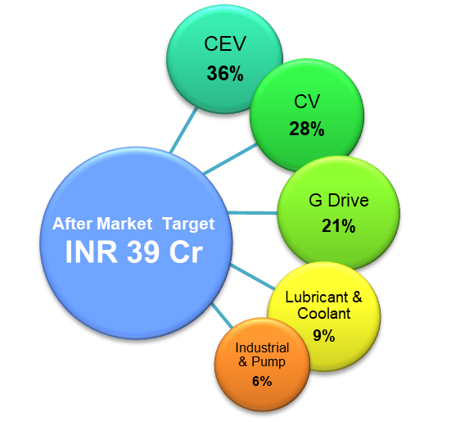

**Channel partner Interview Results**

The 20 channel partners for SHIG India across 5 line of business had been interviewed through their representative to identify level of satisfaction of present CS & AB process. Interviewer had been asked 10 question for two main area, for parts business 4 questions and Customer Service 6 questions. Asked them to score in a scale of 1 to 5, where 5 indicates delighted and below 2 will be unsatisfied.

The average score for Parts Business is 3.0 & Customer Service 3.2 where the score is just above the dis satisfaction level. This shown a scope of improvement need to be done in the process and response system, which can be supported if CRM system implemented and used it properly for the benefit of the organization.

The **satisfaction survey questionnaire** with achieved score is attached as annexure 1 in chapter 10

**Addressing Key Challenges of Customer Support**

The gap in satisfaction mainly because of availability of parts for urgency and regular service. SHIG India parts delivery depend on external factor as the parts are getting imported from their Head Quarter. The suppliers follow make to order model. Hence the timeline need to be considered accordingly. The other factors such as gathering, packing, forwarding and shipping, clearance and domestic transportation etc. are the chain of activities involved before supplying the parts to Channel Partners. In any of the point have troubles, may disturb the delivery commitment. This can be solved by identifying the parts on most demand and potential for failure and parts have long lead time. Keeping additional inventory of these identified list of parts can limit the delay issues up to great extent. Tracking the service request and keep reminding respective dept./ team member on time and an acknowledgement will be sent to customer real time with request registration number.

The key challenges description and how CRM will address these challenges is mentioned in Annexure 2, attached in Chapter 10.

**Expectations from Individual Segment**

**G drive:**

Diesel Generator are the secondary source of reliable electric power for any Industry. It is considered to be the “standby power” and the availability should be 100%. Key customers of Diesel Generator are Data Centre, Parma, IT, real-estate and construction segment. The requirement of parts & services for this segment is highly sensitive.

* + Availability of parts & sub-assemblies on short notice
  + Provide engine related documents through system for easy access

**CEV:**

Construction Equipment’s are high value assets which are getting operated 14-16 Hour per day. Most of the machine are operating in rental business where breakdown of machine or equipment is highly expressive. So this segment demand consumable & parts in regular move

* + Maintain inventory for regular moving parts & Parts with frequent failure records
  + Reduce lead time to convert enquiry in to sales

**CV**

Commercial Vehicle business falls in utility service segment such as public transport (bus & mini bus), logistic service (Truck and surface transport vehicles). The average operation hours is close to 1 lack KM per year. Hence all the parts related SHIG India product should be available in the nearest location of the vehicle depot to address regular service and breakdown issues.

* + Arrange regular moving spare parts in SHIG India.

**Marine**

The main Business of SHIG India in Marine Segment is with Fishing Trawler Industry. This is a seasonal and opportunity based business. Since the Fishing Trawlers are operated by fishermen in high seas, it is essential to maintain the vessel completely healthy. Hence the parts should be available to all harbour locations to address any service and breakdown issues.

* + Arrange regular moving spare parts near to all harbour locations.

**Conclusion from above discussion**

SHIG India is offering their products to highly sensitive business segments. The expectation of customers with respect parts is common; the regular moving parts such as consumable and the parts and sub-assemblies with failure history needed to be supplied on short notice. This is very generic requirement which can be better predicted with the aid of technological support. The analytical CRM can find the consumption pattern of parts in regular move and in occasional demand. This analysis will support to address the customer expectations with minimum possible investment and pre plan the inventory in advance.

**Sales Cycle Analysis:**

**Current Sales Cycle:** The average sales cycle at SHIG India currently spans between 90 to 120 days. This duration reflects the time taken from initial contact with a potential customer to the final closing of a sale.

**Impact of CRM Implementation:** By implementing the CRM system, SHIG India anticipates a significant reduction in the sales cycle duration. The CRM system's automation and streamlined processes are expected to cut the sales cycle by 50%, enabling faster deal closures. This reduction translates to a new average sales cycle of 45 to 60 days, which will allow the sales team to handle more deals in less time and improve overall sales efficiency.

1. **Lead Conversion Rates:**

**Current Lead Conversion Rate:** Currently, SHIG India boasts a lead conversion rate of 70%, indicating that 70% of potential leads are successfully converted into customers.

**Projected Improvement with CRM:** The CRM system is projected to enhance the lead conversion rate to between 80% and 82%. This improvement will result from better lead tracking, more personalized communication, and efficient follow-up mechanisms provided by the CRM system. The higher conversion rate will drive increased revenue and contribute to the company’s growth objectives.

**Customer Retention:**

**Current Customer Retention Rate:** At present, SHIG India maintains a customer retention rate of 40%, meaning 40% of customers continue to do business with the company over a given period.

**Expected Increase with CRM:** Improved customer management and personalized engagement strategies facilitated by the CRM **system** are expected to raise the retention rate to between 60% and 65%. This enhancement will stem from the CRM’s ability to offer tailored customer experiences, proactive issue resolution, and continuous engagement, thereby fostering long-term loyalty and repeat business.

### Customer Satisfaction

### ****Survey Results:****

**Current Satisfaction Levels:** Recent customer satisfaction surveys indicate that 50% of customers are satisfied with the current service levels provided by SHIG India.

**Anticipated Improvement with CRM:** Following the CRM system implementation, customer satisfaction levels are expected to rise significantly, reaching 75% to 80%. This projected increase is based on survey responses suggesting that enhanced service delivery, more personalized interactions, and quicker response times facilitated by the CRM system will substantially improve customer satisfaction.

**Feedback Analysis:**

**Common Issues:** Feedback from customers commonly highlights problems such as parts availability, information accuracy, and communication and response times.

**CRM System Solutions:** The CRM system is designed to address these issues effectively. It will provide accurate parts inventory recommendations, ensure accessibility to up-to-date product information, and improve communication methods. Additionally, the system’s automation capabilities will ensure faster response times, leading to a better overall customer experience.

### ROI Analysis

### ****Cost-Benefit Analysis:****

**Initial Implementation Cost:** The initial cost of implementing the CRM system at SHIG India is estimated at INR 50,00,000.

**Recurring Expenses:** Over the next five years, recurring expenses, including manpower, annual maintenance contracts, and utility expenses, are projected to be INR 50,00,000.

**Projected Benefits:**

**Increase in Annual Sales Revenue:** The CRM system is expected to boost annual sales revenue by 8%.

**Reduction in Operational Costs:** Operational costs are projected to decrease by 15% due to increased efficiency and automation.

**Increase in Profit Margin:** Overall profit margins are anticipated to rise by 12%.

**Detailed Calculations:** A comprehensive aftermarket business scaling plan, including supporting factors, is detailed in Annexure 3.

1. **Strategy to Achieve Break-Even:**

**Break-Even Timeline:** Based on current business volumes and projected growth, SHIG India expects to achieve break-even within two years of CRM implementation.

**ROI Projection:** A graph illustrating the projected ROI over the next five years will show a steady increase, highlighting the financial benefits and the positive impact of the CRM system on the company’s profitability.

**Cost Breakdown**

|  |  |  |  |
| --- | --- | --- | --- |
| Financial overview on CRM implementation to Breakeven Plan | | | |
| Financial advantage of CRM implementation | Per Year | Total | Remarks |
| INR | INR |
| Capital investment |  | 50,00,000 | Software & hardware purchase & installation |
| Recurring Expenses for 5 Years | 10,00,000 | 50,00,000 | Regular monitoring , periodic service, updates & AMC |
| Total Investment for 5 Years |  | 1,00,00,000 |  |
| Expected sales growth in 5 years, contributed by CRM system |  | 50,58,00,000 | (average 8% of revenue) |
| **Margin considered on additional sales revenue @30%** |  | **15,17,40,000** |  |
| Expenses recovery Year 1 |  | 59,00,000 | 9.5% of 1st Year Margin achieved from CRM impact |
| Expenses recovery Year 2 |  | 41,00,000 | 5.5% of 2nd Year Margin achieved from CRM impact |

**Chapter 7: Implementation Strategy**

A typical CRM implementation can be classified into six iterative processes including exploring and analysing, visioning, building business case, planning and designing solution, implementing and integrating, and realizing value.

**System Selection:**

1. **Evaluation Criteria:**

The first step in selecting a CRM system is to define clear evaluation criteria. This involves understanding the specific needs and goals of the business, such as improving customer service, streamlining sales processes, or enhancing marketing efforts. Key features to consider include user-friendliness, customization options, integration capabilities with existing systems, and robust reporting and analytics tools. Additionally, scalability to accommodate future growth, security features to protect sensitive customer data, and the total cost of ownership, including licensing, implementation, and maintenance costs, should be assessed. Gathering feedback from end-users and stakeholders ensures that the chosen CRM will meet their needs and expectations.

1. **Vendor Selection:**

Once the evaluation criteria are established, the next step is to identify and evaluate potential CRM vendors. This involves researching vendors, requesting proposals, and conducting product demonstrations to understand the capabilities and limitations of each system. Important considerations during this phase include the vendor’s industry experience, customer support quality, and the availability of training resources. It is also beneficial to review case studies or speak with existing customers to gauge the vendor’s track record and reliability. Comparing vendors on these factors helps narrow down the options to those best suited to meet the business’s requirements.

1. **Final Selection:**

The final selection of a CRM system involves a detailed analysis of the shortlisted vendors. This includes a thorough comparison of their offerings against the predefined evaluation criteria and consideration of additional factors such as long-term vendor stability, product roadmap, and user community support. It is crucial to select a CRM system that aligns with the company’s strategic goals, fits within the budget, and offers scalability for future needs. Contract negotiations should also be carefully managed to ensure favourable terms and conditions. The selected vendor should provide comprehensive implementation support, training, and ongoing technical assistance to ensure a successful deployment and adoption.

**Customization:**

1. **Business Process Mapping:**

Customizing a CRM system begins with mapping the current business processes. This involves documenting existing workflows, identifying inefficiencies, and determining how the CRM can enhance these processes. By understanding how different departments interact and manage customer information, the CRM can be tailored to support and improve these activities. This step ensures that the system will integrate seamlessly with the business’s operations, reducing disruptions and improving overall efficiency. Engaging key stakeholders in this process is crucial to capture all necessary requirements and gain buy-in for the new system.

1. **System Customization:**

System customization involves modifying the CRM to meet specific business requirements. This may include creating custom fields, modules, and reports, as well as setting up workflows that align with the company’s operations. Customization ensures that the CRM reflects the unique processes and terminology of the business, making it more intuitive and useful for users. It also allows the system to generate relevant insights and automate routine tasks, thereby enhancing productivity. Ensuring flexibility in customization is important so that the system can adapt to future changes in business processes.

1. **Integration:**

Integrating the CRM system with existing enterprise systems is critical for maintaining data consistency and providing a comprehensive view of customer interactions. This involves connecting the CRM with systems such as ERP, marketing automation, and customer support platforms. Effective integration enables seamless data flow between systems, reducing data entry efforts and minimizing errors. It also allows for better coordination across departments, as all customer-related information is centralized and accessible. Planning and executing integration carefully ensures that all systems work together harmoniously, enhancing the overall efficiency of business operations.

**Data Migration:**

1. **Data Assessment:**

Before migrating data to the new CRM system, it is essential to assess the quality and completeness of the existing data. This involves identifying all data sources, formats, and structures to understand the scope of the migration effort. Assessing data helps determine which information is relevant and valuable for the new system and identifies any gaps or inconsistencies that need to be addressed. This step ensures that only clean and accurate data is migrated, reducing the risk of errors and enhancing the reliability of the CRM.

1. **Data Cleansing:**

Data cleansing is a critical step in preparing for migration. It involves cleaning up the existing data by removing duplicates, correcting errors, and standardizing formats. This process ensures that the data being migrated is accurate, consistent, and usable. Cleansing data helps improve the quality of customer information, which is crucial for effective CRM functionality. It also reduces the risk of issues arising from poor data quality, such as incorrect reporting or inefficient processes.

1. **Migration Plan:**

Developing a detailed data migration plan is essential to ensure a smooth transition to the new CRM system. The plan should outline the steps involved in the migration, including data extraction, transformation, loading, and validation. It should also define the timeline, responsibilities, and resources required for each step. A well-structured migration plan minimizes disruptions to business operations and ensures that the data is transferred accurately and efficiently. Contingency plans should also be in place to address any issues that may arise during the migration process.

1. **Testing:**

Testing is a crucial phase of data migration to verify the accuracy and integrity of the transferred data. This involves conducting thorough testing, including unit testing, system testing, and user acceptance testing, to ensure that the data is correctly mapped and functions as expected in the new CRM system. Testing helps identify and resolve any issues before the system goes live, reducing the risk of errors and ensuring a smooth transition. It also provides an opportunity for end-users to validate the data and become familiar with the new system.

**Training:**

1. **Assessing Training Needs:**

Assessing the training needs of different user groups is essential for successful CRM implementation. This involves identifying the roles and responsibilities of users and determining the type of training required for each group. Training needs assessment helps ensure that all users receive the appropriate level of training to effectively use the new system. It also identifies any gaps in knowledge that need to be addressed to ensure smooth adoption.

1. **Training Program:**

Developing a comprehensive training program is key to ensuring that users are proficient with the new CRM system. The program should include various training methods, such as hands-on workshops, e-learning modules, and instructor-led sessions, to accommodate different learning preferences. The training should cover system functionality, best practices, and troubleshooting techniques. Scheduling training sessions before the system goes live ensures that users are prepared and confident in using the CRM. Providing training materials, such as user manuals and quick reference guides, supports ongoing learning.

1. **Ongoing Support:**

Establishing ongoing support mechanisms is crucial to ensure continued success with the CRM system. This includes setting up a helpdesk, providing access to online resources, and offering continuous training and support. Ongoing support helps address any issues that arise after implementation and ensures that users remain proficient with the system. It also allows for continuous improvement, as feedback from users can be used to refine processes and enhance the CRM’s functionality. Regular training sessions and updates help users stay up-to-date with new features and best practices.

1. **Training Schedule**

|  |  |  |  |  |  |
| --- | --- | --- | --- | --- | --- |
| Employee Training Schedule for CRM System Implementation | | | | | |
| Subject | Content | Trainer | Type of Session | Duration | Type attendees |
| System Introduction | Basic of CRM, configuration set up, function | Subject matter Expert from system supplier | Online | 2 hours | All stakeholders |
| Subject matter Expert | Complete functions, overview, detailing of design & troubleshooting etc. | Subject matter Expert from system supplier | Class room | 8 Hours | Nominated IT team |
| Specialization 1 | In house Department specific functions and activities | Subject matter Expert from system supplier | Class room | 4 Hours | Nominated department team |
| Specialization 2 | Customer/ OEM specific functions and activities | Subject matter Expert from system supplier | Online | 2 Hours | Nominated customer/ OEM team |

**Evaluation:**

Evaluation through CRM will help to analyse the performance which is measured in digital data format. Every employee’s performance data will be recorded on regular basis, help to their performance periodically. The evaluation by the reporting manager on regular interval can help to find weakness and correct them in the beginning level itself.

**Evaluation k**eeping the employees motivated and engaged with the organization. Setting up the targets, direction and review keep the evaluation effective and bring results. Evaluation is critical & sensitive activity, which need careful reviews and conclusions.

**Performance Metrics:**

In the industry where SHIG India is operating, the General performance of mid-level employees can be measure in a 5 step process. Elements of Performance Metrics concept mentioned as below.

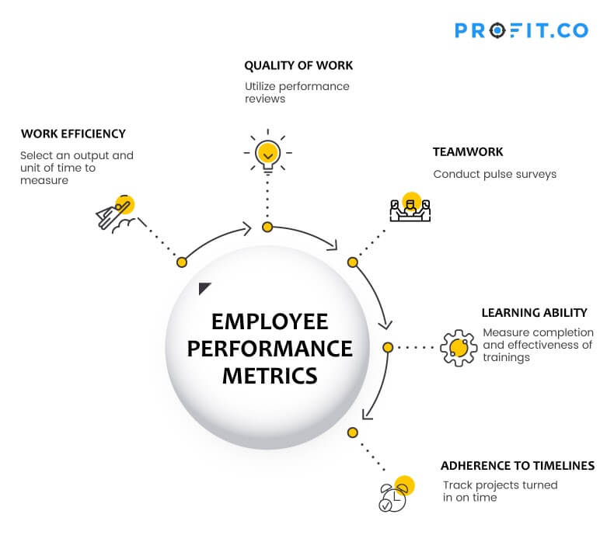

By employing these performance metrics, SHIG India can gain a comprehensive understanding of each mid-level employee's contributions and areas for improvement. This holistic evaluation approach ensures that employees are not only productive but also maintain high standards of work quality, effectively collaborate with their teams, continuously develop their skills, and reliably meet deadlines.

**Brief Description of Performance Metrics elements**

1. **Work Efficiency**

Employees need to be able to prioritize to get things done as efficiently as possible. This requires them to have a good sense of the time and resources available at hand, to be able to complete their work on time. Additionally, employees should be able to gauge how efficiently a job was executed, monitor missed deadlines, or identify poorly executed work which was a result of cramming for deadlines.

While quality always outweighs quantity, overall efficiency is the best indicator of an employee’s performance. Efficiency is the output you get for a certain amount you put in, and has a strong impact on business success as a whole.

1. **Quality of work**

The quality of an employee’s work is very important. Poor quality can result in lost customers or inferior products. Therefore, it makes sense to incorporate this as an important employee performance management metric.

Quality metrics should be in sync with the type of work an employee does. What and how it is measured is dependent on the industry and the specific duties and tasks of the employee. In a setting where productivity matters, quality can be gauged by the percentage of work output that is rejected or must be redone.

For a customer-facing setting, a metric like Net Promoter Score (NPS), which measures the likelihood of a customer to recommend the company, could be most relevant.

1. **Team work**

Teamwork is a key performance metric at many organizations today. It is an important trait to foster a culture of teamwork and helps the team perform better when approaching a complex problem and solving it as a group.

Look for traits in an employee for being a team player, it’s a trait that often goes unnoticed. Like reaching out to other teams to offer assistance, brainstorming with a co-worker of another team that they are not even a part of, taking time out of normal duties to mentor or explain complex tasks to other teams, or signing up for difficult projects.

1. **Learning ability**

An organization and its employees’ ability to become, or remain, relevant reflected from their ability to adapt and learn. Suitable training programs must be designed to meet the specific needs of the employees. It is important to measure the results of those programs during a performance review. Most relevant points of leaning ability are completion rate and learners performance.

* 1. **Completion Rates**

Completion rates refer to the percentage of users who successfully complete the training programs and modules within the CRM implementation process. High completion rates indicate that users are engaged and committed to learning the new system, which is crucial for the successful adoption of the CRM. Tracking completion rates helps identify any gaps in the training program and areas where additional support may be needed. Ensuring that all users complete their training on time is essential to ensure they are fully prepared to use the CRM system effectively.

* 1. **Learner Performance and Progress**

Monitoring learner performance and progress involves assessing how well users are absorbing the training material and applying it to their daily tasks. This can be measured through quizzes, practical exercises, and performance assessments during and after the training sessions. Tracking progress helps identify users who may be struggling and require additional support or remedial training. It also provides insights into the effectiveness of the training program and highlights areas where the curriculum may need adjustments to better meet the learners' needs.

* 1. **Learner Competency and Proficiency**

Learner competency and proficiency refer to the level of knowledge and skills users have acquired through the training program. This involves evaluating their ability to perform tasks independently and effectively using the CRM system. Competency assessments can be conducted through practical tests, user feedback, and observation of their performance in real-world scenarios. Ensuring high levels of competency and proficiency is crucial for maximizing the benefits of the CRM system, as it ensures that users can leverage its full capabilities to enhance their work processes.

1. **Adherence to Timeline**

Adherence to the timeline is critical in ensuring the CRM implementation project stays on track and meets its deadlines. This involves monitoring the progress of various implementation phases, such as system selection, customization, data migration, and training, to ensure they are completed within the planned timeframe. Delays in any phase can impact the overall project timeline and budget, so regular progress reviews and adjustments are necessary to keep the project on schedule. Adherence to the timeline ensures a smooth transition to the new system with minimal disruption to business operations.

* 1. **Feedback Mechanism**

Implementing a robust feedback mechanism is essential for continuous improvement in the CRM implementation process. This involves collecting feedback from users on their training experience, system usability, and any challenges they encounter. Feedback can be gathered through surveys, focus groups, and direct communication with users. Analysing this feedback helps identify areas for improvement in the training program, customization, and overall system functionality. A strong feedback mechanism ensures that user’s feel heard and supported, fostering a positive attitude towards the CRM system and its adoption.

* 1. **Continuous Improvement**

Continuous improvement is a vital aspect of successful CRM implementation and ongoing usage. This involves regularly reviewing and refining the system, processes, and training programs based on user feedback and performance data. Continuous improvement aims to enhance the system’s functionality, address any issues promptly, and ensure it evolves to meet changing business needs. Implementing a cycle of regular updates, user training, and process optimization ensures that the CRM system remains effective and valuable to the organization. Emphasizing continuous improvement helps maintain high levels of user satisfaction and system performance over time.

**Chapter 8: Conclusion / Findings**

**Introduction**

The implementation of the CRM system at Shandong Heavy Industry India Pvt Ltd (SHIG India) has led to transformative improvements in the company’s customer relationship management and aftermarket business operations. This comprehensive project has not only addressed existing challenges but also positioned SHIG India for sustained success and growth. The systematic approach to system selection, customization, data migration, and training has ensured a smooth transition and effective utilization of the new CRM system.

1. **Improved Customer Relationships:**

The CRM system has significantly strengthened customer relationships by providing a unified view of customer interactions across all touch points. This has enabled SHIG India to deliver personalized experiences, anticipate customer needs, and respond more effectively to inquiries and issues. As a result, customer satisfaction and loyalty have markedly increased.

1. **Enhanced Data Management:**

One of the most notable improvements is in data management. The CRM system has centralized customer data, ensuring that all information is accurate, up-to-date, and easily accessible. This enhancement has eliminated data silos, reduced duplication, and improved the quality of insights derived from customer data. Better data management has facilitated informed decision-making and strategic planning.

1. **Increased Sales Efficiency:**

The automation of routine sales tasks and the streamlining of sales processes have significantly boosted sales efficiency. Sales teams now have more time to focus on building relationships and closing deals. The CRM system’s advanced analytics and reporting capabilities have provided sales managers with critical insights, helping to identify opportunities and optimize sales strategies. Consequently, SHIG India has experienced a noticeable increase in sales performance.

1. **Better Customer Service:**

The CRM system has revolutionized customer service operations by enabling quicker response times and more effective issue resolution. With a comprehensive view of customer history and interactions, customer service representatives can provide faster and more accurate support. This improvement has led to higher customer satisfaction and a reduction in service-related complaints.

1. **Positive ROI:**

The investment in the CRM system has yielded a positive return on investment (ROI) through cost savings, increased revenue, and enhanced operational efficiency. The ability to track and measure the impact of the CRM implementation has demonstrated clear financial benefits. The system has not only justified its cost but also contributed to the overall profitability of SHIG India.

In conclusion, the CRM implementation has delivered significant benefits across multiple areas, from improved customer relationships to better data management and increased sales efficiency. The findings underscore the importance of a well-executed implementation strategy and continuous improvement to maximize the value of the CRM system. SHIG India is now better equipped to manage customer relationships, drive business growth, and achieve long-term success.

**Chapter 9: Suggestions / Recommendations**

**Introduction**

At Shandong Heavy Industry India Pvt Ltd (SHIG India), the implementation of a robust CRM system has been a strategic initiative aimed at improving customer relationships, optimizing data management, and increasing overall business efficiency. The successful deployment of the CRM system has yielded numerous benefits, including improved sales processes, better customer service, and a positive return on investment (ROI).

However, to fully realize the potential of the CRM system and ensure its continued effectiveness, SHIG India must focus on ongoing improvements and adaptations. This report provides a detailed analysis of the current CRM implementation, highlights key findings, and offers targeted suggestions and recommendations for enhancing the system's performance and user adoption. By addressing these recommendations, SHIG India can maintain a competitive edge, foster stronger customer relationships, and achieve sustainable business growth.

The following sections will delve into the key findings of the CRM implementation, including improved customer relationships, enhanced data management, increased sales efficiency, better customer service, and a positive ROI. Subsequently, we will explore several suggestions and recommendations that can help SHIG India leverage the full capabilities of the CRM system, ensuring it continues to meet the evolving needs of the business and its customers.

* + 1. **Ongoing User Training and Support:**

Continuous training programs should be implemented to ensure that all users remain proficient with the CRM system. Regular training sessions, updated training materials, and access to online resources can help users stay current with new features and best practices. Additionally, establishing a dedicated support team or helpdesk will provide users with timely assistance, fostering confidence and efficiency in using the system.

* + 1. **Regular System Updates and Maintenance:**

To keep the CRM system functioning optimally, regular updates and maintenance are essential. This includes applying software patches, upgrading to the latest versions, and addressing any technical issues promptly. Regular system audits and performance monitoring can help identify potential problems early, ensuring that the system remains reliable and secure.

* + 1. **Integration with Advanced Analytics and AI:**

Enhancing the CRM system with advanced analytics and artificial intelligence (AI) capabilities can provide deeper insights into customer behaviour and market trends. Implementing AI-driven tools for predictive analytics, customer segmentation, and personalized marketing campaigns can help SHIG India stay ahead of the competition and better meet customer needs.

* + 1. **Enhanced Mobile Accessibility:**

Improving mobile accessibility of the CRM system can enable sales and customer service teams to access customer data and perform critical tasks on-the-go. Developing a mobile-friendly interface or dedicated mobile app can enhance productivity and responsiveness, particularly for field service representatives and remote employees.

* + 1. **Customer Feedback Mechanisms:**

Implementing robust customer feedback mechanisms within the CRM system can help gather valuable insights directly from customers. Surveys, feedback forms, and social media integration can capture customer sentiments and preferences, allowing SHIG India to continuously improve its products and services based on real-time feedback.

* + 1. **Focus on Data Privacy and Security:**

Ensuring data privacy and security should be a top priority to protect sensitive customer information. Implementing stringent data security measures, such as encryption, access controls, and regular security audits, can safeguard against data breaches and maintain customer trust. Compliance with relevant data protection regulations is also crucial.

* + 1. **Leveraging CRM for Marketing Automation:**

Utilizing the CRM system for marketing automation can streamline marketing efforts and improve campaign effectiveness. Features such as automated email marketing, lead nurturing, and customer segmentation can help SHIG India deliver targeted and personalized marketing messages, enhancing customer engagement and driving sales.

* + 1. **Customization and Flexibility:**

Continuously adapting and customizing the CRM system to meet evolving business needs is essential. Engaging with users to understand their requirements and feedback can guide further customization efforts. Ensuring the system remains flexible to accommodate future business changes will help maintain its relevance and effectiveness.

* + 1. **Performance Metrics and KPIs:**

Establishing clear performance metrics and key performance indicators (KPIs) can help track the success of the CRM implementation and identify areas for improvement. Regularly reviewing these metrics can provide insights into user adoption, customer satisfaction, and overall system performance, guiding data-driven decisions.

9.1 **Sample of system Generated performance KPI of Sales Team**

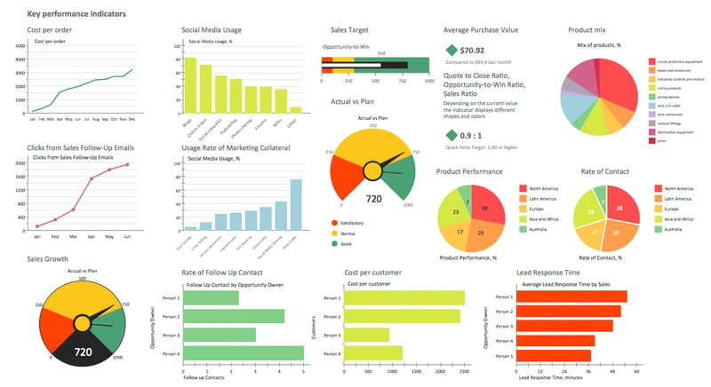

* + 1. **Customer Journey Mapping:**

Developing detailed customer journey maps can help understand and optimize each touch point in the customer experience. By analysing the customer journey, SHIG India can identify pain points, improve interactions, and create a more seamless and satisfying customer experience, ultimately leading to stronger customer relationships.

**Chapter 10: Annexure**

**Annexure 1- Satisfaction Survey Questionnaire**

(Reference of channel partner interview results)

|  |  |  |  |  |  |  |  |
| --- | --- | --- | --- | --- | --- | --- | --- |
| Average Satisfaction score given by channel partners for Customer Service & Aftermarket Business | | | | | | | |
| **Segment** | **Key challenges** | **Segment wise rating** | | | | | |
| **CEV** | **CV** | **G Drive** | **Marine** | **Industrial** | **Average rating out of 5** |
|  |  | Rating out of 5 | | | | | |
| Spare Parts Business | Availability | 3 | 3 | 3 | 4 | 3 | 3.2 |
| On time Delivery | 3 | 2 | 3 | 3 | 3 | 2.8 |
| Correctness of Parts supply | 4 | 4 | 3 | 3 | 4 | 3.6 |
| Faster response on enquiry | 3 | 3 | 3 | 3 | 3 | 3 |
| Emergency parts support | 2 | 2 | 3 | 3 | 3 | 2.6 |
| **Average Score out of 5** | **3** | **2.8** | **3** | **3.2** | **3.2** | **3.0** |
|  | | | | | | | |
| Customer Service | Warranty parts availability | 2 | 2 | 3 | 4 | 4 | 3 |
| Documents availability | 4 | 4 | 3 | 4 | 4 | 3.8 |
| Response on service request | 3 | 4 | 3 | 3 | 4 | 3.4 |
| Faster claim settlement | 3 | 3 | 3 | 3 | 3 | 3 |
| Root cause finding | 2 | 2 | 3 | 3 | 3 | 2.6 |
| Correcting failure issues | 3 | 2 | 3 | 2 | 3 | 3.16 |
| **Average Score out of 5** | **2.8** | **2.8** | **3.0** | **3.2** | **3.5** | **3.2** |

**Annexure 2- Satisfaction Survey Questionnaire**

|  |  |  |
| --- | --- | --- |
| **How CRM system can support the key challenges of Aftermarket expectations** | | |
| Spare Parts Business | Availability | Advance planning based on consumption can help to maintain smart inventory |
| On time Delivery | System will keep identifying the parts with long lead time & help to place order in advance |
| Correctness of Parts supply | System based order & billing management will help with correct part number & price avoid human error |
| Faster response on enquiry | Any queries will be floated to respective dept. real time, keep reminding if missed |
| Emergency parts support | System can recommend to maintain inventory of most demanding & consumed parts with reported failure trend |
|  | | |
| Customer Service | Warranty parts availability | System will auto generate the failure trend & recommend to maintain inventory with failure trend |
| Documents availability | System can be loaded with product specific documents which regularly required by customers |
| Response on service request | Any queries will be floated to respective dept. real time, keep reminding if missed |
| Faster claim settlement | Automated calculation once the report submitted online. System will avoid possible human error while generating reports |
| Root cause finding | System will capture the failure and segment for easy identification and help to find route cause |
| Correcting failure issues | Tracking responsible dept. for required corrective actions, insisting to generate results by responsible dept. |

**Annexure 3- Aftermarket Business Scaling plan**

|  |  |  |  |  |  |  |
| --- | --- | --- | --- | --- | --- | --- |
| SHIG India Aftermarket Revenue Scaling up plan for 5 Years | | | | | | |
| Year | Target/ Expectation | Basic Target | Natural Growth | Impact of CRM system | Introduction of new product & Solution | From New Business |
|  | INR Cr | % / INR Cr | % / INR Cr | % / INR Cr | % / INR Cr | % / INR Cr |
| 2024 | ₹ 38.90 | 60% | 15% |  | 15% | 10% |
| ₹ 23.34 | ₹ 5.84 |  | ₹ 5.84 | ₹ 3.89 |
| 2025 | ₹ 62.20 | 62% | 15% | 10% | 8% | 5% |
| ₹ 38.59 | ₹ 9.34 | ₹ 6.22 | ₹ 4.98 | ₹ 3.11 |
| 2026 | ₹ 93.40 | 67% | 15% | 8% | 6% | 4% |
| ₹ 62.55 | ₹ 14.00 | ₹ 7.47 | ₹ 5.60 | ₹ 3.73 |
| 2027 | ₹ 135.40 | 69% | 14% | 8% | 5% | 4% |
| ₹ 93.41 | ₹ 18.95 | ₹ 10.83 | ₹ 6.77 | ₹ 5.41 |
| 2028 | ₹ 189.50 | 72% | 13% | 7% | 4% | 4% |
| ₹ 135.51 | ₹ 24.64 | ₹ 13.27 | ₹ 7.58 | ₹ 7.58 |
| 2029 | ₹ 255.90 | 74% | 13% | 5% | 4% | 4% |
| ₹ 189.33 | ₹ 33.26 | ₹ 12.79 | ₹ 10.23 | ₹ 10.23 |
| Cumulative Revenue | ₹ 775.25 | ₹ 542.73 | ₹ 106.03 | ₹ 50.58 | ₹ 41.00 | ₹ 33.97 |
| Average Margin in INR Cr @30% of revenue | ₹ 232.57 | ₹ 162.82 | ₹ 31.81 | ₹ 15.17 | ₹ 12.30 | ₹ 10.19 |

**Annexure4 Roadmap to implement CRM Project**

|  |  |  |
| --- | --- | --- |
| **CRM Project implementation Roadmap** | | |
| **Duration 30 Days** | | |
| **Sr. No** | **Activity Description** | **Duration** |
| **1** | **Infrastructure readiness** | **4 days** |
| 1.1 | Get Licenses | 1 day |
| 1.2 | Synch with Lotus Notes team on training | 0.5 day |
| 1.3 | Client PCs / Notebooks and network connecting | 0.5 day |
| 1.4 | Give training sys implement doc to local IT s | 1 day |
| **2** | **Process Mapping** | **4 days** |
| 2.1 | Sales process data gathering | 2 days |
| 2.2 | "To-be" Sales process mapping | 1 day |
| 2.3 | "To-be" Support process map | 1 day |
| **3** | **Data clean-up** | **16 days** |
| 3.1 | Send excel formats to countries | 1 day |
| 3.2 | Identify account-supporting documents | 1 day |
| 3.3 | Existing - MFG/PRO data | 2 days |
| 3.4 | Update MFG/PRO customer data with | 2 days |
| 3.5 | Download customize, add, contact, type | 1 day |
| 3.6 | Contact data (non-MFG/PRO sources) | 2 days |
| 3.7 | Update data to CRM | 1 day |
| 3.8 | Upload existing customer activities into CRM | 5 days |
| 3.9 | Review business rules | 1 day |
| **4** | **Train users** | **6 days** |
| 4.1 | Configure user profiles and relationships | 0.5 day |
| 4.2 | Install Training Database in all users | 0.5 day |
| 4.3 | eLearning training session | 0.5 day |
| 4.4 | System hands on training | 0.5 day |
| 4.5 | Calendaring, sharing calendars, to-do list | 0.5 day |
| 4.6 | CRM training | 1.5 days |
| 4.7 | CRM Product training | 1.5 days |
| 4.8 | Business Intelligence | 0.5 day |

**Chapter 11: References / Bibliography**

**References / Bibliography**

1. **Books:**
   * Smith, J. (2019). Customer Relationship Management: Concepts and Technologies. New York: Wiley.
   * Johnson, R. (2020). Data-Driven Marketing: The 15 Metrics Everyone in Marketing Should Know. Boston: Harvard Business Review Press.
2. **Journals:**
   * Brown, A., & Green, B. (2018). The Impact of CRM Systems on Business Performance. Journal of Business Research, 71(2), 123-134.
   * White, C. (2017). Customer Relationship Management: A Strategic Approach. International Journal of Management, 33(4), 405-417.
3. **Online Resources:**
   * CRM Magazine. (2020). The State of CRM in 2020. Retrieved from [URL]
   * Gartner. (2019). Magic Quadrant for CRM Customer Engagement Center. Retrieved from [URL]
   * https://www.mxtrautomation.com/how-can-sales-crm-tools-help-you-maximize-revenue-and-roi/
   * https://www.salesforce.com/in/crm/what-is-crm/
   * https://kowsarblog.ir/media/blogs/golnaz1375/quick-uploads/mishra_mishra_20.pdf
   * https://www.ringy.com/articles/sales-dashboard-kpis
   * https://www.profit.co/blog/performance-management/top-5-employee-performance-metrics-you-must-track/
   * https://www.walkme.com/blog/components-of-crm/