1. **Operation Management**

Mid – Term : Marks : 30

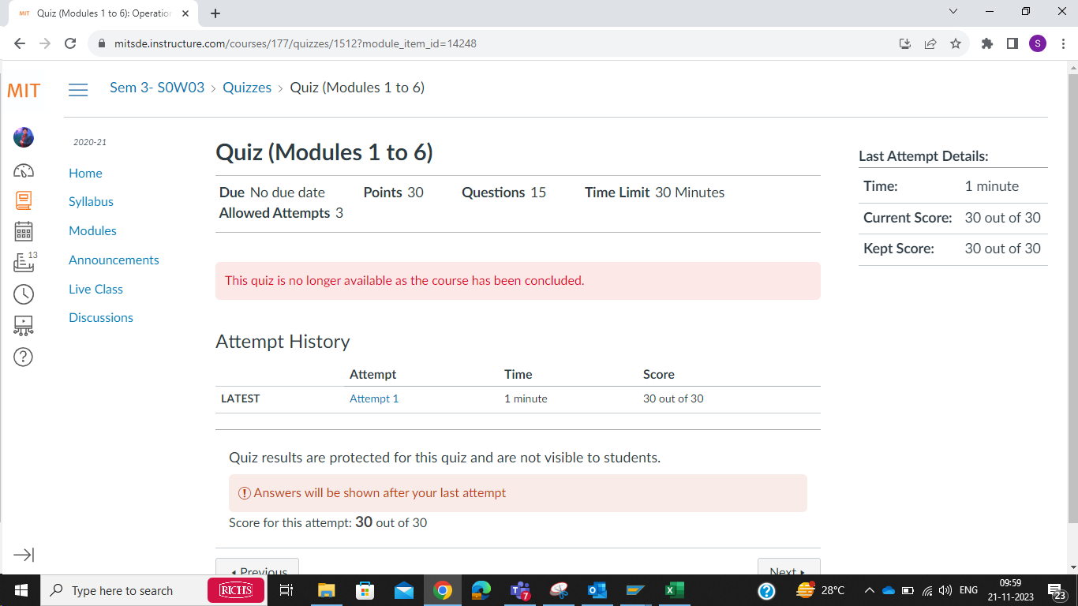

End Term : Marks : 30

1. **Supply Chain Analytics**

**Mid Term : Marks : 28**

**End Term : 30**

1. **Lean Management System**

**Mid Term : 30 Marks**

**End Term : 30 Marks**

1. **Production, Planning and Control (PPCw)**

**Mid Term : Marks : 30**

**END Term : Marks : 30**

1. **Project Management**

**Mid Term : Marks :30**

**End Term : Marks : 30**

