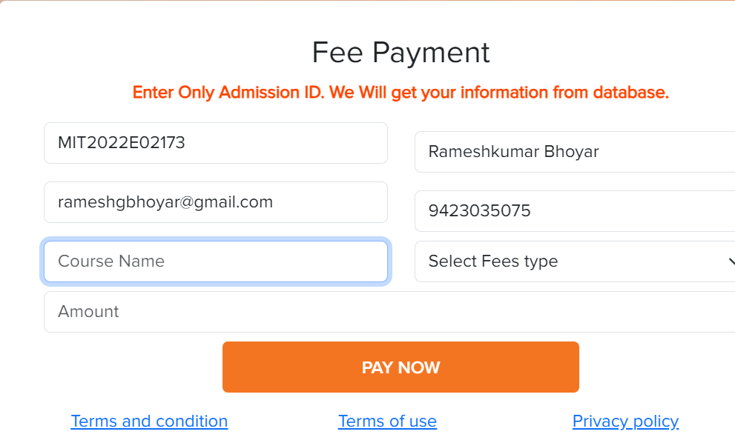

COUSER NAME NOT COMING OR TO ENTER ,