**A PROJECT REPORT**

**ON**

# “Impact of Social media in marketing”

**UNDERTAKEN AT**

# “Grocebin.com”

**IN PARTIAL FULFILMENT OF**

# “PGDM in Marketing Management”

**MIT SCHOOL OF DISTANCE EDUCATION, PUNE.**

**GUIDED BY**

# “Kuldeep Sharma”

**SUBMITTED BY**

# “Manish Kumar Pandey”

**STUDENT REGISTRATION NO.: MIT202102271**

# MIT SCHOOL OF DISTANCE EDUCATION PUNE - 411 038

**YEAR 2022-24**

# Exempt Certificate - If you’re not able to provide the Project Executed Certificate

To,

The Director

MIT School of Distance Education, Respected Sir,

This is to request you to kindly exempt me from submitting the certificate for Project Work due to the reason mentioned below:

Tick the right option

1. As per the Rules of the Organisation

* 2. Self Employed

1. Working in Public Sector
2. Full-time Student

Thanking you in anticipation of your approval to my request. Regards

**Student Name:-** Manish Kumar Pandey

**Student ID:-** MIT202102271

# DECLARATION

I hereby declare that this project report entitled **“Impact of Social media in marketing”** bonafide record of the project work carried out by me during the academic year **2022-2024**, in fulfillment of the requirements for the award of **“PGDM in Marketing Management”** of MIT School of Distance Education.

This work has not been undertaken or submitted elsewhere in connection with any other academic course.

**Name:- Manish Kumar Pandey**

**Student ID: MIT202102271**

# ACKNOWLEDGEMENT

I would like to take this opportunity to express my sincere thanks and gratitude to **“Kuldeep Sharma”**, Faculty of Ashok Leyland Ltd, for allowing me to do my project work in your esteemed organization. It has been a great learning and enjoyable experience.

I would like to express my deep sense of gratitude and profound thanks to all staff members of MIT School of Distance Education for their kind support and cooperation which helped me in gaining lots of knowledge and experience to do my project work successfully.

At last but not least, I am thankful to my Family and Friends for their moral support, endurance and encouragement during the course of the project.

**Name:- Manish Kumar Pandey**

**Student ID: MIT202102271**

# ABSTRACT

Social media marketing is a new trend and the most successful among all the types of marketing tools. For a business to succeed, Advertisement should reach maximum users and create a full clear and visible image of its brand. No doubt, social media marketing is the most cost effective advertising strategy. Most social networking platforms provide free accounts and signup and some online advertising tools come with some cost. On the other hand, the return is much more than investment, in case of social media advertising. Only by investing a little money and time, any one can greatly maximise and increase conversion rate and get high return on investment for the money invested in advertising.

The main aim of this study is to examine how social media marketing will affect the final decisions and behaviour of the consumer who spend their maximum time on social networking platforms and forecast relationships among various consumer activities, marketing activities and choice with the behaviour of the consumer.

Social media marketing is emerging continuously to satisfy the basic needs of website users and on the other side it also has increased the opportunities for companies to advertise their products and services in personalised way. The previous record shows that social media has contributed greatly in changing consumer behavior and organisations got to know about the customer behaviour.

Social media marketing has changed the marketing structure of the place where the goods are sold and purchased online. Social media marketing has significantly changed the way of thinking of the consumer and the organisations should not ignore the social media marketing

Growing popularity of social media compelled the marketers to think about this media along with traditional functional areas of marketing. Social media is based primarily on the internet or cellular phone-based applications and tools to share information among people. The number of social media user’s is more than the population of some of the countries today. Impact of social media on marketing can be judged by comparing marketing before social media and marketing after the introduction of social media and the type of technologies used in social media.

# TABLE OF CONTENTS

|  |  |  |
| --- | --- | --- |
| **Chapter No.** | **Title** | **Page No.** |
|  | **INTRODUCTION** |  |
| **1** | 1.1 Social Media Marketing | **1** |
| 1.2 Benefits Of Social Media Marketing | **2** |
| 1.3 Develops Loyal Fans | **3** |
| 1.4 Social Media Marketing Techniques | **4** |
| 1.5 Some *Social Media Marketing Tools* | **6** |
| 1.6 Statement Of The Problem | **6** |
| 1.7 Primary Objective Of The Study | **7** |
| 1.8 Scope Of The Study | **7** |
| 1.9 Company Profile | **8** |
| 1.10 Why Should One Use Grocebin.Com | **8** |
| 1.11 Industry Profile | **9** |
| **2** | **Review of literature** | **10-12** |
| 2. Introduction | **10** |
| **3.** | **RESEARCH METHODOLOGY AND RESEARCH DESIGN** | **13** |
| 3.1 Research design | **13** |
| 3.2 sample design | **13** |
| 3.3 source of data | **14** |

|  |  |  |
| --- | --- | --- |
|  | 3.4 Analytical tools | **14** |
| 3.5 Hypothesis testing | **15-18** |
| **4** | **DATA ANALYSIS AND INTERPRETATION** | **19-39** |
| **5** | **FINDINGS,SUGGESTIONS AND CONCLUSION** | **40-41** |
|  | 5.1 Findings | **40** |
| 5.2 Suggestions | **41** |
| 5.3 Conclusion | **41** |
|  | **REFERENCES** | **42-45** |
|  | **APPENDIX (QUESTIONNAIRE)** | **46-53** |

## CHAPTER-1

## 1.INTRODUCTION

For any Organisation, the most valuable as it is it's brand and the modern organisation should realise that capitalising on brand can help achieve growth, profitability objective and sustainability. Along with incessant globalisation social media has emerged as the best platform for Advertising and Marketing for companies. It increased the visibility of services and products.

For every businessman the only aim is how various marketing tools and techniques can increase the number of selling services and products. The main aim of the study is to examine how social media marketing will affect the final consumer behaviour among persons who mostly use social media websites and also to find out the forecasted relationships among various social media marketing activities, customer activities and behaviour of the consumer.

The Social media has changed the entire structure as to where the goods should be sold and where to purchase online. It plays a very important part in modern day advertisement by describing attributes and possible roles for marketing planning, recognising various marketing tools and techniques. Not only that social media is changing the mind of consumer behaviour but also to a great extent used for direct marketing and as a tool for personalized goods.

Social media like Facebook, Twitter, YouTube and Instagram are dynamic tools that facilitate online relationships. It is a relatively low cost form of marketing and allows organisations to engage direct and end-user contact. The choice of social media marketing organisation creates an influential impact of brands by recommending personalized consumer choice. Brands influence customers, customers influence other customers and the chain continues which further affects future earnings of the organisation and long-term organisational sustainability.

In this fast growing world, all ones have busy schedules, so for the customer it is difficult to spend time on purchasing goods or services. Nowadays users are collecting information from different sites and platforms Online without wasting time and labour. And social media marketing is not only useful for customers, in that it provides information about the company but also provides information of the customer's choice to the company. Every social media tool tries to build an image of the company's brands and goods. So we can say that consumers can change their mind for purchasing any good or service by social media marketing and taking the goods or services online.

### **1.1. SOCIAL MEDIA MARKETING**

It is a method by using social media sites to attain the attention of people. These programs concentrate on developing content which will attract the attention of the readers in social media and make them share the contents in their social networking site.

Any statement that is shared in the social networks, which includes short messages, information about a product or service, brand or a company is termed as electronic word of mouth. When the information about a product / service / brand / company is shared in a social media by a user, it is reshared by many users in other social networks and when the information is shared by a trustworthy source, it becomes a positive promotion for the product than the promotion done through paid sources. This shows the power of social media marketing.

What the major search engines seek for in terms of social media signals are the source's authoritativeness and trust. Authoritativeness is different from Authorship. Authorship is a function released by Google in 2011, which permits authors and publishers to add varied parts, including photos, ratings and more details to search engine results pages. Trust is fundamental to social signals being read by the search engines. Those people, whose social media profiles have a trust score, are called influencers.

As per consumer socialization theory, communication with customers plays an important role and its influence the psychological feature of the customer. It also has an impact on the attitude of the customer. Social media networking sites provide an environment that enables the consumers to communicate on the web which will have an important impact on consumer socialization concepts.

### **BENEFITS OF SOCIAL MEDIA MARKETING**

Social marketing is an approach used to develop activities aimed at changing or maintaining people's behaviour for the benefit of individuals and society as a whole.

### **Increased Exposure:**

Now a days the importance of Social Media Marketing has increased. Consumers and Marketers are using Social Networking too much. The exposure increased now a days which is showing 92%.

### **Increased Traffic:**

With the introduction of web based marketing the users are increasing day by day. The research says that consumers and even marketers use social networking sites too much and due to that sites the traffic has increased day by day which is showing the research that traffic increased up to 80%.

## Develops loyal fans:

Brand Loyalty is the other is the most important advantage of social networking sites. Taking an example if a consumer is satisfied with any product he or she will never go to any other company to buy the product. This creates brand loyalty.

### **Provided Marketplace Insight:**

Social networking sites provide information about products and is available clearly. That means its Features, Functions, Price etc. Consumers will get full information about products only on websites and customers don‟t have to go anywhere. The result shows that 72% of customers agreed that social networking sites are providing marketing insights.

### **Generated Leads:**

There are various different ways to lead generation. Most of the social networking sites generate leads for products and services. For example A blog is a hub for customers engagement. No doubt Face Book is also an important source, so in short it is generated leads.

### **Improved Search Ranking**

Most of the customers are now spending hours even more than watching television too. And what curiosity they get as social networking sites are the search engines. With the help of social networking the ranks are given to products on the basis of feedback given by the customer online.

### **Growing Business Partnership**

As a Trading form of selling and purchasing is now replaced with Social Media the same idea of business is also changing. After taking many years now Binch Box wants beauty obsessed Instagram followers to join them.

Nowadays growing partnerships are also an important advantage of social networking sites too.

### **Reduced Marketing Expenditure**

Trading method of selling the product is too costly. A businessman needs salesman, office and many more requirements. But now a days social networking sites are user friendly and anybody can use the social media at any time and even businessmen can do the advertisement on social media sites very cheaply.

### **Improved Sales**

In the present scenario where 600 photos are shared, 20 websites are created every day. 1,00,0 tweets are sent. Now a days different social networking sites are created so differently as customers can purchase the goods online at any time. No doubt now a days revenue has increased online as compared to earlier days.

### **Social Media Marketing Techniques**

The main purpose of social media marketing is communicating about the product to the consumer and making it accessible to people who doesn’t know about the product. Social media is used by companies to promote the product to the prospective customers. Social media marketing helps the consumers at various stages of the buying process.

Research indicates that of these ten factors for effective marketing, Social media is one amongst them, which indicates if any brand is in operative on social media, then the result will be less chances of the brand to be present on google searches.

There are large no of users in facebook, Twitter and Google and there is huge exchange of information which made the business firms use social media to interact with prospective customers.

Instagram has hundred thirty million users monthly and twitter has two hundred ten million monthly users and the average communication rate ranges from 1.46 percent on Instagram and 6.03% in the case of twitter. The cost involved in social media marketing is very less when compared to ancient modes of advertisements using TV/Radio/Print channels. In Fact there is no price involved when using social networking sites, it also covers a wide range of people.

Many firms are now changing their approach for interaction with customers. They are using online platforms for better client interaction and visibility. Social media are used as a platform by customers to post reviews, recommendations, ratings, and raise queries to the firms.

Companies are employing people to handle social media communication with the customers and they are working as online community managers. The job of these managers are to handle social media communications in an effective manner and win the trust of customers. Firms are taking steps to manage client issues, identify various modes of social media marketing, engage the customers to influence the new and prospective customers to market their product/service.

### **Advantage of social media marketing**

* + - * **Increased brand recognition**

Social Media is a new platform for promoting the brand. Social Media helps the companies to attain new customers and also have quick access to customers. When a particular brand is familiar and available in multiple social media sites, It increases the brand recognition to the customers and also attracts new customers. When the brand is tweeted frequently in the social media, then the company‟s brand image will get increased, thereby increasing the growth of the company business.

### **Improved Brand Loyalty**

A research work published in the US, indicated that when there is a higher level of interaction about a brand in social media, then there exists a higher level of trust about the brand among customers. It also suggests that companies can take the benefit by using social media tools to connect with its customers. The study also suggests there should be some strategic plan for use of social media to influence the customers. Another study indicates that fifty three out of hundred in American population are following their brands in social media and also they found to be loyal to their brands.

### **Chances to Convert**

There is a chance that each and every comment, post, sharing, likes in social media will become a sale and bring customers. Every comment, post, website link, video, tweet will make the viewers visit the page and view the product and thereby there is a chance for conversion into sale. Though all the comments may not get a chance for conversion into sale but every good comment about the product will get a chance for conversion into sale.

### **Conversion Ratio**

The conversion rate of conversion of discussion in social media into sales is high. It is the important element as seen by business people nowadays. The brands and the reviews about the product started to speak like individual salesmen in the social media channels. Due to this effect business people want to improve and increase their business with various people in social media than with firms.

### **Brand Authority**

Continuous communication with the customers will bring faith about the product among the customers. People are searching and viewing the comments in the social media about products and services, whenever they are planning to buy a product or avail a service. Every new post about a product in social media by a user will attract many users in social media and they follow the page for information updates. When there is more talk about a product in social media, there it becomes a more attractive brand.

### **Reduction in selling price**

Due to the presence of social media, the advertising cost is getting reduced by way of advertising through twitter, facebook etc… Hub spot research concludes that six hours of spending on the net in a week by a seller for social media will bring more viewers to the product in social media. In order to get more customers, sellers can spend one hour a day on social media which will definitely bring more customers and thereby reducing the cost of advertisement which in turn can reduce the price of the goods.

#### **Some social media marketing tools**

1. Social Media Monitoring.
2. Social Media.
3. Blog Marketing
4. Social Bookmarking and Tagging.
5. Social Analytics and Reporting.
6. Social Aggregation. With the fickle popularity of various Social Media Marketing like Google+, Facebook, Myspace. Etc. which is affecting consumer behaviour.

### **Statement of the Problem**

The social experience in the research guides the components of the consumers buying behaviour through Online Platforms and the Impact of Social Media in Marketing.Many Social Media Marketing techniques like search engine optimization campaigns are used by businesses to boost their businesses. There are many Data Analysis that shows Social Media is affecting the Marketing behaviour of customers.

* + - Social networking is used by about 76% of businesses in order to achieve their marketing objectives.
    - Business retailers experience about 133% increase in revenues after marketing their business in the mobile market that promotes social media marketing value for their business.
    - 40% of online shoppers from the US use the Smartphone for in-store shopping.

### **Primary Objectives of the study**:

**Following are main and primary objectives of the present study**:

1. To study the concept of social media.
2. To evaluate the various channels preferred by consumers for buying decisions over Traditional Channels
3. To analyse the impact of social media on consumer buying behaviour.
4. To find out which is the best social media preferred by customers.
5. To find out the impact of social media on consumers with reference to the Sitamarhi area.

### **1.7.1 Objective of the present paper**

* + - To study the present status of E-Commerce in India.
    - To examine the barrier of E-Commerce in India.
    - To discuss the future of E-Commerce in India.
    - To study the growth of the E-Commerce industry in India along with the factors responsible for it.

#### **Scope of the study**

1. The Scope of this research is ultimately to understand many features, advantages of social media marketing.
2. Understand the behaviour of the consumer, factors affecting consumer behaviour.
3. Traditional methods of marketing like Radio, Television are considered Upstarts with questionable staying power.
4. Many progressive business owners are dabbling in social media Marketing
5. The long term benefit of an effective broad scope social media marketing campaign cannot be measured in days or weeks.
6. Bloggs, Twitter, Facebook fans, Dig links, Skype are various tools Adopted by customers as well as marketers too.
7. Scope is concerned with the place of the research also, for that researcher Has taken the area in respect of Sitamarhi district.

### **Company profile** Grocebin.com

Grocebin is the youngest Online Grocery store in India, primarily operating out of Sitamarhi in the state of Bihar.

Bihar has always been an underdeveloped state since India got freedom particularly in the field of marketing. Grocebin has always believed in the concept of Supply-Chain management strategy to maximize customer value and gain a competitive advantage in the marketplace. We encompass everything from delivering of source materials from supplier to the manufacturer through its eventual delivery to the end user. We envision expanding to other cities of the country at the earliest.

Grocebin wide range of products include all the grocery and supermarket items a typical family would need on a daily basis including fruits and vegetables. The comprehensive mix of the products listed with us reflects the prerequisites of our modern times.

For now Grocebin stock and sell, from our warehouses, thereby cutting middlemen resulting in Low Costs for you. We have tied up with HDFC Payment Gateway, the country’s most trusted payment gateway to ensure that all your transactions are safe and secure.

Grocebin is a people-oriented company and we believe that even in this automated world we always try our best to stay connected to our beloved customers every time they place an order. We are always looking for feedback from each and every customer to ensure that they are thoroughly satisfied with our supply.

Finally, we would strongly recommend and request you to provide feedback to us about your End-to-End experience of your grocery shopping with us and we would ensure that we shall update our features and functionalities to meet your expectations because you, the Customer is the PIVOT of our business and everything we do revolves around you.

### **Why should one use grocebin.com ?**

*Grocebin allows you to walk away from the drudgery of grocery shopping and welcome an easy relaxed way of browsing and shopping for groceries. Discover new products and shop for all your food and grocery needs from the comfort of your home or office. No more getting stuck in traffic jams, paying for parking, standing in long queues and carrying heavy bags – get everything you need, when you need, right at your doorstep. Food shopping online is now easy as every product on your monthly shopping list is now available online at grocebin.com, India’s best online grocery store.*

### INDUSTRY PROFILE E-COMMERCE

E-Commerce stands for electronic commerce and caters to exchange of products, services and information via the internet. Electronic commerce is more than just buying and selling products online. It includes the entire online process of developing, marketing, selling, delivering, serving and paying for products and services. It is doing business online. It includes any commercial activity that takes place directly between a business, its partners, or its customers through electronic communication and digital information processing technology.

E-Commerce is a modern business methodology that addresses the needs of the organisations, merchants and consumers to cut costs while improving the quality of goods and services and increasing the speed of service delivery. India has shown tremendous growth in the E-Commerce segment. E-Commerce has become an important tool for small and large businesses worldwide, not only to sell to customers but also to engage them. Although the transition from traditional purchasing to online purchasing was very slow initially in Indian market because of less number of internet users due to lack of internet facility and awareness in public. But now the situation has changed and the e-commerce industry is growing rapidly in our country.

### 1.11.1 PURPOSE OF THE STUDY

The purpose of this present study is to investigate the impact of social media marketing on individual attitude and perception. More specifically, this study will examine the perception of social media marketing and how it affects purchasing decisions. Although several researches that have been conducted on the effects of social media marketing on financial gains, the study’s interests are specifically geared towards the examined effects of the use of social media on brand awareness and customer loyalty, which essentially could lead to an increase in business revenue. The study will be conducted via surveys on social media presence of businesses with participants being students at SATHYABAMA INSTITUTE OF SCIENCE AND TECHNOLOGY.

**INTRODUCTION**

***CHAPTER-2***

# Review of literature

Literature review is among the most important steps in the process of any research work. Literature review is to find out and understand the main objective of a particular subject or research which has been taken by the researcher. It is a record which shows what has been done in this regard in the recent past. Thus, it is the current trend in the selected subject when the review of literature is made by the researcher. He/she will become an expert in his/her subject and eventually become a master. It shows the direction is which the research direction must go. Research work clearly showing there should not be duplication of work. It also indicates what type of methodology should be adopted by various experts and researchers.

### Bikhchandani et al., (1998)

In their research describes whether or not shoppers shall purchase a product and whether or not they suggest a product to others. These are normally used as parameters for purchase intention. The study additionally reveals the result of knowledge cascades on social media by different product attributes is unconditional with different involvement strengths by shoppers. It concludes that the shoppers try to show totally different levels of involvement in different situations wherever they face with brand buying and recommending to others.

### Manju Ahuja et al., (2003)

In their article, targeted on investigating the factors that influence the shopping behaviour and browsing behaviour of consumers during online purchase specifically, the study has been conducted about the consumers using business-to-consumer sites. The researchers also investigated buying preferences of consumers with varied demographic profiles which may reveal different buying approaches and consumer behaviours for a specific class of merchandise and services. Social media is the1 most effective factor that influences buying behaviour of customers.

### Muhammad Shafiqul et al., (2004)

In the analysis, the researchers concentrated on finding the relationship of Social Media and buying behaviour of customers. The study involved the students of academic institutes of Karachi. Around two hundred and sixty questionnaires were answered by the students. The study finds that there is no strong relationship between Customer Buying behaviour and Social Media.

### Ramsunder (2011)

Their study says that shoppers‟ decisions are influenced heavily by on-line brands. Opinion of consumers will influence one another. This type of opinion by other consumers affects the repurchases. So, Consumers are moving to the Internet to get more data for their buying decisions.

### RaghuramIyengar et al., (2012)

Investigated in Korea, how friends influence shopping through Social Network. Their study concentrates on two important questions, the first question is “Is there any influence by friends on purchases by consumers in social media networks”, the second question is “if there is such influence which consumers are affected “. To strengthen the analysis, sample data were taken from social networking website Cyworld. Sample data of 208 users of Cyworld for ten weeks of purchase and non-purchase information was collected. The researchers build a model on the decision of buying and non buying and also with the amount spent. Markov chain Monte Carlo technique and Bayesian approach is used to estimate the model. The results indicated that there are three different categories of consumers with different buying behaviour.

### TeenaBagga et al., (2013)

The study analyses the inner and outer factors of consumer’s online buying behaviour. A structured form was used and a survey was conducted with two hundred samples. Questionnaires were sent through the mail and also posted through online web pages and were answered by the respondents themselves. The statistical analysis found seven major factors that govern the consumer’s buying behaviour. These seven factors were: would like for Social Communication, website Attributes, on-line Advertising, Recreation, Convenience, privacy issues and data Search.

### Garima Gupta (2013)

In her paper analysed the influence of social media on product buying. The results proved the actual fact that social media have an effect on product buying intentions. Particularly, there's a powerful impact of 3 factors called information about product, peer communication and the level of product involvement on shoppers purchase intentions with respect to social media. The author infers that, because the product is sold through on-line, it can't be examined; perceived data shared about the product on social media and information sharing among peer teams facilitates consumer’s analysis on the product and makes decisions accordingly.

### GeetanjaliNaidu et al., (2013)

Their study analyses the influence of social media in purchasing behaviour of customers in Raipur. According to the survey result 75% of Indian youth use the internet for sharing their opinion, views and comment in numerous websites. The analysis concludes that people use social media widely for collecting information regarding products.

### Dr. Surbhi Chaturvedi et al., (2014)

Their study indicated that there may be 100 crore members present in social media; social media sites became an important medium for firms and consumers to meet each other for the exchange of information about products. They also suggest that the influence of social media on customer buying behavior is tremendous. Buying behavior in social networks is influenced by gender, education, income, age etc.

### Alireza Mohammadpour et al., (2014)

The study aims to find the impact of social media marketing on online buying behaviour of customers with respect to brand capital using path analysis technique. A sample 160 from university of Tehran were asked to fill the questionnaire on social media marketing, brand capital and online shopping behaviour of consumers. The results indicated that social media had a significant impact on brand name. Social media marketing had a significant indirect positive impact on online shopping behavior of consumers. The results conform the role of brand marketing in concurrence with media and online buying behavior of consumers.

### Marta Zembik (2014)

His study explains that Social media comprises blogs, public forums, social media sites, that are used for communication of some information. The data provided in social media is beneficial for organization/ firms and customers. Customers benefited from the product information posted by others, recommendations by other customers. Firms benefited by the information provided by the customers in social media about their products, getting the feedback on their product market, information about the prospective customers, customers needs and demographic characteristics. This article emphasizes how social media information is essential for companies and customers in their decision-making process.

### Prof. Assoc. Dr. ElenicaPjero et al., (2015)

The researchers conducted the study in the Albania reality sector. Their article targeted on Social Media and its capacity to affect the buying behavior of customers. The researchers discussed the growth and adaptability of Social Media networks by numerous users in the world. The researchers made a multifaceted analysis on the impact of Social Media on consumers and buying intentions. The samples are selected from users of Social Media in all dimensions and the result depicts the significant behavior of consumers.

***CHAPTER-3***

### **RESEARCH METHODOLOGY AND RESEARCH DESIGN**

* 1. **RESEARCH DESIGN**

Descriptive Research design has been used which clearly indicates that the study is about the characteristics of individuals or investors towards their investments.

### **SAMPLE DESIGN**

*T*he sampling design is the definite plan for obtaining a sample from a given population. It consists of number of items such as sample size, sampling unit,

sampling technique, sampling area.In the current research, mostly qualitative primary data collected through online questionnaires with various types of customers through questionnaire which is pre coded and pre tested contacts; whereas secondary data collected among various Social Websites, various Literature Review, National, International Journals and various Thesis.Probability sampling design technique has been used in this study.

### **SAMPLING TECHNIQUE**

The sampling technique used in the project is Stratified Random Sampling. Stratified random sampling is the procedure of dividing the population into different strata and choosing one among them for analysis.

### **SAMPLE SIZE**

The survey will be conducted on the basis of sampling methods. The total population Is 200 customers. The researcher is going to develop sample design, the respondents will be collecting the information from 200 customers that is 1% of the population were selected for the present study in Sitamarhi city.

#### **AREA OF STUDY**

The selected area of study is Sitamarhi (Bihar).

#### PERIOD OF STUDY

The study was conducted for a period of three months from January 2021 - March 2021.

#### SOURCES OF DATA

The study used both primary data and secondary data

#### Primary Data

The primary data was collected through 128 respondents.

#### Secondary Data

The secondary data was collected from reviewing various literature, internet and ma related books .

#### ANALYTICAL TOOLS

Various tables and charts are used as a means for easy representation of data analyzed through Percentage Analysis.

#### SOFTWARE USED

Microsoft Excel

SPSS :Statistical Package for the Social Science

### Hypothesis testing

The hypothesis will be tested by the following techniques:

1. CHI-SQUARE TEST
2. ANOVA

### Chi-square test

Chi-square is the measure which checks or evaluates the extent to which a set of the observed frequencies of a sample deviates from the corresponding set of expected frequencies of the samples. It is the measure of aggregate discrepancies actual and expected frequencies. This distribution is called χ2 distribution. It was first introduced by helmet in 1875. It is also known as “goodness for fit”. It is used as a test static in testing hypotheses that provides the theoretical frequencies with which observed frequencies are observed.

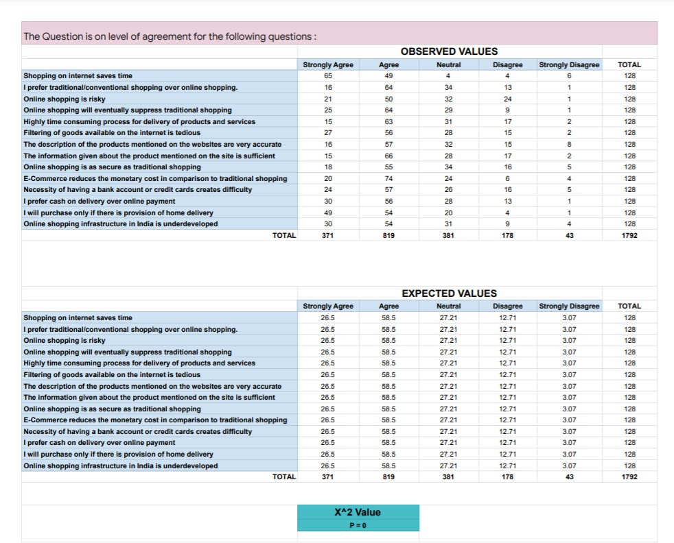

The result of the ‘Pearson Chi-Square’ says that ‘P=0’ indicates a significant relationship between all the variables like Shopping on the Internet saves time, Online Shopping is Risky, etc.

### Anova (analysis of variance)

In stats we mostly want to get information if the mean of two popular people are equal. To answer this, we need to use Anova (analysis of variance). It is a particular type of statistical hypothesis testing mostly used in the analysis of experimental data. In the typical application of Anova (analysis of variance), the Hypothesis which is Null is that all groups are simply random samples of the same population. The wording of Anova (analysis of variance) is the synthesis of different types ideas and it is always used for various purposes and implement it.

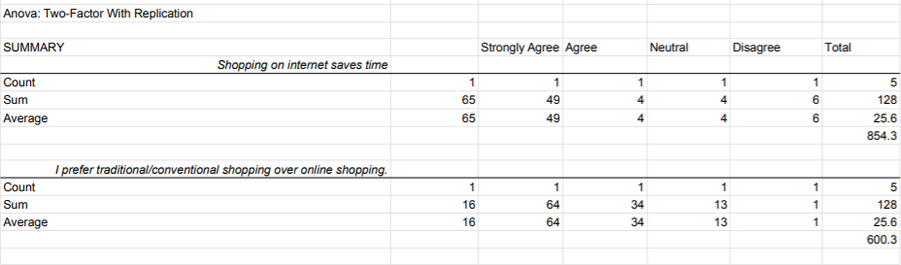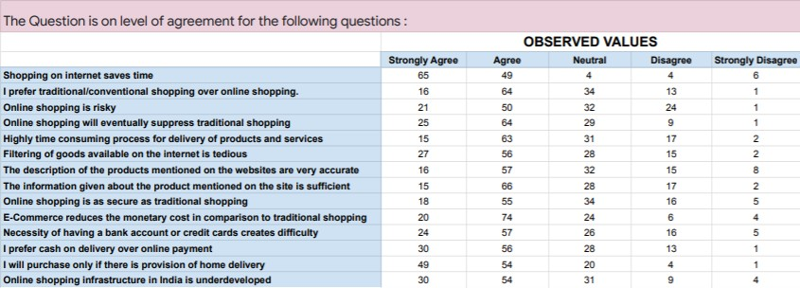

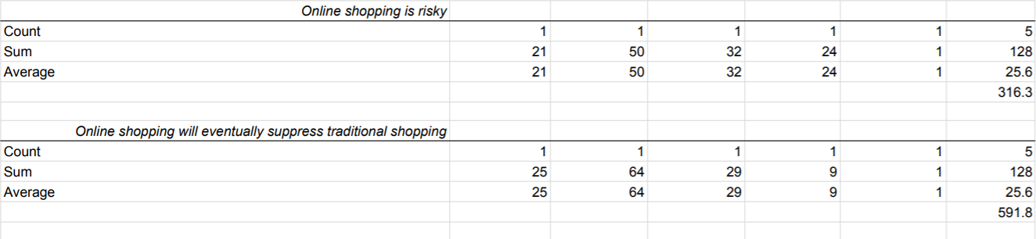

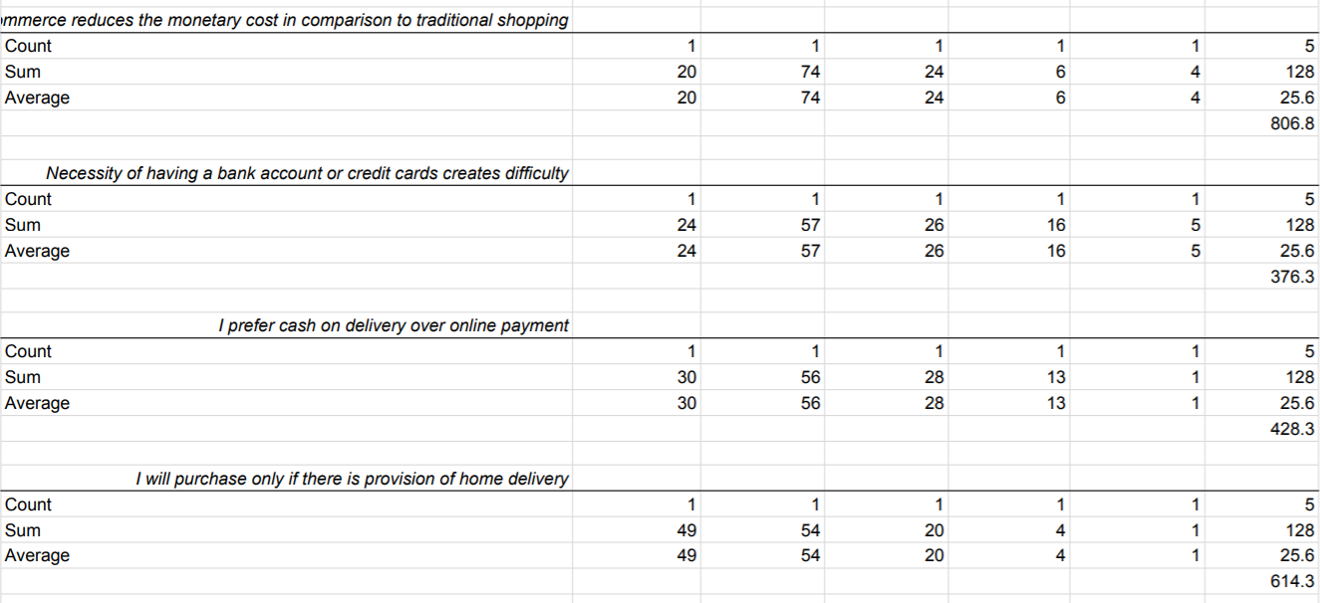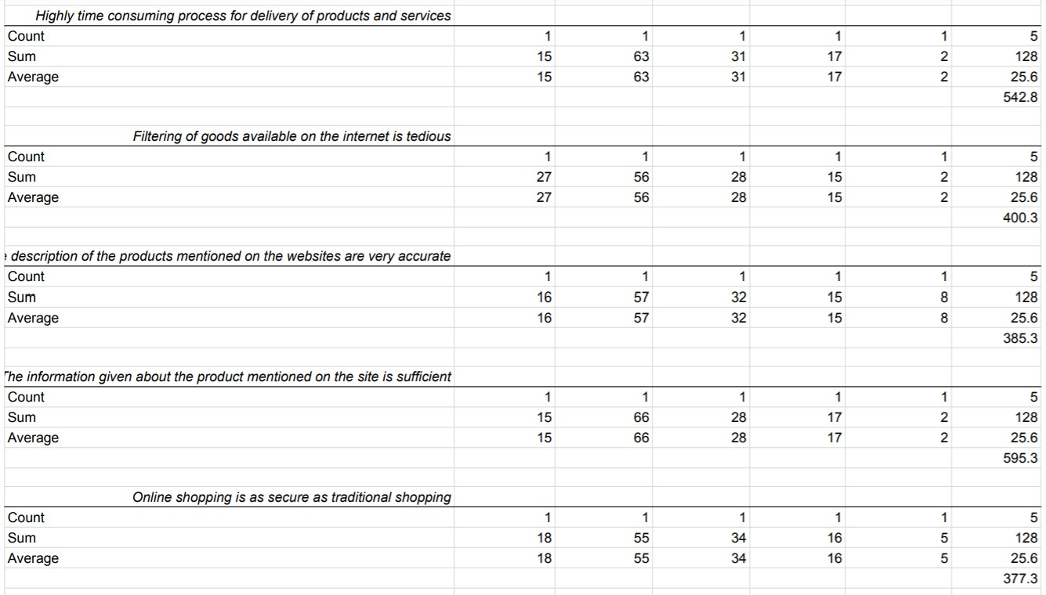

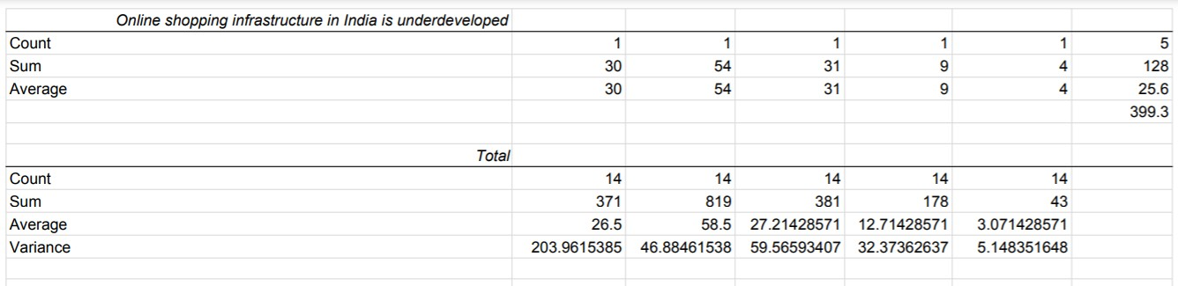

## CHAPTER-4

### DATA ANALYSIS AND INTERPRETATION

***Below are the analysis done during the research study***

### 4.1 age profile

**TABLE 4.1 SHOWING THE RESPONDENT OF AGE**

|  |  |  |
| --- | --- | --- |
| **Particulars** | **No. of Respondents** | **Percentage of Respondents** |
| Below – 20 | 10 | 7.8% |
| 20 -30 | 96 | 75% |
| 30 – 40 | 18 | 14.1% |
| 40 – Above | 04 | 3.1% |
| Total | 128 | 100% |

### CHART 4.1 SHOWS THE AGE OF RESPONDENTS INTERPRETATION

From the above data total Respondents are 128 from which 10 members are Below 20 means 7.8%, 96 members are between 20 -30 means 75%, 18 members are

between 30 – 40 means 14.1%, and 04 members are 40 – Above means 3.1%.

### Inference

Majority of the respondents are between 20-30 years old i.e 75%

### Gender profile

**TABLE 4. 2 SHOWING THE GENDER OF THE RESPONDENT**

|  |  |  |
| --- | --- | --- |
| **Particulars** | **No. of Respondents** | **Percentage of Respondents** |
| Male | 101 | 78.9% |
| Female | 27 | 21.1% |
| Total | 128 | 100% |

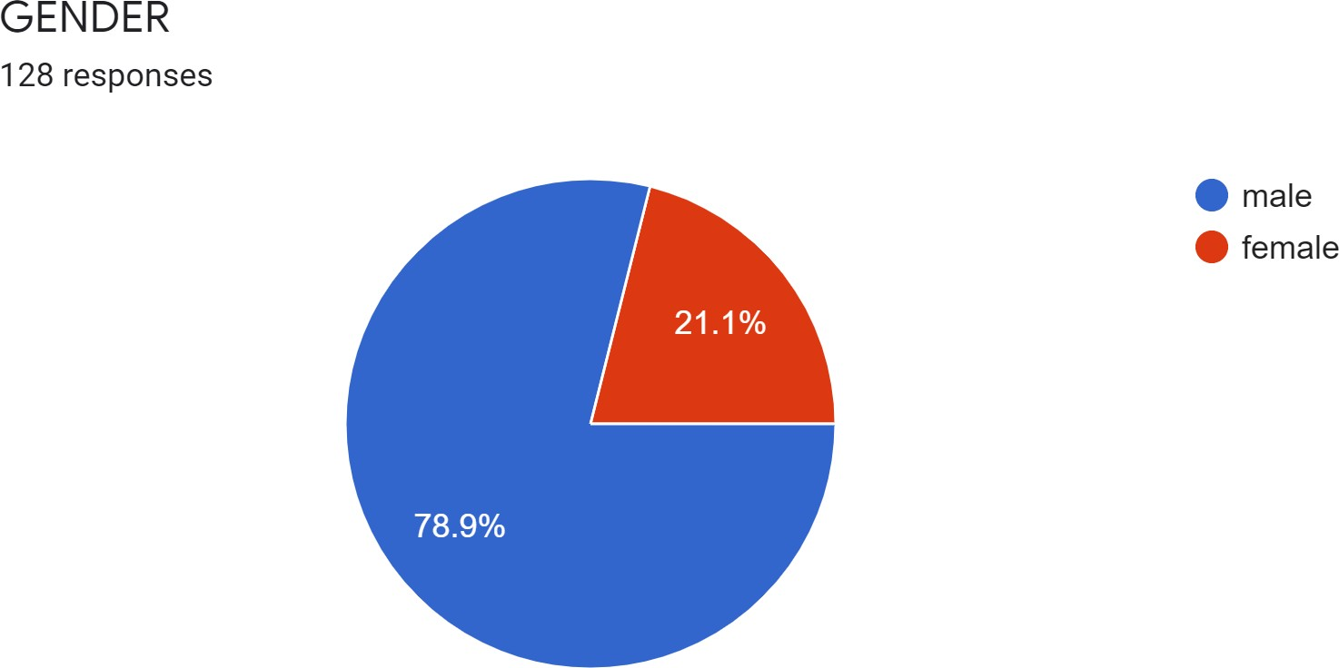

### CHART 4.2 SHOWS GENDER OF THE RESPONDENT INTERPRETATION

From the above data total respondents are 128 from which 78.9% are the respondents are men and the 21.1% are Women.

### Inference

Majority of the respondents are Male i.e 78.9%

### Marital Status

**TABLE 4.3 SHOWING THE MARITAL STATUS OF THE RESPONDENT**

|  |  |  |
| --- | --- | --- |
| **Particulars** | **No. of Respondents** | **Percentage of Respondents** |
| Married | 29 | 22.7% |
| Un Married | 99 | 77.3% |
| Total | 128 | 100% |

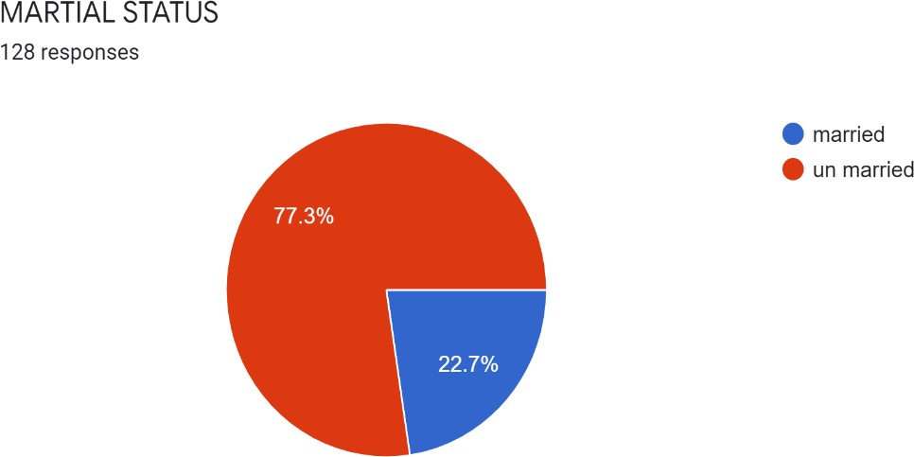

### CHART 4.3 SHOWS MARITAL STATUS OF THE RESPONDENTS INTERPRETATION

From the above data total respondents are 128 from which 77.3% are the Respondents are Married & 22.7% are Un Married

### Inference

Majority of the respondents are Unmarried i.e 77.3%

### Education Qualification profile

**TABLE 4.4 SHOWING THE EDUCATION BACKGROUND OF THE RESPONDENT**

|  |  |  |
| --- | --- | --- |
| **Particulars** | **No. of Respondents** | **Percentage of the Respondents** |
| High School | 06 | 4.7% |
| Undergraduate | 54 | 42.2% |
| Post Graduate | 58 | 45.3% |
| PhD & Above | 06 | 4.7% |
| Other | 04 | 3.1% |
| Total | 128 | 100% |

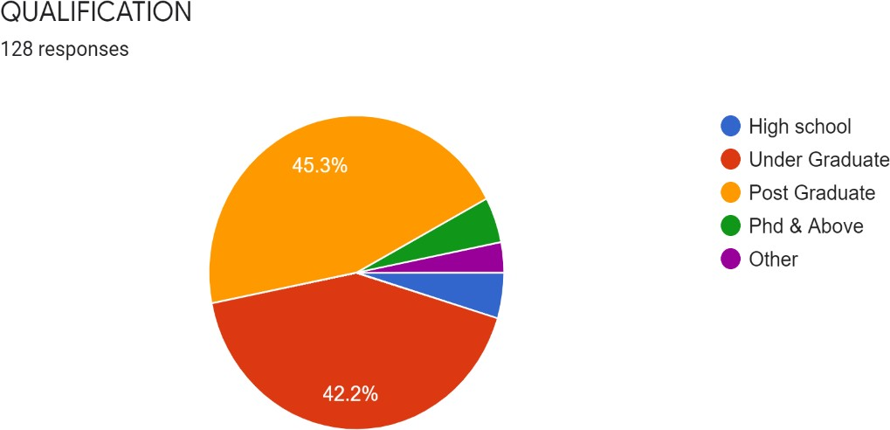

### CHART 4.4 SHOWS THE QUALIFICATION OF THE RESPONDENTS INTERPRETATION

From the above data total Respondents are 128 from which 58 members i.e., 45.3% are Post Graduate, 54 members i.e., 42.2% are Under Graduate, 06 members i.e., 4.7% are High School, also 06 member i.e., 4.7% are PhD & Above and the 04 members i.e., 3.1% are others.

### Inference

Majority of the respondents are Post graduate i.e 45.3%

#### Occupation profile

***TABLE 4.5 SHOWING THE OCCUPATION PROFILE OF THE RESPONDENT***

|  |  |  |
| --- | --- | --- |
| **Particulars** | **No. of Respondents** | **Percentage of Respondents** |
| Employed | 35 | 27.3% |
| Un Employed | 23 | 18% |
| Self Employed | 11 | 8.6% |
| Students | 56 | 43.8% |
| Others | 03 | 2.3% |
| Total | 128 | 100% |

### CHART 4.5 SHOWS THE OCCUPATION OF THE RESPONDENTS INTERPRETATION

From the above data total respondent are 128 from which 35 is Employed i.e., 27.3%,

23 are Un Employed means 18%, 11 members is Self Employed i.e., 8.6%, 56 is Student i.e., 43.8%, and the others 03 i.e., 2.3%.

### Inference

Majority of the respondents are students i.e 43.8%

### Annual Income profile

**TABLE 4.6 SHOWING THE ANNUAL INCOME OF THE RESPONDENT**

|  |  |  |
| --- | --- | --- |
| **Particulars** | **No. of respondents** | **Percentage of Respondents** |
| Bellow – 2,00,000 | 77 | 60.2% |
| 2,00,000 – 4,00,000 | 23 | 18% |
| 4,00,000 – 6,00,000 | 10 | 7.8% |
| 6,00,000 - Above | 18 | 14% |
| Total | 128 | 100% |

### CHART 4.6 SHOWS THE ANNUAL INCOME OF THE RESPONDENTS INTERPRETATION

*I*n the above data total no. of Respondents are 128 from which 77 members are Bellow – 2,00,000 i.e., 60.2 %, 23 are Between 2,00,000 – 4,00,000 i.e., 18%, 10

members are in Between 4,00,000 – 6,00,000 i.e., 7.8%, 18 members are 6,00,000 –

Above i.e., 14%

### Inference

Majority of the respondents are Bellow - 2,00,000 i.e 60.2%

### Have you ever had online shopping Respondents

**TABLE 4.7 SHOWING RESPONDENTS OF ONLINE SHOPPING**

|  |  |  |
| --- | --- | --- |
| **Particulars** | **No. of Respondents** | **Percentage of Respondents** |
| Yes | 126 | 98.4% |
| No | 02 | 1.6% |
| Total | 128 | 100% |

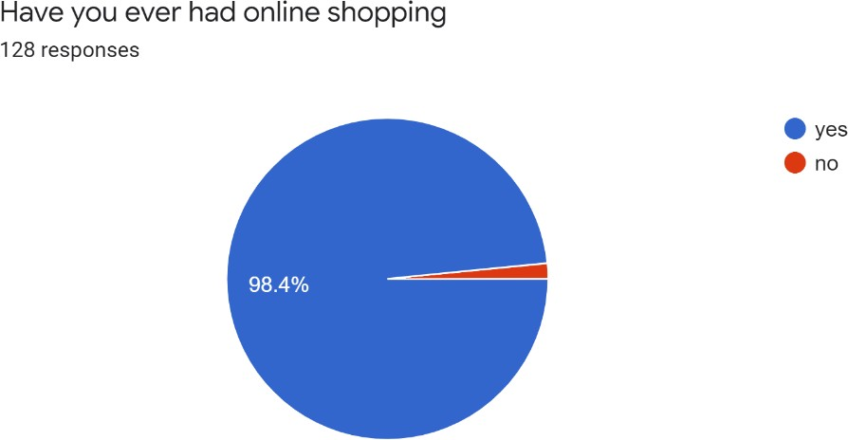

### Chart 4.7 Shows the Respondents of ever had online shopping INTERPRETATION

In the above data total no. of Respondents are 128 in which 126 members are doing online shopping i.e., 98.4% and the 02 members are not doing online shopping i.e., 1.6%

### Inference

Majority of the respondents are doing online shopping i.e 98.4%

### How often you do online shopping

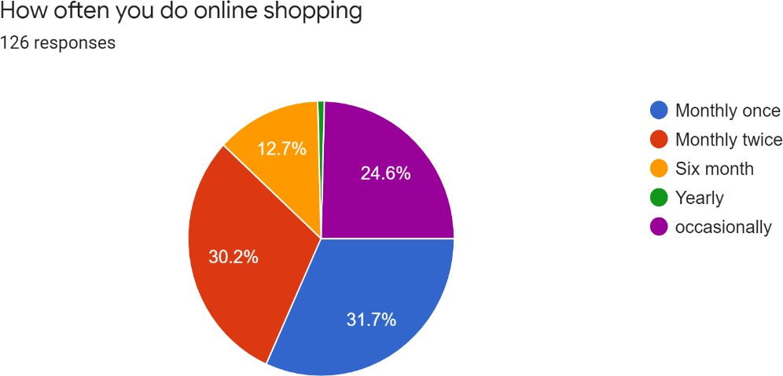**TABLE 4.8 SHOWING RESPONDENTS HOW OFTEN DOES ONLINE SHOPPING**

|  |  |  |
| --- | --- | --- |
| **Particulars** | **No. of Respondents** | **Percentage of Respondents** |
| Monthly Once | 40 | 31.7% |
| Monthly Twice | 38 | 30.2% |
| Six Month | 16 | 12.7% |
| Yearly | 01 | 0.8% |
| Occasionally | 31 | 24.6% |
| Total | 128 | 100% |

### Chart 4.8 Shows the Respondents often do online Shopping INTERPRETATION

*I*n the above data total no. of Respondents are 128 in which 40 members are shopping online in monthly once i.e., 31.7%, 38 members are doing monthly twice i.e., 30.2%, 16 members are doing online shopping in 16 months at once i.e., 12.7%, 01 member are doing yearly i.e., 0.8% and 31 members is doing occasionally i.e., 24.6%.

### Inference

Majority of the respondents are doing online shopping is monthly once i.e 31.7%

### For how long have you been shopping online?

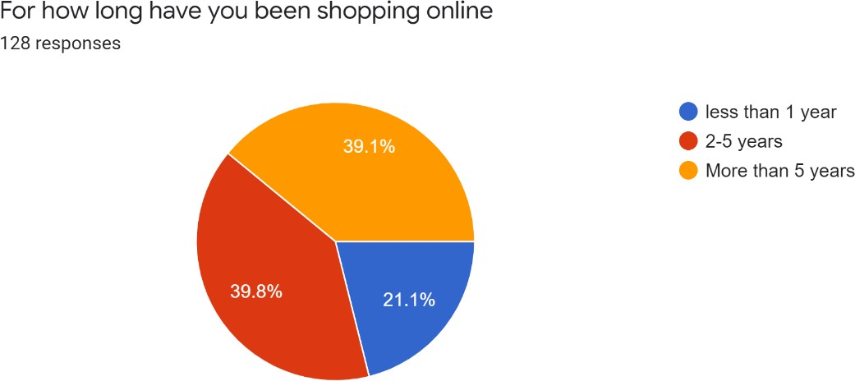**TABLE 4.9 SHOWING HOW LONG RESPONDENT HAVE BEEN SHOPPING ONLINE**

|  |  |  |
| --- | --- | --- |
| **Particulars** | **No. of Respondents** | **Percentage of Respondents** |
| Less than 1 year | 27 | 21.1% |
| 2 – 5 Years | 51 | 39.8% |
| More than 5 Years | 50 | 39.1% |
| Total | 128 | 100% |

### Chart 4.9 Shows the Respondents how long they shopping online INTERPRETATION

In the above data total no. of Respondents are128 in which 27 members are doing online shopping less than 1year i.e., 21%, 51 members are doing online shopping between 2 - 5 years i.e., 39.8%, 50 members are doing online shopping more than 5

years i.e., 39.1%.

### Inference

Majority of the consumer responds that they are doing online shopping for more than 2-5years i.e 39.8%

### The main objective of using online shopping according to you is

**TABLE 4.10 SHOWING MAIN OBJECTIVE OF USING ONLINE SHOPPING**

|  |  |  |
| --- | --- | --- |
| **Particulars** | **No. of Respondents** | **Percentage of Respondents** |
| Price | 28 | 21.9% |
| Convenience & Time  Savings | 71 | 55.5% |
| Fast Shipping | 13 | 10.2% |
| Trust | 04 | 3.1% |
| Brand Conscious | 09 | 07% |
| Friend Referral | 03 | 2.3% |
| Total | 128 | 100% |

### Chart 4.10 Shows the Respondents main objective of using online shopping INTERPRETATION

In the above data total number. of Respondents are 128 in which 28 members are using online shopping due to price i.e., 21.9%, 71 members are doing online shopping due to convenience and time savings i.e., 55.5%, 13 members are doing online shopping due to Fast shipping i.e., 10.2%, 04 members due to trust i.e., 3.1%, 9 members due to brand conscious i.e., 07%, 03 members due to friend referral i.e., 2.3%

### Inference

Majority of the consumer are Respond that they are doing online shopping due to convenience and time savings i.e 55.5%

### Have you ever faced any problem while conducting online shopping

**TABLE 4.11 SHOWING THE RESPONDENTS EVER FACED ANY PROBLEM WHILE CONDUCTING ONLINE SHOPPING.**

|  |  |  |
| --- | --- | --- |
| **Particulars** | **No. of Respondents** | **Percentage of Respondents** |
| Yes | 82 | 64.1% |
| No | 46 | 35.9% |
| Total | 128 | 100% |

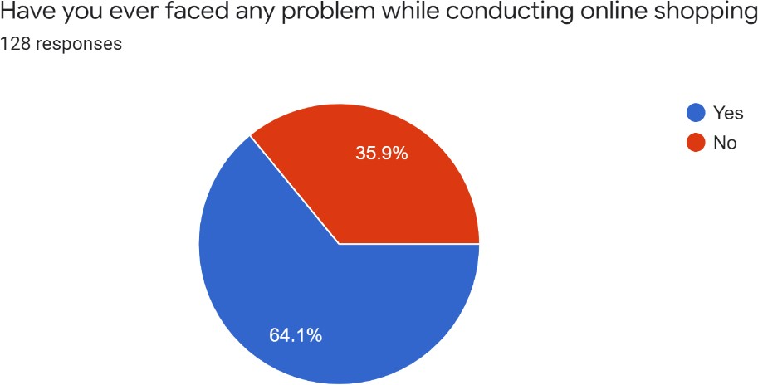

### Chart 4.11 Shows the Respondents ever faced any problem while conducting online shopping.

**INTERPRETATION**

In the above data total number of members are 128 in which 82 members are faced problem while conducting online shopping i.e., 64.1%, and 46 members are not facing any problem while conducting online shopping i.e., 35.9%, According to my Response

### Inference

Majority of the consumer are respondents that they facing the problem while they are doing online shopping i.e 64.1%

### If Yes, What kind of Problem

**TABLE 4.12 SHOWING THE RESPONDENTS WHAT KIND OF PROBLEM THEY FACED**

|  |  |  |
| --- | --- | --- |
| **Particulars** | **No. of Respondents** | **Percentage of Respondents** |
| Delay in Deliver | 19 | 14.8% |
| Cheap Quality of Product | 57 | 44.5% |
| Product Damage | 16 | 12.5% |
| Non-Delivery | 04 | 3.1% |
| Other | 32 | 25% |
| Total | 128 | 100% |

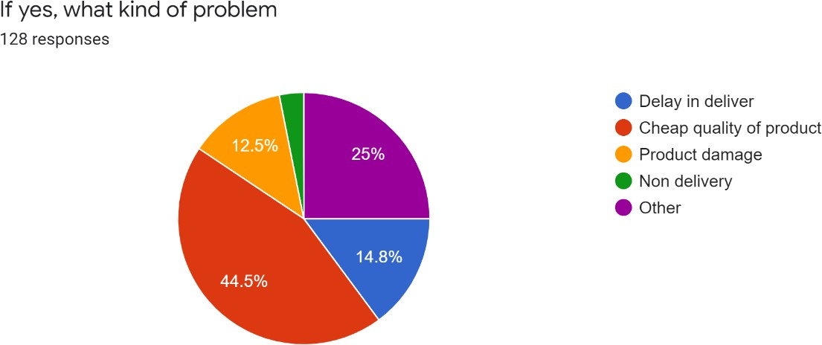

### Chart 4.12 Shows the Respondents what kind of problem they faced INTERPRETATION

In the above data total number of members are 128 in which 19 members are facing problem in delay in deliver i.e., 14.8%, 57 members are facing problem in cheap quality of product i.e., 44.5%, 16 members are facing problem in product damage i.e., 12.5%, 04 members are facing problem in Non-Delivery i.e., 3.1% 32 members are facing other type of problem i.e., 25%.

### Inference

Majority of the consumer shows their respondents that what they facing the problem the cheap quality of product i.e 44.5%

### How Often do you use Internet Everyday

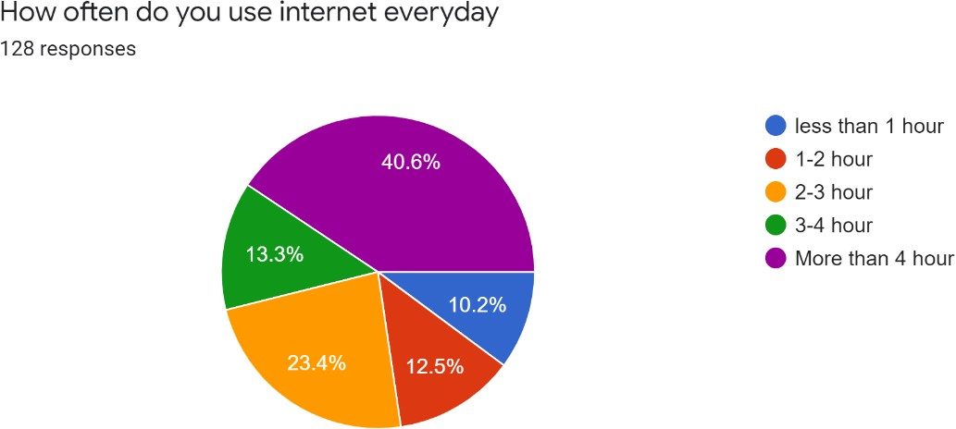**TABLE 4.13 SHOWS THE RESPONDENTS HOW OFTEN DO USE INTERNET EVERYDAY**

|  |  |  |
| --- | --- | --- |
| **Particulars** | **No of Respondents** | **Percentage of Respondents** |
| Less than 1 hr. | 13 | 10.2% |
| 1 – 2 hr. | 16 | 12.5% |
| 2 – 3 hr. | 30 | 23.4% |
| 3 – 4 hr. | 17 | 13.3% |
| More than 4 hr. | 52 | 40.6% |
| Total | 128 | 100% |

### Chart 4.13 Shows the Respondents how often do use internet everyday INTERPRETATION

In the above data total number. of members are 128 in which 13 members are using the internet less than 1 year i.e., 10.2%, 16 members are using the internet 1 – 2hr. i.e., 12.5% 30 members are using the internet daily 2 – 3hr. i.e23.4%, 17 members are using the internet daily 3 – 4hr. and 52 members are using the internet daily more than 4 hr. i.e., 40.6%

### Inference

Majority of the consumers show the respondents that they often use the internet more than 4hrs. In a day i.e 40.6%

### How would you Describe your Internet Proficiency

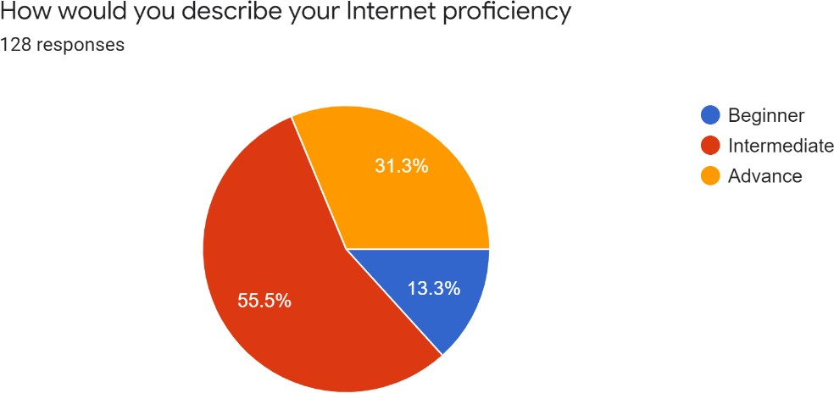**TABLE 4.14 SHOWING THE RESPONDENTS WOULD DESCRIBE INTERNET PROFICIENCY**

|  |  |  |
| --- | --- | --- |
| **Particulars** | **No. of Respondents** | **Percentage of Respondents** |
| Beginner | 17 | 13.3% |
| Intermediate | 71 | 55.5% |
| Advance | 40 | 31.3% |
| Total | 128 | 100% |

### Chart 4.14 Shows the Respondents would describe internet proficiency INTERPRETATION

In the above data total number. of member are 128 in which 17 are beginners in his internet proficiency i.e., 13.3%, 71 members are Intermediate to using internet proficiency i.e., 55.5%, 40 members are advanced to using Internet proficiency i.e., 31.3%,

### Inference

Majority of the members shows that they are intermediate to describe the internet proficiency i.e 55.5%

### How often do you use Internet for Shopping

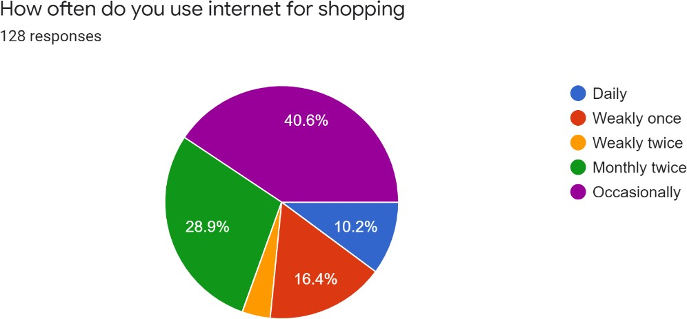**TABLE 4.15 SHOWING THE RESPONDENTS HOW OFTEN USE INTERNET FOR SHOPPING**

|  |  |  |
| --- | --- | --- |
| **Particulars** | **No. of Respondents** | **Percentage of Respondents** |
| Daily | 13 | 10.2% |
| Weakly Once | 21 | 16.4% |
| Weakly Twice | 05 | 3.9% |
| Monthly Twice | 37 | 28.9% |
| Occasionally | 52 | 40.6% |
| Total | 128 | 100% |

### Chart 4.15 Shows the Respondents how often use internet for shopping INTERPRETATION

In the above data total number. of members are 128 in which 13 members use internet daily for online shopping i.e., 10.2%, 21 members use weakly once internet for shopping i.e., 16.4%, 5 members use internet for online shopping weakly twice i.e., 3.9%, 37 members are using internet for online shopping monthly twice i.e., 28.9%, 52 members use internet for online shopping Occasionally i.e., 40.6%.

### Inference

Majority of consumer shows the respondents to often use internet for shopping is occasionally i.e 40.6%

### How much do you think you Involved in the decision-making Process for buying any product at your family level

**TABLE 4.16 SHOWING THE RESPONDENTS HOW MUCH INVOLVED IN THE DECISION MAKING PROCESS FOR BUYING ANY PRODUCT AT HIS FAMILY LEVEL**

|  |  |  |
| --- | --- | --- |
| **Particulars** | **No. of Respondents** | **Percentage of Respondents** |
| Completely | 26 | 20.3% |
| To a great Extent | 42 | 32.8% |
| To moderate Extent | 47 | 36.7% |
| Never | 13 | 10.2% |
| Total | 128 | 100% |

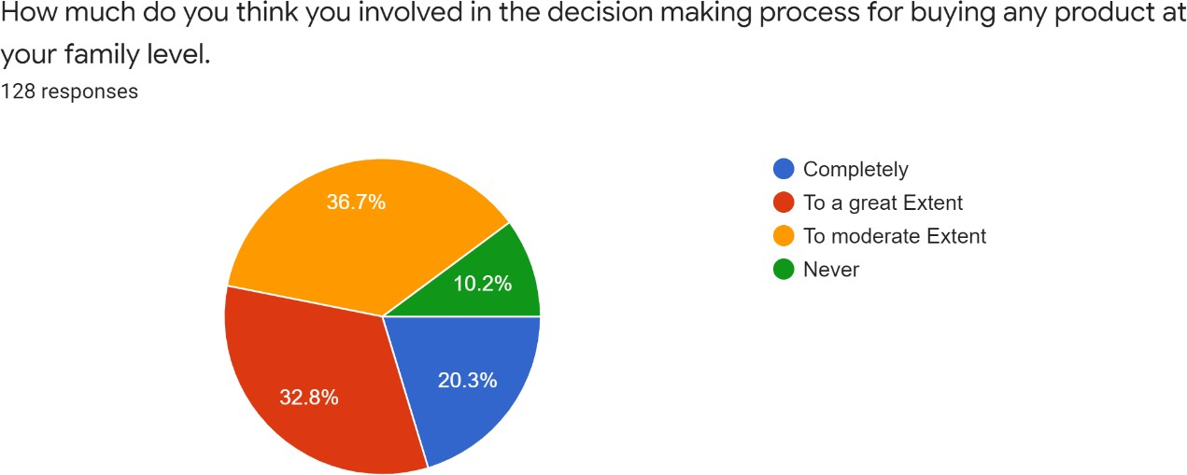

### Chart 4.16 shows the respondents how much involved in the decision making process for buying any product at his family level

**INTERPRETATION**

In the above data the total v. of members who gave the Response is 128 in which 26 members have completely decision-making process for buying any product at his family level i.e., 20.3%. 42 members have a great extent for decision making process for buying any product at his family level i.e., 32.8%, 47 members have to moderate extent in the decision-making process for buying any product at his family level i.e., 36.7% 13 members who have never involved in the decision-making process for buying any product at his family level i.e., 10.2%.

**Inference** Majority of the members respondents how much involved in the decision making process for buying any product at his family level to moderate extent i.e 36.7%

### If you never had online shopping please specify the reason

**TABLE 4.17 SHOWING THE RESPONDENTS EVER HAD ONLINE SHOPPING**

|  |  |  |
| --- | --- | --- |
| **Particulars** | **No. of Respondents** | **Percentage of Respondents** |
| I don’t know about online shopping | 04 | 3.1% |
| Risk of credit card  transaction | 33 | 25.8% |
| Internet literacy | 12 | 9.4% |
| Risk of identity theft | 10 | 7.8% |
| Other reason | 69 | 53.9% |
| Total | 128 | 100% |

### Chart 4.17 Shows the Respondents ever had online shopping INTERPRETATION

In the above data total number. of respondents, I have 128 in which 04 members who don’t know about online shopping i.e., 3.1%. 33 members have getting risk of credit card transaction while doing online shopping i.e., 25.8%, 12 members have internet literacy for online shopping i.e., 9.4%, 10 members who never had online shopping due to risk of identity theft i.e., 7.8%, 69 members never had online shopping due to other reasons i.e., 53.9%.

### Inference

Majority of the members Shows the Respondents ever had online shopping for other reason i.e 53.9%

### How often you rely on information available on social media if you have uncertainties regarding a purchase.

**TABLE 4.18 SHOWING THE RESPONDENTS RELY ON INFORMATION AVAILABLE ON SOCIAL MEDIA IF THEY HAVE UNCERTAINTIES REGARDING A PURCHASE**

|  |  |  |
| --- | --- | --- |
| **Particulars** | **No. of Respondents** | **Percentage of Respondents** |
| Always | 13 | 10.2% |
| Often | 26 | 20.3% |
| Sometimes | 48 | 37.5% |
| Seldom | 16 | 12.5% |
| Rarely | 09 | 07% |
| Never | 16 | 12.5% |
| Total | 128 | 100% |

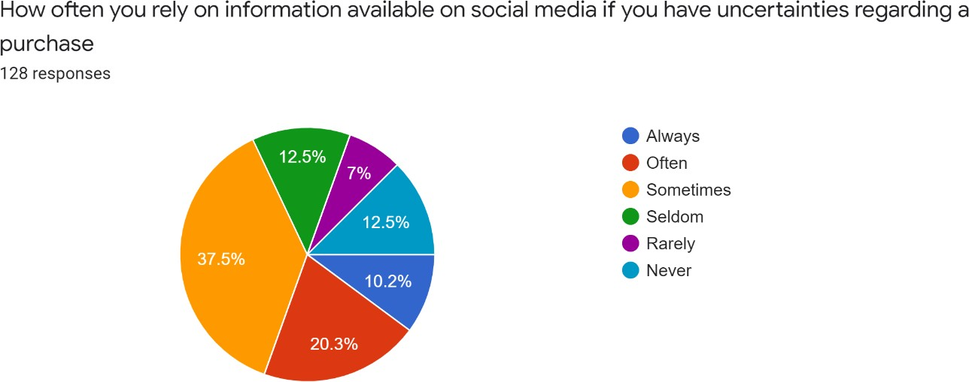

### Chart 4.18 Shows the respondents rely on information available on social media if they have uncertainties regarding a purchase

**INTERPRETATION**

In the above data total no. of Respondents, I have is 128 in which 13 members always who often rely on information available on social media if he has any uncertainties regarding a purchase i.e., 10.2%, 26 members often who rely on information available on social media i.e., 20.3%, 48 members sometimes who get relay information on social media if he gets any uncertainties regarding a purchase i.e.,37.5%, 16 members seldom who rely on information available on social media i.e., 12.5%, 9 members rarely who get information available on social media i.e., 7%, 16 members who get never any information on social media if he have uncertainties regarding a purchase i.e., 12.5%.

### Have you changed your initial purchase preference after searching relevant information via social media sites?

**TABLE 4.19 SHOWING THE RESPONDENTS CHANGE THEIR INITIAL PREFERENCE AFTER SEARCHING RELEVANT INFORMATION VIA SOCIAL MEDIA SITES**

|  |  |  |
| --- | --- | --- |
| **Particulars** | **No. of Respondents** | **Percentage of Respondents** |
| Always | 12 | 9.4% |
| Often | 23 | 18% |
| Sometimes | 61 | 47.7% |
| Seldom | 05 | 3.9% |
| Rarely | 12 | 9.4% |
| Never | 15 | 11.7% |
| Total | 128 | 100% |

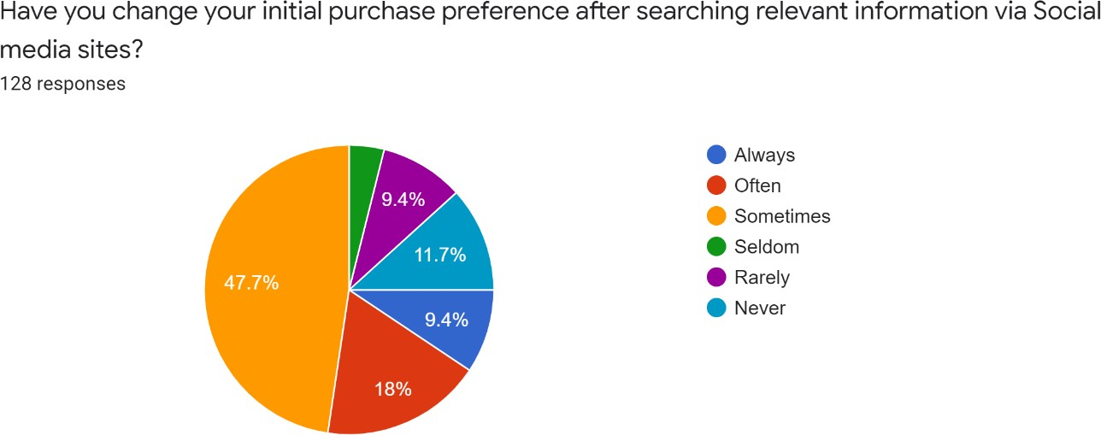

### Chart 4.19 Shows the respondents change their initial preference after searching relevant information via social media sites

**INTERPRETATION**

In the above data total number of respondents, which I collect is 128 in which 12 members always change his initial purchase preference after searching relevant information via social media sites i.e., 9.4%, 23 members often change his decision i.e., 18%, 61 members sometimes change his decision i.e., 47.7%, 5 members seldom change his decision while purchasing i.e. 3.9%, 12 members rarely change his decision while purchasing i.e., 9.4%, 15 members who never change his decision while purchasing i.e., 11.7%.

**Inference** Majority of the members are showing sometimes they change their initial after searching relevant information via social media sites i.e 47.7%

### Advertisements / Reviews / Blog posts etc. have higher credibility than Advertisements / Editorials / other marketing means on mass media?

**TABLE 4.20 SHOWING THE RESPONDENTS HAVE HIGHER CREDIBILITY THAN ADVERTISEMENTS / EDITORIALS / OTHER MAKING MEANS ON MASS MEDIA**

|  |  |  |
| --- | --- | --- |
| **Particulars** | **No. of Respondents** | **Percentage of Respondents** |
| Strongly Agree | 35 | 27.3% |
| Agree | 58 | 45.3% |
| Neutral | 26 | 20.3% |
| Disagree | 04 | 3.1% |
| Strongly Disagree | 05 | 3.9% |
| Total | 128 | 100% |

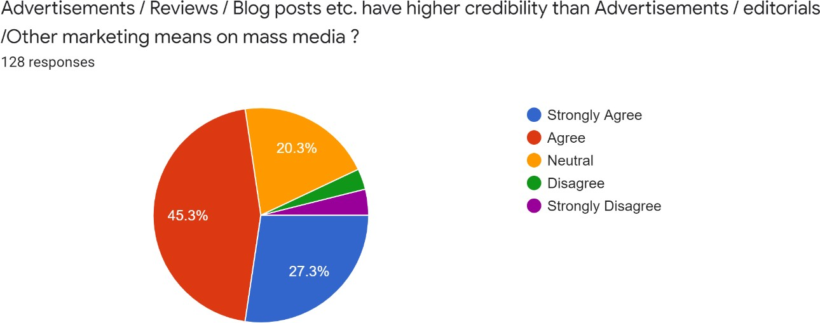

### Chart 4.20 Shows the Respondents have higher credibility than Advertisements / editorials / other marketing means on mass media

**INTERPRETATION**

In the above data total number of respondents which I collect is 128 in which 35 consumers strongly agree that Advertisements / Reviews / Blog posts etc. have higher credibility than Advertisements / Editorials / other marketing means i.e., 27.3%, 58 members get agree with this i.e., 45.3%, 26 members are neutral on this statement i.e., 20.3%, 4 members are getting disagree with this statement i.e., 3.1% and 5 members are getting strongly opposed i.e., 3.9%.

### Inference

Majority of members are agree to show the Respondents have higher credibility than Advertisements / editorials / other marketing means on mass media i.e 45.3%

### Which according to you have highest media potential

**TABLE 4.21 SHOWS THE RESPONDENTS HAVE HIGHEST MEDIA POTENTIAL**

|  |  |  |
| --- | --- | --- |
| **Particulars** | **No. of Respondents** | **Percentage of Respondents** |
| Social media | 101 | 78.9% |
| Print media | 09 | 07% |
| Television ads | 11 | 8.6% |
| Radio | 00 | 00% |
| In person media | 07 | 5.5% |
| Total | 128 | 100% |

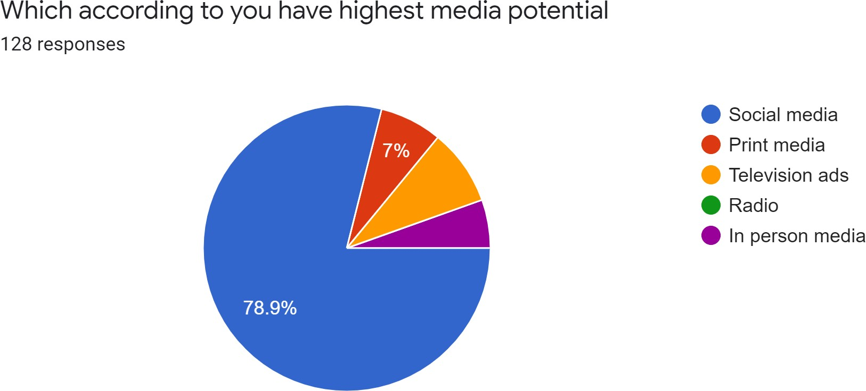

### Chart 4.21 Shows the Respondents have highest media potential INTERPRETATION

In the above data total number of responds which I collect is 128 in which 101 members are getting privilege to social media to get highest media potential i.e., 78.9%, 9 members giving to print media highest media potential i.e., 7%, 11 members giving in the favour of television media to highest media potential i.e., 8.6%, no one getting respond on radio and 7 members getting respond in person media i.e.,5.5%.

### Inference

Majority of the members are getting responds that social media have highest media potential i.e 78.9%

# CHAPTER-5 FINDINGS,SUGGESTIONS AND CONCLUSION

### **Findings**

I find that 93% of all marketers indicated that their social media efforts have generated more exposure to their business, increased traffic was the second major benefit, with 87% reporting positive results.

❏ Majority of the respondents are between 20-30 years old i.e 75%

❏ Majority of the respondents are Male i.e 78.9%

❏ Majority of the respondents are Unmarried i.e 77.3%

❏ Majority of the respondents are Post graduate i.e 45.3%

❏ Majority of the respondents are students i.e 43.8%

❏ Majority of the respondents are Bellow - 2,00,000 i.e 60.2%

❏ Majority of the respondents are doing online shopping i.e 98.4%

❏ Majority of the respondents are doing online shopping is monthly once i.e 31.7%

❏ Majority of the consumer responds that they are doing online shopping for more than 2-5years i.e 39.8%

❏ Majority of the consumer are Respond that they are doing online shopping due to convenience and time savings i.e 55.5%

❏ Majority of the consumer are respondents that they facing the problem while they are doing online shopping i.e 64.1%

❏ Majority of the consumer shows their respondents that what they facing the problem the cheap quality of product i.e 44.5%

❏ Majority of the consumers show the respondents that they often use the internet more than 4hrs. In a day i.e 40.6%

❏ Majority of the members shows that they are intermediate to describe the internet proficiency i.e 55.5%

❏ Majority of consumer shows the respondents to often use internet for shopping is occasionally i.e 40.6%

❏ Majority of the members respondents how much involved in the decision making process for buying any product at his family level to moderate extent i.e 36.7%

❏ Majority of the members Shows the Respondents ever had online shopping for other reason i.e 53.9%

❏ Majority of the member responds that they sometimes rely on information available on social media if they have uncertainties regarding a purchase i.e 37.5%

❏ Majority of the members are showing sometimes they change their initial after searching relevant information via social media sites i.e 47.7%

❏ Majority of members are agree to show the Respondents have higher credibility than Advertisements / editorials / other marketing means on mass media i.e 45.3%

❏ Majority of the members are getting responds that social media have highest media potential i.e 78.9%

### **Suggestion**

Social media is an essential piece of your business marketing strategy. Social platforms help you connect with your customers, increase awareness about your brand and boost your leads and sales. 52% of social media marketers believe social media positively influences their companies revenue and sales.

❏ Identify the right social media channel

❏ Make the most of live videos

❏ Create your brand story

❏ Leverage user-Generated content

❏ Use social friendly images

❏ Use instagram for posting ads

❏ Use relevant Hashtags

❏ Utilize the power of employee advocacy

❏ Get your timing right

### **CONCLUSION**

Social media is creating a great influence on the business all around the globe. From creating a clear image of their brands by sharing their pages on social platforms. Social media also suggests the customer liked products through various Data Analytics and Data Science technology. People follow brand pages on social media to get notification. Social media is not an option but a necessity of modern business. Hence, the new social media marketing creates a lot of opportunities for new businesses and challenges to get customer space. And Social Media is occupying or shifting the traditional way of marketing to Digital advertisements of businesses and their products.

### **REFERENCES**

1. Achille s. j. (2008). world statistics on the Number of Internet Shoppers [Online].USA:SanteAchille Available:

<http://blog.webcertain.com/worldstatistics-on-the-number-ofinternet>shoppers.

1. Aldo Syarief, and Genoveva, (2015),The Analysis of Communication between Friends on Social Media towards Purchase Intention (A Study Case of Companies in Entrepreneurship Project of President University, Bekasi, Indonesia), Procedia - Social and Behavioral Sciences, Vol. 169, , pp. 31-42, ISSN number 1877-0428
2. Anthony Miles, D. (2014) "Social Media and Consumer Behavior: A Marketing Study On Using Structural Equation Modeling for Measuring the Social Media Influence On Consumer Behavior.", Academy of Business Research Conference, pp. 43-72
3. AsadRehman. and Sharma, S., (2012). Assessing the Impact of Web 2.0 on Consumer Purchase Decisions: Indian Perspective. International Journal of Marketing and Technology, vol. 2(7), pp.125-139.
4. Azhar Ahmad Nima Barhemmati (2015), “Effects of Social Network Marketing (SNM) on Consumer Purchase Behavior through Customer Engagement ”, Journal of Advanced Management Science Volume. 3, Number. 4, pp. 307-311
5. Bayazit Ates Hayta (2013), “A study on the of effects of social media on young consumers' buying behaviors”, European Journal of Research on Education, ISSN Number: 2147-6284 , Main Issue: Human Resource Management, Page.Number 65-74
6. Belch, M.A. Belch, G.E. and Belch, (2003) Advertising and promotion : an integrated marketing communications perspective”, sixth edition Berkshire, England: McGraw Hill.
7. Berland Associates LLC and Penn Schoen .(2010), “A more social future: New research on how the growth of social media will impact consumer electronics,” Jan 2010.
8. Bhatt, M and Bagga, T. (2013). A Study of Intrinsic and Extrinsic Factors Influencing Consumer Buying Behaviour online. Asia pacific Journal of Management Research and Innovation, 9 (1), pp.77-90. Xvii
9. Birol Topcu and Erkan Akar (2011) ,“An examination of the factors influencing consumer‟s attitudes towards social media marketing”, Journal of Internet Commerce, Routledge Informa Ltd, pp. 35-67, Vol. 10, Iss. 1.
10. Brengman, M and Karimov, F.,. (2011). "The Role of Online Social Media Applications in Initial Trust Formation Towards Unknown ERetailers." Multi Conference on Computer Science and Information Systems, PP : 73

.

1. Charita Jashi Nugzar Todua, (2015) , Some Aspects of Social Media Marketing (Georgian Case), International Journal of Social, Behavioral, Educational, Economic and Management Engineering, ISSN (Print): 1307 6892 Volume:9, No:4, pp 1165-1168
2. Charles-Henri Gros, .(2012) The influence of social media on consumers during their purchase decision-making process and the implications for marketer., Dissertation submitted to Dublin Business School.
3. Chiahui Yu Yichuan Wang, (2015),Social interaction-based consumer decision-making model in social commerce: The role of word of mouth and observational learning, International Journal of Information Management, ISSN number 0268-4012.
4. Cothrell, J., and Williams, L., (2000). four smart ways to run online communities”, Sloan Management Review, 4 (1), pp.81-91
5. Cvijikj Irena Pletikosa (2010), “Influence of Facebook on Purchase Decision Making,” paper presented at 8th International Conference on Pervasive Computing, Helsinki, Finland.
6. D.J. Hoyer, W.D. and MacInnis, (2010) Consumer behavior”, 5th ed. London: South-Western Cengage Learning.
7. DEI Worldwide OTX Research (2008), “The Impact of Social Media on Purchasing Behavior,” USA,.
8. Dr.K.V.A Balaji Bidyanand Jha, (2015) , Social Media Communication and Purchase Intention: Learning style as moderating variable, Research Journal of Social Science & Management-, ISSN Number : 2251-1571 ,Vol: 05, Number: 2, June 2015, PP- 59-74.
9. E. Lee, (2013). Impacts of social media on consumer behavior: decision making process., Bachelor's Thesis Turku University Of Applied Sciences xviii International Business Bachelor of Business Administration May 2013 pp.77 pages
10. Edison, (2011). The Social Habit 2011”, taken from <http://www.edisonresearch.com-home/archives/2011/>05/the_social_habit_2011.php
11. Fotis John , (2010) “The Impact of Social Media on Consumer Behaviour. Focus on Leisure Tourism Services'', Ph.D. diss., School of Tourism, Bournemouth University, UK.
12. Geetanjali Naidu and Sunil Agrawal ( 2013), “A Study on Impact of Social Media in Buying Behavior of Consumer/Customer with Special Reference To Raipur city “, Journal of Harmonized Research in Applied Sciences, ISSN number 2321 – 7456 , Vol. I , Issue 3, 2013, pp.98-101
13. Girish Ramani, Alok R. Saboo, V. Kumar, , Evaluating the impact of social media activities on human brand sales, International Journal of Research in Marketing, Available online 10 April (2015), ISSN Number 0167-8116.
14. Greenleigh, Ian. (2012), “Talking to strangers. How social influences millennials shopping decisions”, Retrieved from <http://www.bazaarvoice.com/blog/> 2012/01/24/infographic millennials will change-the way-you-sell/
15. Gupta Garima, (2013), “Assessing the Influence of Social Media on Consumer‟s Purchase Intentions”, Asia-Pacific Marketing Review, Asia Pacific Institute of Management, pp.31-39, Volume .2 , Issue No. 1.
16. Gupta, S Iyengar, R. Sangman, H S.(2012). Do Friends Influence Purchases in a Social Network, Harvard Business School Working Paper, Online: <http://www.hbs.edu/> research /09-123.pdf
17. Gürsakal, N. (2009), Social Network Analysis , Dora Publishing. Bursa
18. H. Choubtarash Dehghani, Milad, and Salber Nourani.(2013) "The impact of information cascade on consumer‟s decision making in the frame of brand image within social media." , Marketing and Innovation Management 3 : pp.69-75.
19. Haciefendioğl of Senol (2011) . "Social networking sites as an advertising and research environment. " Knowledge Economy and Management Journal six .
20. Hafsa Mateen Saadia Nasir , and Dr. Prakash Vel, (2012), Social Media and Buying Behavior of Women in Pakistan toward Purchase of Textile Garments”, Business Management Dynamics Volume number.2, No.2, Aug 2012, pp.61-69
21. Hajli Nick (2015) Social commerce constructs and consumer's intention to buy, International Journal of Information Management, Vol. 35, Issue 2, pp. 183-191, ISSN number 0268-4012,
22. Han, S. L. and Noreen, T.. (2015). Exploratory Study of the Impact of Social Media Marketing on Consumer Purchase Intention. Asia marketing journal, 17(3), 53-72.
23. Harshini CS (2015), “Influence of Social Media Ads on Consumer‟s Purchase Intention”, International Journal of Current Engineering And Scientific Research, ISSN (print): 2393-8374, (online): 2394-0697, Vol.-2, Issue-10, 2015 pp 110-115
24. Hennig-Thurau, T Vor dem Esche, J., (2013). German Social Media Consumer Report 2012-2013. Social Media Think: Lab.
25. Ismael, S and Al-Dhuhli, I., (2013). The Impact of Social Media on Consumer Buying Behaviour, Thesis submitted to College of Economics and Political Science, Sultan qaboos University Special topics in Information Systems.
26. Ivona Stoica, Elisabeta Ioanas ( 2014), Social Media and its Impact on Consumers Behavior, International Journal of Economic Practices and Theories, Vol. 4, No. 2, 2014, Special issue on Marketing and Business Development, e-ISSN Number 2247–7225, pp.- 295-303
27. Jure Leskovec, Guo, Stephen, Mengqiu Wang, .(2011) "The role of social networks in online shopping: information passing, price of trust, and consumer choice." , Proceedings of the 12th ACM conference on Electronic commerce. ACM.
28. Kawalek, P Diffley, S., and Kearns, J., Bennett, W., (2011). Consumer behavior in social networking sites: Implications for marketers. Irish Journal of Management, 30(2), pp.47.
29. Khan, M. I. Rehmani, M., (2011). The impact of E-media on customer purchase intention”, International journal of advanced computer science and applications, vol. 2(3).
30. Vargo, S.L. and Lusch, R.F., 2004. Evolving to a New Dominant Logic for Marketing. Journal of Marketing, 68, pp.1-17.
31. Vollmer, C. and Precourt, G., 2008. Always on: advertising, marketing and media in an era of consumer control. United States of America: McGraw-Hill Professional.
32. Williams, J. and Curtis, T., 2006. Marketing Management in Practice. Elsevier Science & Technology.
33. Windham, L. and Orton, K., 2000. The soul of the new consumer. Skyhorse Publishing
34. Woerndl, M. Papagiannidis, S. Bourlakis, M. and Li, F., 2008. Internet-induced marketing techniques: Critical factors in viral marketing campaigns. International Journal of Business Science and Applied Management, 3(1), pp.34-45.
35. Wollen, R. Smith, N. and Zhou, C., 2011. The Social Media Management Handbook: Everything You Need to Know to Get Social Media Working in Your Business. New Jersey: John Wiley and Sons.
36. Wood, L., 2000. Brands and brand equity: definition and management. Management Decision, 38(9), pp.662-669.

### **APPENDIX I (QUESTIONNAIRE) QUESTIONNAIRE**

**Personal Profile**

1. Name.
2. Age.

(a) Below – 20 (b) 20 – 30

(c) 30 – 40 (d) 40 – Above

1. Gender.
   1. Male (b) Female
2. Marital Status.
   1. Married (b) Un Married
3. Qualification.
   1. High School (b) Undergraduate

(c) Post Graduate (d) PHD & Above

(e) Other

1. Occupation.
   1. Employed (b) Un Employed

(c) Self Employed (d) Student

(e) Other

1. Annual Income.

(a) Bellow – 2,00,000 (b) 2,00,000 – 4,00,000

(c) 4,00,000 – 6,00,000 (d) 6,00,000 – Above

1. Have you ever had online shopping?
   1. yes (b) no
2. How often you do online shopping.
   1. Monthly Once (b) Monthly twice

(c) Six Month (d) Yearly

(e) Occasionally

1. For how long have you been shopping online?
   1. Less than one year (b) 2 – 5 years

(c) More than 5 years

1. The main objective of using online shopping according to you is.
   1. Price (b) Convenience & Time savings

(c) Fast shipping (d) Trust

(e) Brand conscious (f) Friend referral

1. Have you ever faced any problem while conducting online shopping?
   1. Yes (b) No
2. If yes, what kind of problem
   1. Delay in deliver (b) Cheap quality of product

(c) Product damage (d) Non delivery

(e) Other

1. How often do you use internet everyday
   1. Less than – 1 hr. (b) 1 – 2 hr.

(c) 2 - 3 hr. (d) 3 – 4 hr.

(e) 4 – more than

1. How would you describe your internet proficiency
   1. Beginner (b) Intermediate

(c) Advance

1. How often do you use internet for shopping
   1. Daily (b) Weakly once

(c) Weakly twice (d) Monthly twice

(e) Occasionally

1. How much do you think you involved in the decision-making process for buying any product at your family level
   1. Completely (b) To a great extent

(c) To moderate extent (d) Never

1. If you never had online shopping please specify the reason.
   1. I don’t know about online shopping
   2. Risk of credit card transactions
   3. Internet literacy
   4. Risk of identity theft
   5. Other reasons
2. How often you rely on information available on social media if you have uncertainties regarding a purchase.
   1. Always (b) Often

(c) Sometimes (d) Seldom

(e) Rarely (e) Never

1. Have you changed your initial purchase preference after searching relevant information via social media sites?
   1. Always (b) Often

(c) Sometimes (d) Seldom

(e) Rarely (f) Never

1. Advertisements / Reviews / Blog Posts etc. have higher credibility than Advertisements / Editorials / other marketing means on mass media?
   1. Strongly Agree (b) Agree

(c) Neutral (d) Disagree

(e) Strongly disagree

1. Which according to you have highest media potential
   1. Social media (b) Print media

(c) Television ads (d) Radio

(e) In person media

1. please select to your level of agreement to the following question
2. Shopping on the internet saves time.

(a) Strongly Agree (b) Agree

(c) neutral (d) Disagree

(e) Strongly Disagree

1. I prefer traditional/conventional shopping over online shopping.

(a) Strongly Agree (b) Agree

(c) neutral (d) Disagree

(e) Strongly Disagree

1. Online shopping is risky

(a) Strongly Agree (b) Agree

(c) neutral (d) Disagree

(e) Strongly Disagree

1. Online shopping will eventually suppress traditional shopping

(a) Strongly Agree (b) Agree

(c) neutral (d) Disagree

(e) Strongly Disagree

1. Highly time-consuming process for delivery of products and services

(a) Strongly Agree (b) Agree

(c) neutral (d) Disagree

(e) Strongly Disagree

1. Filtering of goods available on the internet is tedious

(a) Strongly Agree (b) Agree

(c) neutral (d) Disagree

(e) Strongly Disagree

1. The description of the products mentioned on the websites are very accurate

(a) Strongly Agree (b) Agree

(c) neutral (d) Disagree

(e) Strongly Disagree

1. The information given about the product mentioned on the site is sufficient

(a) Strongly Agree (b) Agree

(c) neutral (d) Disagree

(e) Strongly Disagree

1. Online shopping is as secure as traditional shopping

(a) Strongly Agree (b) Agree

(c) neutral (d) Disagree

(e) Strongly Disagree

1. E-Commerce reduces the monetary cost in comparison to traditional shopping

(a) Strongly Agree (b) Agree

(c) neutral (d) Disagree

(e) Strongly Disagree

1. Necessity of having a bank account or credit cards creates difficulty

(a) Strongly Agree (b) Agree

(c) neutral (d) Disagree

(e) Strongly Disagree

1. I prefer cash on delivery over online payment

(a) Strongly Agree (b) Agree

(c) neutral (d) Disagree

(e) Strongly Disagree

1. I will purchase only if there is provision of home delivery

(a) Strongly Agree (b) Agree

(c) neutral (d) Disagree

(e) Strongly Disagree

1. Online shopping infrastructure in India is underdeveloped

(a) Strongly Agree (b) Agree

(c) neutral (d) Disagree

(e) Strongly Disagree

1. how important are each of the following factors in refraining you from shopping on the internet
2. Risk of credit/debit transactions

(a) Highly satisfied (b) Satisfied

(c) Neutral (d) Disagree

(e) Highly disagree

1. Risk of losing privacy

(a) Highly satisfied (b) Satisfied

(c) Neutral (d) Disagree

(e) Highly disagree

1. Risk of identity theft

(a) Highly satisfied (b) Satisfied

(c) Neutral (d) Disagree

(e) Highly disagree

1. Waiting to receive the product

(a) Highly satisfied (b) Satisfied

(c) Neutral (d) Disagree

(e) Highly disagree

1. Difficulty in returning products /items

(a) Highly satisfied (b) Satisfied

(c) Neutral (d) Disagree

(e) Highly disagree

1. Not being able to identify product quality

(a) Highly satisfied (b) Satisfied

(c) Neutral (d) Disagree

(e) Highly disagree

1. Risk of not getting what I paid for

(a) Highly satisfied (b) Satisfied

(c) Neutral (d) Disagree

(e) Highly disagree

1. Not skilful with internet

(a) Highly satisfied (b) Satisfied

(c) Neutral (d) Disagree

(e) Highly disagree

1. Lack of trust worthless of vendors

(a) Highly satisfied (b) Satisfied

(c) Neutral (d) Disagree

(e) Highly disagree

1. Complex compared to traditional shopping

(a) Highly satisfied (b) Satisfied

(c) Neutral (d) Disagree

(e) Highly disagree

1. More expensive than retail store

(a) Highly satisfied (b) Satisfied

(c) Neutral (d) Disagree

(e) Highly disagree