**MIT Harbour**

Skill Development beyond Academics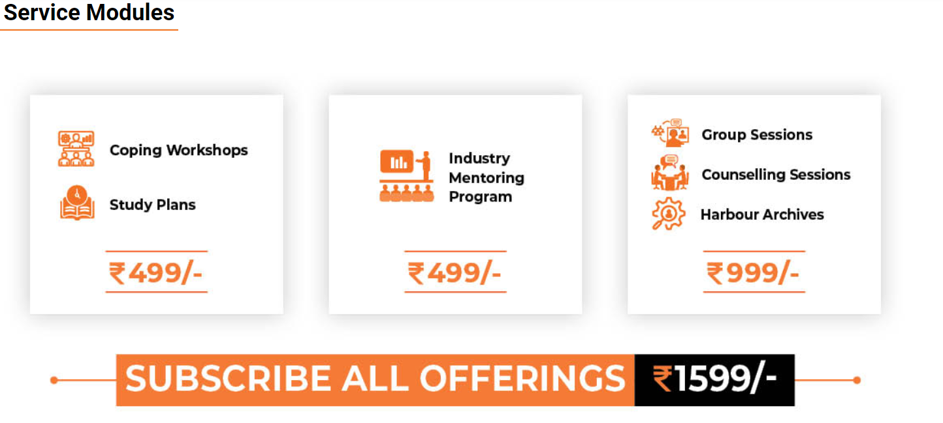

Offerings:

1. **LIVE Coping Workshops**

**28 Coping Workshops ( 42 Hrs)**

1. **Soft Skill Workshops**

* Time Management
* Personal Branding & Networking
* Public Speaking
* Interview Skills
* CQ & Problem Solving

**b) Mental Health Workshops**

* Practicing Mindfulness
* Managing Burnout and Stress
* Work-Life Balance
* Developing Emotional Intelligence

**c) Leadership Skill Training**

* Planning & Decision Making
* Coaching Skills for Leaders
* Conflict Resolution Skills
* Multitasking and Delegation Skills

**2. Mentoring from Distinguished professionals**

* Duration 4 months
* Domain Specific

**3. Study Plan**

* Study Schedule based on your work timings

**4. Personal Counselling Sessions**

* 2 Telephonic Counselling Sessions with Psychologist

**5. Group Therapy/ Group Counselling Sessions**

* Access to Support group meetings

**6. Self Help Content on LMS**

* 50 + Content for Self Development
* Sample Topics : Tips to improve English Communication, Reducing your Anxiety, Identifying early stages of Depression, Self -Assessment Tests (E.Q / Leadership skills)

********************

**How to Register**

* Inform your sales counsellor

OR

* Directly subscribe on <https://mitsde.com/harbourPayment>

********************

**Certifications**

Participant Certificates to Learners on

* Leadership Skill Training
* Soft Skill Training
* Mental Health Awareness Training